Tax Incentives for Preceptors of Nurse Practitioner Students in Massachusetts: A Potential Solution
Katherine Valorie Carelli, PhD Candidate MSN RN CHPN, University of Massachusetts Boston, USA
Peris N. Gatiba, MSN BSN, University of Massachusetts Boston, USA
Dr. Linda S. Thompson, Mph DrPH RN FAAN, University of Massachusetts Boston, MA

Abstract (300 word limit)
Statement of the Problem and Purpose: With a growing population, there is an increasing need for Nurse Practitioners to improve access to health care. There is currently a shortage of Nurse Practitioner (NP) preceptors across Massachusetts, making clinical placements difficult and at times unachievable. Lack of NP preceptors has a direct impact on student outcomes, educational programs, and ultimately access to care. The authors explored lessons learned about the national scale of this problem, and whether Massachusetts should entertain legislative initiatives similar to other states as a solution. Methodology: Data were collected from Boards of Nursing and the national and state chapters of the American Association of Nurse Practitioners regarding current and pending legislation. State and federal sources and the Massachusetts Association of Colleges of Nursing provided statistical and qualitative data on current and future needs for NP preceptors. Findings: States that have successfully passed legislation have awarded tax incentives to NP preceptors, although none of the existing regulations have assessed for their effectiveness in improving preceptor availability. Although NP students are in great need of preceptors, Massachusetts will have a projected 990 practitioner surplus of Nurse Practitioners by 2025. This is not the national trend and there are many geographical areas within Massachusetts that are in need of primary care providers. Conclusion & Significance: Massachusetts may benefit from legislation to improve NP student access to preceptors, however incentives related to geographical location may best serve both students and the greater population.

Image
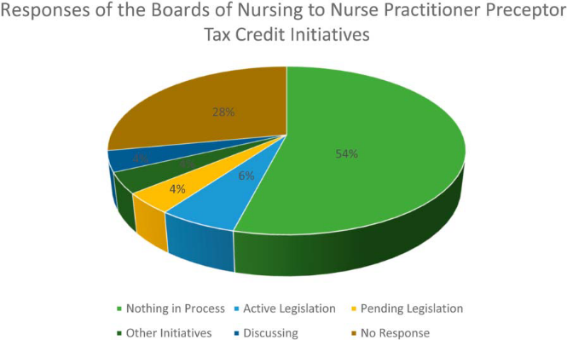
Figure 1. Responses of the boards of nursing
Recent Publications (minimum 5)
- Berry, D. L., Blonquist, T. M., Halpenny, B., Hong, F., Morrison-Ma, S. C., McCullough, M. C., Carelli, K., Dominici, L. S., & King, T. A. (2019). The Jacki Jacket after Mastectomy with Reconstruction: A Randomized Pilot Study. Manuscript submitted for publication.
- Carelli, K. V., Gatiba, P. N., & Thompson, L. S. (2019). Tax incentives for preceptors of nurse practitioner students in Massachusetts: A potential solution. Journal of the American Association of Nurse Practitioners, 31, 462-467.
- Fawcett, J., Cronin, J., Cuccovia, B., & Valorie, K. (2019). Still more thoughts about conceptual models and literature reviewed: Focus on health policy. Nursing Science Quarterly, 32, 78-81. doi: 10.1177/08943184188-7946

Photograph

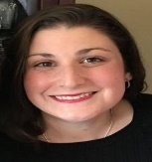Biography (150 word limit)
Katherine is a PhD Candidate in the Nursing and Health Policy program at the University of Massachusetts Boston. Her research interests are improving quality of life outcomes in hospice patients by concentrating on mental health wellness. Her dissertation research focuses on how the emotional needs of hospice patients are met by Medicare-certified hospice organizations across the United States. She received her Bachelor of Arts degree in Psychology from Clark University in 2007, her Nursing Diploma from St. Joseph School of Nursing in 2010, and Master of Science in Nursing Administration and Leadership in 2017 from Northeastern University. She is a practicing hospice nurse case manager and is a Certified Hospice and Palliative Nurse. She is a member of the Hospice and Palliative Nurses Association, the American Nurses Association, and the Sigma Theta Tau International Honor Society. Her future goals include informing health policy through research and work in vulnerable populations.
Email: katherine.carelli001@umb.edu

Notes/Comments:

