The Impact of COVID-19 Pandemic on the Municipal Solid Waste (MSW) Generation and the Potential Environmental Health Risks
Dr Sharifah Norkhadijah Syed Ismail, PhD, Universiti Putra Malaysia

Abstract (300 word limit)
Statement of the Problem: Solid waste volume is expected to increase with the implementation of the COVID-19 restriction movement. This study provides an insight of municipal solid waste generation (MSW) and recycling rates amid of COVID-19 pandemic. Methodology & Theoretical Orientation: The MSW generation and recycling rate were measured from the datasets before and during COVID-19. The environmental impact in terms of the greenhouse gases (GHG) emission (i.e. methane and carbon dioxide) and leachate production were quantified using the Intergovernmental Panel on Climate Change (IPCC, 2013) and the mathematical models. The health risk from the potential exposure to the landfills Non-methane volatile organic compound (NMVOC) was measured using the United States Environmental Protection Agency (USEPA, 2011). Findings: The municipal solid waste generation decreased during the pandemic. The domestic waste contributed the highest composition from the total solid waste generated during the pandemic, followed by the bulky and garden waste and public cleansing waste. The amount of recycled waste during the pandemic also was significantly higher compared to before the pandemic. This has significantly reduced the GHG emission and waste leachate production in the landfill. Despite of the decreased trend of the total solid waste, an increased pattern of food waste generation was observed during the pandemic. The carcinogenic risk and non-carcinogenic risk towards inhalation exposure to the selected NMVOC compounds were in acceptable limit with Hazard Quotient (HQ<1) and Lifetime Cancer Risk (LCR<1.0E-04). Conclusion & Significance: The COVID-19 pandemic has significantly impacted the volume of waste generated where the overall volume decreased with the increase of the recycling rate and food waste. Appropriate measures needed to manage the solid waste sustainably especially with the increase of single use plastic during pandemic.

Image

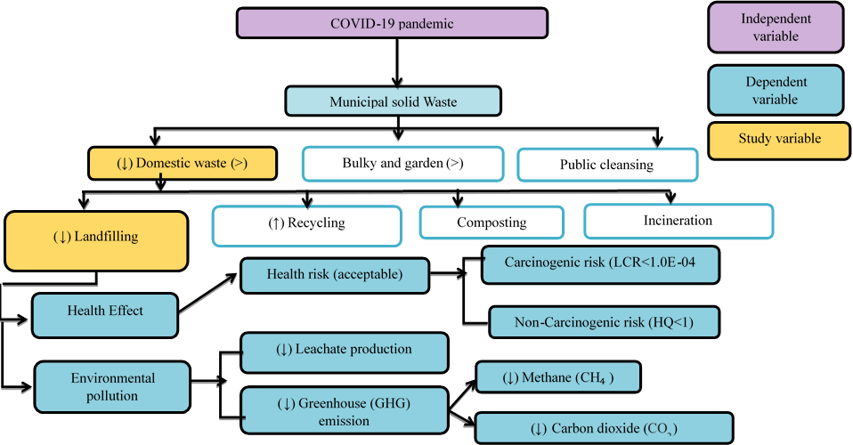
Figure 1: The Impact of COVID-19 Pandemic on the Municipal Solid Waste (MSW) Generation and the Potential Environmental Health Risks. (↓: decrease; ↑:increase, > more than)
Recent Publications (minimum 5)
- Ng J.X., Abdullah R., Syed Ismail S.N., ELTurk M (2021). Ecological and Human Health Risk Assessment of Sediments near to Industrialized Areas along Langat River, Selangor, Malaysia. Soil and Sediment Contamination, VOL:30(4), page: 49 – 476
- Razali A., Syed Ismail S.N., Awang S., Praveena S.M., Zainal Abidin E. (2021). Distribution and source analysis of bioavailable metals in highland river sediment Environmental Forensics, VOL: 22(44228), Page: 205 – 218.
- R.A. Adnan, M.F. Ramli, H.F. Othman, Z.H. Asha’ri, S.N. Syed Ismail, S. Samsudin (2021). The Impact of Sociological and Environmental Factors for Dengue Infection in Kuala Lumpur, Malaysia. Acta Tropica 216 (2021) 105834
- Azlini Razali, Sharifah Norkhadijah Syed Ismail, Suriyani Awang, Sarva Mangala Praveena & Emilia Zainal Abidin (2020). The impact of seasonal change on river water quality and dissolved metals in mountainous agricultural areas and risk to human health. Environmental Forensics. Environmental Forensics, VOL:21(2), Page: 195 – 211, DOI: 10.1080/15275922.2020.1728434.
- Ismail S.N.S., Abidin E.Z., Rasdi I.( 2020). A case study of Pasir Gudang chemical toxic pollution: A review on health symptoms, psychological manifestation and biomarker assessment Malaysian Journal of Medicine and Health Sciences, VOL:16, Page: 175 – 184.

Photograph


Biography (150 word limit)

Dr Sharifah has her expertise on environmental health modeling and waste management. She has been involved in modelling the impact of waste generation on the environment such as climate change specifically to Greenhouse gases emission, leachate production and other type of chemical exposure as well as to the carcinogenic and non-carcinogenic health risk. This is to provide an insight of the significant impact from waste generation towards human and environment and it allows to create a sustainable waste management system. Her assessment mainly based on various calculation model such as LCA, CBA etc. This approach is cost effective, and manage to assist the stakeholders in their decision making.
Email: norkhadijah@upm.edu.my

Notes/Comments:

