Exploitation of mineral waste fine fraction to produce cultivable substrates to use for land rehabilitation
PhD Eng. Giovanna Antonella DINO, UNITO, ITALY
Dr. Iride PASSARELLA, HORIZON srl, ITALY
Phd. Dr. Elio PADOAN, UNITO, ITALY
Prof. Franco AJMONE MARSAN, UNITO, ITALY

Abstract

Waste coming from mining and quarry industry and the ones coming from construction and demolition waste (C&DW) and rock and soil from excavation works (RSE) represent the 2nd and the 1st source of waste production at EU level (25 and 36% respectively, Eurostat 2019 – data 2016). They can cause serious environmental and economic problems in view of the difficulties related to its disposal, especially of the finest fraction. At present little is known about their potential as components of a cultivation substrate; indeed they are characterized by low physical and chemical fertility, which require the mixing with organic materials to improve their general properties. The aim of this study is to test the agronomic characteristics of the produced mixes in order to evaluate their potentiality to be used for land rehabilitation. The investigated mineral waste (fine fraction) were: residual sludge from ornamental stones working activity, sludge coming from aggregates production, tailings and waste rock fine fraction from mining activity (Zn-Pb and Ni closed mines), fine fraction connected to C&DW and RSE recycling activities. These waste materials were collected and mixed with compost, shredded green compounds, wastewater sludge and soil material. The original materials and the mixtures were analyzed for metals and hydrocarbons (TPH, where present) and for their phytotoxicity (seed germination and plants growing). The results show that mixing with organic compounds can improve the overall quality and fertility of the mineral waste fine fraction and that the mixture is not phytotoxic. This indicates that the mineral waste fine fraction could be employed, when properly managed and treated, for land rehabilitation after improvement of its fertility and of its environmental quality.

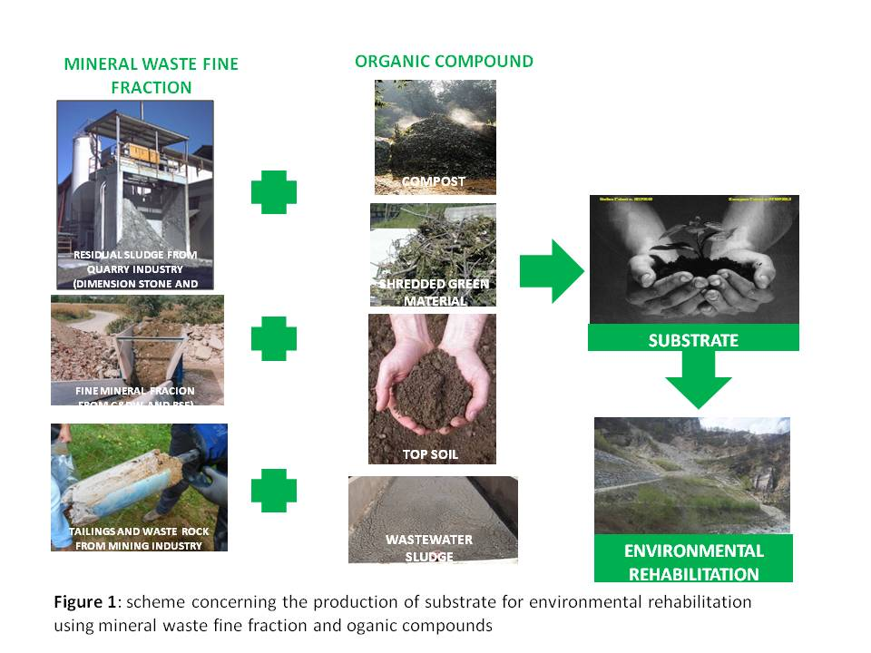
Recent Publications
- Burragato F, Mecella G, Scandella P (1999) Waste muds from Processing of the siliceous sands from Priverno: potential use for environmental rehabilitation. 2nd National Congress “Valorisation and recycling of industrial wastes”. L’Aquila, Italy, 5-8 July 1999
- Castillejo JM, Castello R (2010) Influence of the application rate of an organic amendment (Municipal Solid Waste (MSW) Compost) on gypsum quarry rehabilitation in semiarid environments. Arid Land Research and Management, 24:344-364.
- Dino G A, Passarella I, Ajmone-Marsan F (2015) Quarry rehabilitation employing treated residual sludge from dimension stone working plant. Environ Earth Sci. 73: 7157-7164.
- Mehta N, Cocerva T, Cipullo S, Padoan E, Dino GA, Ajmone Marsan F, Cox S, Coulon F, De Luca DA (2019) Linking oral bioaccessibility and solid phase distribution of potentially toxic elements in extractive waste and soil from an abandoned mine site: Case study in Campello Monti, NW Italy. Science of the total environment. Volume 651, Part 2, 15 February 2019, Pages 2799-2810.
- Sivrikaya O, Kıyıldı KR, Karaca Z (2014) Recycling waste from natural stone processing plants to stabilise clayey soil. Environ Earth Sci 71:4397–4407

Biography
Giovanna Antonella DINO, environmental engineer and PhD in environmental geo-engineering, research assistant at the Earth Sciences Department- University of Torino. Currently she is also a member of the Board of Director at CIDIU S.P.A. (Public enterprise dealing with waste management and recycling). Her research activity focuses mainly on issues related to the circular economy, landfill mining, sustainable mining and promotion and dissemination of heritage stones and. Involved, also as Project Manager, in several national and international projects concerning the aforementioned research themes. From January to May 2019 involved as external technical expert (for issues related to sustainable mining and the circular economy) for the TEG dealing with the implementation of the European Commission's Sustainable Finance Action Plan. Since 2001 she has been publishing more than 100 scientific papers and abstracts. She has been involved, as a speaker and/or chair, in more than 30 national and international conferences.
e.mail: giovanna,dino@unito.it

Notes/Comments:

