THE DEGRADING EFFECTS OF THE RADIATION ON THE PROPERTIES OF BUTYL RUBBER COMPOUNDS
Sandra R. Scagliusi, PhD, IPEN/CNEN, Brazil.
Elizabeth C. L. Cardoso, PhD, IPEN/CNEN, Brazil.
Ademar B. Lugão, PhD, IPEN/CNEN, Brazil.

Abstract
Polymeric materials (plastics and rubber) have been contributing in a continuously and raising way for the generation of litter and industrial wastes discarded in landfills. Gamma ionizing radiation has capacity for changing structure and properties of polymeric materials and can be applied to almost all types of polymers; irradiation is an expectation for problem-solving of rubber wastes management that can be utilized as raw-materials or chemical additives. butyl rubber has excellent mechanical properties and oxidation resistance, as well as low gas and water vapor permeability. At the initial stage of irradiation the degradation of butyl rubber occurs predominantly via random chain-scission This work aims to the introduction of a new recovery technique for butyl rubber, by using processing via gamma-rays followed by shear. 5 kGy, 15 kGy, 25 kGy, 50 kGy, 100 KGy, 150 kGy and 200 KGy doses were used, in order to study the feasibility of butyl rubber for recycling. Doses within 5 to 25 kGy applied to butyl rubber and further shear pointed toward a less degraded material, indicating that this type of elastomer is able to be incorporated to a new rubber compound and replacing some parts of pristine rubber in formulations without imparting great losses in physical-chemical properties.

Image

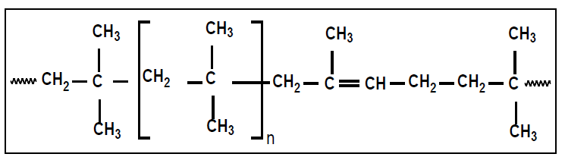
Butyl rubber structure illustration.

Recent Publications (minimum 5)
- Scagliusi, S.R., Cardoso, E. C. L., Esper, F. Lugão, A. B (2018) Butyl Rubber Recycling Via Gamma Radiation Followed by Mechanical Shear, Ecology, Pollution and Environmental science journal . 1: 84-88.
- Scagliusi, S.R., Cardoso, E. C. L., Lugão, A. B. (2016) Study of recycling feasibility of bromobutyl rubber to gamma radiation, Journal of Materials Sciences and Applications 2: 1-9.
- Zaharescu.T., Zen, H. A., Marinescu, M., Scagliusi S. R., Cardoso, E. C. L., Lugão A. B., (2016) Prevention of degradation of γ-irradiated EPDM using phenolic antioxidants, Chemical Papers 70 (4): 495–504.
- Scagliusi S.R., Cardoso E.C.L., Lugão A.B. (2015) A influência da incorporação de borracha irradiada em compostos de borracha clorobutílica, Revista Ibero Americana de Polímeros, 16(4): 185-190.
- Scagliusi S.R., Cardoso E.C.L., Parra D.F., Lima L.F.C.P., Lugão A.B (2013) Evaluation of “Payne effect” in radiation-induced modification of chlorobutyl rubber, Radiation Physics and Chemistry 84: 42-46.

Biography
Sandra Regina Scagliusi: Great experience with elastomers. Upgraded in recovering of rubbers, in general, specially dealing with butyl and halo-butyl rubbers (chlorine and bromine). She is deeply involved with irradiation, recycling, de-vulcanization, micro-wave. She developed a new process of rubbers recovering via radiation and mechanical shear. She has been dedicating in research toward environmental area in recycling of solid materials and elastomers. Proved experience in research and quality control laboratories.

Email: scagliusi@usp.br

Notes/Comments:

