A PROPOSAL FOR THE SUSTAINABLE TREATMENT AND VALORISATION OF OLIVE MILL WASTES

*Hafsa Annabª ; Nuria Fiol^{b} ; Isabel Villaescusa^{b}; Azzouz Essamriª
ª: Department of Chemistry, Faculty of Science, University campus,14000 Kenitra, Morocco
^{b}: Chemical Engineering Department, University of Girona, Avda M. Aurelia Campany 61. 17003 Girona, Spain

Abstract (300 word limit)
Olive mill technology generates a considerable amount of both solid (olive pomace OP) and liquid by-products (olive mill waste water OMWW) during olives milling season, usually between November and March. These wastes represent a great challenge for olive oil producers since they must find technical, environmental and economic solutions to manage these by-products. The aim of this work was to explore and propose a complete cycle of olive mill wastes treatment. Two sorbents based on olive pomace chemical activation, granular (GAC) and powdered (PAC) activated carbons were successfully synthetized and encapsulated in calcium alginate. The obtained gel beads (GAC-B and PAC-B) were tested as sorbents for gallic acid adsorption. Both sorbents showed great potential for gallic acid sorption; although PAC-B beads resulted to be the most efficient. The major efficiency presented by PAC-B beads for gallic acid removal was attributed to the basic character and high porosity of PAC. In view of an industrial application, PAC-B beads were used to treat OMWW with the aim to adsorb polyphenols from the effluent, and, at time, to reduce the contamination of so strongly polyphenols loaded effluents. The outcomes of this study attest proofs of great potential of PAC-AC beads for polyphenols removal. Briefly, this paper suggests a proposal for sustainable treatment and valorization of both olive mill waste water and olive pomace, as they can be recycled and reused for own benefit of the industry

Image
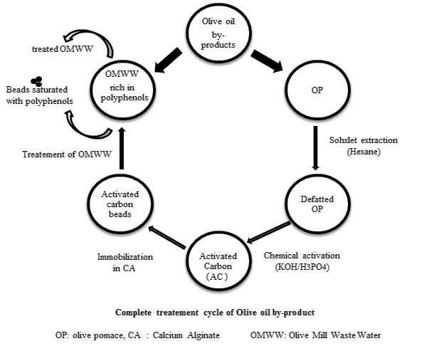
Recent Publications
L. Bertin, F. Ferri, A. Scoma, L. Marchetti, F. Fava. Recovery of high added value natural polyphenols from actual olive mill wastewater through solid phase extraction. Chemical Engineering Journal 171 (2011) 1287– 1293

I. Dammak, M. Neves, H. Isoda, S. Sayadi, M. Nakajima. Recovery of Polyphenols from Olive Mill Wastewater using Drowning-out Crystallization based Separation Process. Innovative Food Science and Emerging Technologies. (2016).Doi:10.1016/j.ifset.2016.02.014

S. Dermeche, M. Nadour, C. Larroche, F. Moulti-Mati, P. Michaud. Olive mill wastes: Biochemical characterizations and valorization strategies. Process Biochemistry 48 (2013) 1532–1552
A. Elmouwahidi, E. Bailon-Garcıa, A.F. Pérez-Cadenas, F.J. Maldonado-Hodar, F. Carrasco-Marin,. Activated carbons from KOH and H3PO4-activation of olive residues and its application as super capacitor electrodes, Electrochimica Acta EA 28 (2017) 819
S.M. Yakout, G. Sharaf El-Deen. Characterization of activated carbon prepared by phosphoric acid activation of olive stones. Arabian Journal of Chemistry 9, (2016) S1155–S1162

Photograph

Biography (150 word limit)
Dr Hafsa ANNAB received her Phd in Basic and Applied Chemistry in February 2019, from the University of Ibn Tofail of Morocco in collaboration with the university of Girona in Spain, Dr. Hafsa ANNAB has worked as lead manager of laboratory of olive mill wastes valorization of Hawd Society for five years. Her interests are focused on the elaboration of new sorbents based on solid waste of olive oil industry (olive pomace) for the use in polyphenols recover from the liquid influent of the same industry.
Email: hafsa.annab@gmail.com

Notes/Comments:

