Abstract
Abstract Title: SOLID WASTE MANAGEMENT IN SOUTH AFRICAN TOWNSHIPS
First Author: Elijah Mabogo

¹ First Author Affiliation (University of Venda, RSA)

Abstract

The presentation is about waste management facilities in South African townships. The first facility is a Morden-design landfill site called Ondersterpoort Landfill site. This facility takes general waste such as household waste, building rubble and garden waste. It is located in Pretoria North a few kilometres from Rooslyn Town. It allows the municipalities to bring general waste from the surrounding areas, however the public is also allowed to bring waste upon agreement with the facility. To encourage recycling, this facility management allows Waste-reclaimers to come and collect recyclable waste on the facility. The lifespan of this facility is estimated at above twenty years.

The second facility is also a modern design waste buy-back centre called Attredgeville Waste Buy-back. It is located in Pretoria West at a township called Attredgeville. As the name indicates, this facility is focussed on collecting recyclable waste from the general public and small businesses for the purpose of packaging, weighing and transportation to the recycling facilities out of the area. The recyclables allowed includes: papers, cardboard paper, white paper, plastic bottles and metal cans. The recyclables brought into the facility are weighed then packaged, some are also cleaned before they can be weighed. The people who bring waste are given money for the waste that they bring to the facility, the fees differs from the type of waste they bring and the weight thereof.

The third facility is also found in Pretoria West in a township called Attridgeville. Here waste is weighed, sorted, packaged and sent for recycling, the remaining non-recyclables are then used to make manure whereas the remainder out of that is then dumped in the landfill on site. The machinery on site is made for waste separation, packaging and compacting. The local municipalities and businesses are allowed to bring waste into the facility.

Keywords—Solid waste, Waste Facilities, Recycling, Buy-back Centre.

Professional Biography

Elijah Mabogo has completed his Degree in Environmental Sciences (ENVSC) at the age of 21 years from the University of Venda (South Africa) in 2008. Other qualifications obtained includes: First Aid Level 1,2,3, Environmental & Sustainability Law, Integrated Waste Management, Advanced Safety Management, Safety Health and Environmental Quality Management, Management of Hazardous & Toxic Waste, Health & Safety for Supervisors, Generic Safety Health and Environmental Quality, Safety Health and Environmental Representative, all from the University of Venda. He is the director of Core-Line Solutions, a company dedicated to Environmental Consulting, Health and Safety Consulting.
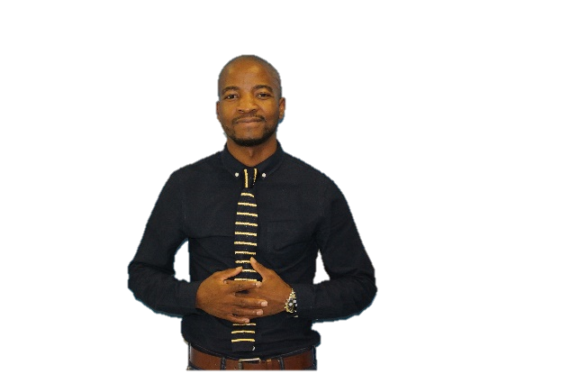

Email Id: elijah@coreskills.co.za

I would like to express my sincere gratitude for the opportunity given to me so that I can share my presentation. I am hopeful that this short presentation will serve the intended purpose. Thank you.

