Abstract
Abstract Title: SOLID WASTE MANAGEMENT IN SOUTH AFRICAN TOWNSHIPS
First Author: Elijah Mabogo

¹ First Author Affiliation (University of Venda, RSA)

Abstract

Solid waste management in South Africa has undeniably developed over the years. This presentation is focused on research done on small scale waste management facilities in South Africa. The management of solid waste is done at different facilities depending on the type of waste and the location of the waste management facility. Within this presentation, I discuss the management of general waste, recycling of plastic bottles and the different infrastructure used for waste management.

Keywords—Solid waste, Waste Facilities, Recycling, Buy-back Centre.

Professional Biography

Elijah Mabogo has completed his Degree in Environmental Sciences (ENVSC) at the age of 21 years from the University of Venda (South Africa) in 2008. Other qualifications obtained includes: First Aid Level 1,2,3, Environmental & Sustainability Law, Integrated Waste Management, Advanced Safety Management, Safety Health and Environmental Quality Management, Management of Hazardous & Toxic Waste, Health & Safety for Supervisors, Generic Safety Health and Environmental Quality, Safety Health and Environmental Representative, all from the University of Venda. He is the director of Core-Line Solutions, a company dedicated to Environmental Consulting, Health and Safety Consulting.
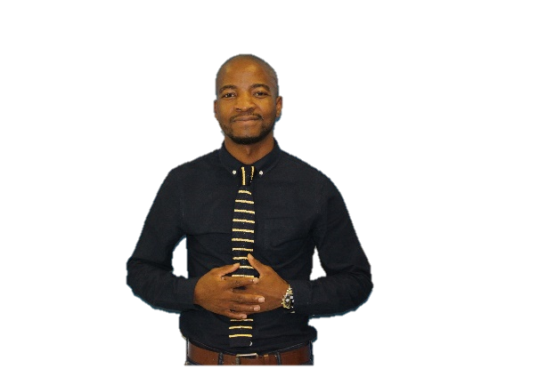

Email Id: elijah@coreskills.co.za

I would like to express my sincere gratitude for the opportunity given to me so that I can share my presentation. I am hopeful that this short presentation will serve the intended purpose. Thank you.

