Title: “Governance Failure in Public Service Delivery; A Study of Solid Waste
Management in Kathmandu Metropolitan City, Nepal”
Name: Dahal, Indra Prasad
Affiliation: Nepal Rural Development and Environment Protection Council, Kathmandu, Nepal

Abstract
Solid waste management in Kathmandu Metropolitan City, Nepal has been in crisis though the city is followed by a series of efforts. This research aims to probe governance at the national and local levels of government and to determine the driver of persistent failure in the field of governance. This research used tools from social sciences disciplines such as group interviews in landfill sites, consolations with government, and a literature review. There are laws,policies, guidelines, as well as national and local organizations covering waste management and yet the laws are not enforced and instead they are frequently repealed and replaced with new orders. The hierarchic structure of employment adds more challenges to waste management. Governance from the national government to local agencies is poor with reports and charges of corruption. Waste management in Kathmandu serves as an example of the failure in the various views, especially in the field of governance. So, the governmental efforts need better governance and improve accountability to sustain its practices.

Keywords:- Accountability, Fiscal Health, Governance, Institutional Framework, Waste Management.

Biography Of the Author.
Personal Details
- Name : INDRA PRASAD DAHAL ( Ph. D Scholar)

- Passport no :10007364

- Date of Birth : 19 Dec,1973

- Father's Name : Tanka Nath Dahal

- Nationality : Nepali

- Gender : Male

- Religion : Hindu

- Language Fluency: Nepali, Hindi & English both in written/spoken.

Contact Details
Address : Gongabu-6, Kathmandu, Nepal.

Contact No. : +977 1-4359451(O), +977 9851043164.

E-mail : indrapddhl@gmail.com/lincolncollege@edu.np/

Academic Qualifications:
- M.B.A. in 2nd Div. from Saraswati Multiple Campus, Thamel,Kathmandu under Tribhuwan University of Nepal with 55.6% in 1998.
- M.phil in 3.71 GPA in 2017 from Central Department of Public Administration College,Jamal,Kathmandu under Tribhuwan University of Nepal.
- Ph. D. Scholar in Tribhuwan University of Nepal from 2018 for three years and research topic is also under waste management.

Email ID: indrapddhl@gmail.com

Presenter Name: Dahal, Indra Prasad.
Type of Presentation: Speaker
Contact Number:+977 9851043164
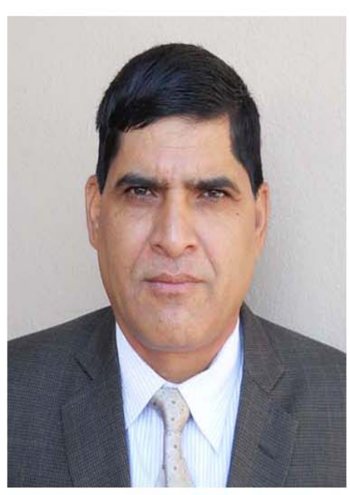picture



