Abstract Template
Abstract Title: Waste to Wealth: Livelihood Generation from Composting at Jamshedpur, India
Dr Hishmi Jamil Husain¹
Gaurav Anand²

¹ Tata Steel Limited, Jamshedpur - 831 001, India
² Jamshedpur Utilities and Services Company, Jamshedpur - 831 001, India

Abstract (not more than 300 words)

Waste is unwanted or undesired material left over after the completion of a process. In other words, it can also be stated that any substance or object which the holder discards or intend to discard is also waste. Recycling of waste material has been appreciated for centuries. Waste generation is increased several folds from 1960s to 2010. To combat problem of waste management several solutions are suggested but composting from organic waste is widely acceptable method and easy to implement. This replaces chemical fertilizers to organic manures. In early 1990s scientists around the world realized the limitations and adverse effect of chemical fertilizers used for fertility management in agriculture. Organic matter recycling has been in use in India for centuries. The waste management and recycling particularly the use of vermin-cultural practices to produce a valuable organic medium for use in plant growth, demonstrates best practice for conserving environment and promote organic cultivation. Organic farming is a form of agriculture that relies on ecosystem management and attempts to reduce or elimina1te external agricultural inputs, especially chemicals. It is a holistic production management system that promotes and enhances agro-ecosystem health, including biodiversity, biological cycles, and soil biological activity. The nutrients are readily available to crops, with the added benefit of microbial organisms that are essential for plant growth. The combination of nutrients and microbial organisms are essential for healthy and productive crops. Due to fertile properties and demand of organic agriculture products, there is good market available for compost.
Jamshedpur city generates 270 to 300 tonne of solid waste every day. In 2012, Jamshedpur Utilities and Services Company (Jusco) has installed the first composting plant to deal the waste generated. Average price of 5 kg compost is USD 1$ and this is generating the livelihoods for the people. The quantity of compost being produced per year varies from 600 MT to 725 MT. The collection of solid waste has given opportunity to employ the local people. This is help in revenue generation from the selling of compost material.

Keywords—Composting, Waste Management, Livelihood Generation, Organic Farming

Professional Biography (100-150 words)

Dr Hishmi is having two-decade experience in the field of environment management and sustainable development. Dr Hishmi is Lead Author for Asia-Pacific Regional Assessment Biodiversity Assessment of Intergovernmental Science Policy Platform on Biodiversity and Ecosystem Services (IPBES) and Commission Member of International Union for Nature and Conservation (IUCN). He is on board of several national and internal bodies. He is visiting faculty and distinguished speaker in India. He is having two books, several papers and more than 160 articles in his credit. In 2015 Dr Hishmi awarded Young Scientist Award and in 2016 was awarded Environment Scientist Award for his outstanding work on biodiversity conservation and environment management.

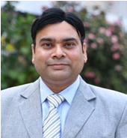

Gaurav Anand’s Biography -
Gaurav Anand is an Environmental Engineer . He has worked in the field of City Management, Climate change, River Action Plan and is also dedicated towards the Protection and Sustenance of the Environment through continuous learning, innovative approaches & implementation along with excellent team-building skills. Apart from his University degree, He has completed online certifications in Climate change, Public health, Solar Energy, Innovation & Solid State Chemistry.
As an Officer of the JUSCO for 12 years, he has worked on Waste Management, Quality Assurance, Environment and Climate Change projects and Internet of Things. He has presented ‘Papers’ regarding Waste management possibilities and feasibilities for Indian city at various forums.
Gaurav Anand is a passionate volunteer and contributor in Smart City and Swachha Bharat Campaign; associated with teaching environment to several city college students; supports citizens in setting up smart city framework; and provides technical help for Biogas systems, Plastic Tar road, Vehicle Tracking System and City management projects. He follows innovative approach to make complex things ‘simple.
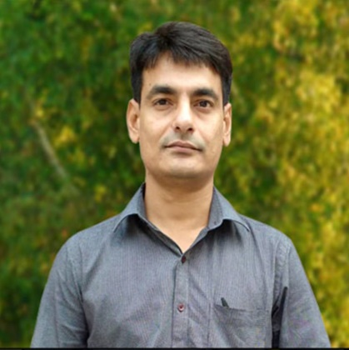
Paste your Photograph here
Email Id: hishmi.husain@tatasteel.com
Any Comments:

