International Conference & Expo on recycling on August 20-21, 2018 in Hyatt place, Amsterdam, Netherland
Theme: Recycling- the World perception
Title: Recycling is the major industry for the absorbing millions of technical and non-technical peoples, generate income, create employment, stronger economy, reduce crises, poverty and hunger in the world.
Abstract:

The aim of presentation consist of industry, production, income, employment, economy, crises, poverty and hunger were study and reported that Recycling is the major industry for the reproduction, absorbing millions of technical and non-technical peoples, generate income, create employment, stronger economy, reduce crises, poverty and hunger in the world. The study reported that unless you have been on another planet for the last century, then you have probably heard of it. Recycling is the process of breaking down and re-using materials that would otherwise be thrown away as trash. Many communities and businesses make it easy to recycle by placing labeled containers in the open for public use, or providing bins for home and business owners who have curbside pickup. There are numerous benefits to recycling, and with so many new technologies making even more materials recyclable, with everyone’s help we can clean up our Earth. Recycling not only benefits the environment but also have a positive effect on the economy. Recycling is reported throughout human history but has come a long way since the time of Plato when humans re-used broken tools and pottery when materials were scarce. Today, there is a multitude of benefits that come from recycling as well as tons of items that can be recycled. The different types of recycling are Waste Paper Recycling, Cardboard Recycling, Plastic Recycling, Metal Recycling, Wood Recycling, Textiles Recycling, Bricks/Inert Waste Recycling and Glass Recycling. In the light of the above study it is concluded that Recycling is the major industry for the reproduction, absorbing millions of technical and non-technical peoples, generate income, create employment, stronger economy, reduce crises, poverty and hunger in the world.

Biography: Mr. Muhammad Usman, Former Director General of Agricultural Research System, Government of Pakistan who retired from service after a spotless career of about 35 years with senior level experience on research and development of integrated agricultural production particularly recycling on a sustainable way.
Mr. Usman is consider as the senior most scientist in the world, always participated in the international conferences.
Mr. Usman has established “Prominent Agro Based Industries SDN BHD”, “Agro Based Industries and Consultancy SDN BHD” in Malaysia and “Foundation for Rural Development in Pakistan”, with primarily aims to work on integrated agricultural project for Rural Development through improvement in agriculture and consultancy services to the formers at Malaysia.

References
- 1) Ackerman, Frank. (1997). Why Do We Recycle?: Markets, Values, and Public Policy. Island Press. ISBN 1-55963-504-5, ISBN 978-1-55963-504-2
- Ayres, R.U. (1994). "Industrial Metabolism: Theory and Policy", In: Allenby, B.R., and D.J. Richards, The Greening of Industrial Ecosystems. National Academy Press, Washington, DC, pp. 23–37.
- Braungart, M., and W. McDonough (2002). Cradle to Cradle: Remaking the Way We Make Things. North Point Press, ISBN 0-86547-587-3.


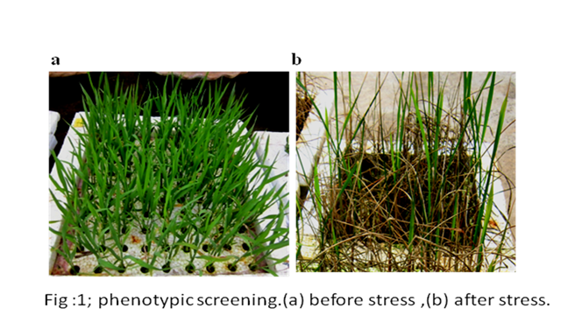
Name: Muhammad Usman
Contact number: +923459455262
Session: Biofuel 2018
Category: Oral Presentation, Keynote Speaker
Passport No: AP2854952

Muhammad Usman, Moderator of The conference of Biochemistry 2017 Felicitate Prof. Jaleel K Ahmed with Keynote Certificate On Sep, 29 at Dubai

