Anti-MosquiCoat: Integration of Extracts and Wastes
into an Anti-mosquito Paint

Sam Tyra Co, Erika Vixeen Dia

¹ De La Salle- College of Saint Benilde, Manila, Philippines
² De La Salle- College of Saint Benilde, Manila, Philippines

Abstract

PET plastics are one of the major contributor of wastes in the Philippines. These plastics also become the breeding ground of mosquitoes that carries dengue viruses, a mosquito-borne disease that is harmful to humans. In this study, PET plastics components are combined with citronella extracts to create a special indoor paint specifically made to repel and knockdown mosquitoes. With the properties of PET bottles, this shows the potential to be recycled into a paint component. Furthermore, with the prevalence of mosquito-borne diseases, it is timely to create an architectural product to fight against this uprising problem in the Philippines with the integration citronella oil extracts, PET plastic bottles, and permethrin into a paint. This would benefit especially the children who are most vulnerable to mosquito-borne diseases. By creating a new alternative anti-mosquito paint, this would lessen the prevalence of mosquito borne diseases and because of the integration of plastic wastes in the paint, this would also help contribute in the reduction of solid wastes in the country.

Keywords—PET plastics, plastics, dengue, mosquitos, paint

Professional Biography

Sam Tyra Co is a 5th year undergraduate student of the Architecture Program at the De La Salle- College of Saint Benilde, School of Design and Arts.
Erika Vixeen Dia has completed her Master of Architecture, Major in Architectural Science at the University of Philippines. She is currently an assistant professorial lecturer at De La Salle- College of Saint Benilde, School of Design and Arts-Architecture Program.

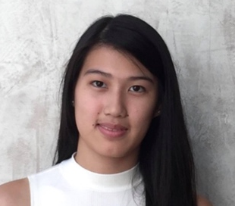

Email Id: samtyra.co@benilde.edu.ph and/or erikavixeen.dia@benilde.edu.ph.

Any Comments:
We wish to submit a new study entitled "Anti-MosquiCoat: Integration of Extracts and Wastes into an Anti-Mosquito Paint" for consideration for the International Conference & Expo on Recycling this August of 2018.

We confirm that our research has not yet been presented nor published to any local or international publications.

In this study, we attempted to create a mosquito-repellent paint using citronella and PET bottles. We believe that our research is suited for this conference and its theme.

Please address all correspondence concerning this manuscript at samtyra.co@benilde.edu.ph and/or erikavixeen.dia@benilde.edu.ph.

Thank you for your consideration of this abstract.

Sincerely,
Sam Tyra Co
Student Architecture Program
School of Design and Arts
DLS-College of St. Benilde

