Application of Machine Learning and Deep Learning in Brain Tumor Detection in MRI Scans – Comparison and Analysis of Different Models
Aarav Goyal, GMA, Dubai, UAE
Shreya Parchure, Department of Bioengineering, University of Pennsylvania, USA

Abstract
Statement of the Problem: Detecting brain tumors from MRI scans is a complex and time-consuming task for radiologists, who must review numerous scans before identifying positive cases. Missing a tumor (false negative) can have severe consequences for patient outcomes. Current research on AI-based brain tumor detection focuses exclusively on neural networks without comparing them to conventional machine learning models. Methodology & Theoretical Orientation: This study employed two distinct datasets: one for binary classification (tumor presence) with 253 low-resolution images, and another for multiclass classification (tumor type) with 5,712 high-resolution images of pituitary tumors, gliomas, meningiomas, and controls. Multiple machine learning algorithms—including Random Forest, K-Nearest Neighbors (KNN), Logistic Regression, and Gaussian Naive-Bayes—as well as neural networks like Multi-Layer Perceptron (MLP) and Convolutional Neural Networks (CNN) were trained and evaluated. Findings: CNNs achieved the highest accuracy of 90.2% for binary and 88.9% for multiclass classification, demonstrating significant potential due to their ability to extract spatial features from images. The Random Forest classifier also achieved high accuracy (89.5% binary, 86.9% multiclass) and strong recall rates, indicating robust tumor detection capabilities. KNN exhibited the highest sensitivity at 91%, minimizing false negatives. Conclusion & Significance: Integrating machine learning models like Random Forest and CNNs into clinical practice could greatly help radiologists accurately detect and classify brain tumors, resulting in improved patient outcomes. Future research with larger, more diverse datasets could further validate these models for real-world clinical applications.

Image
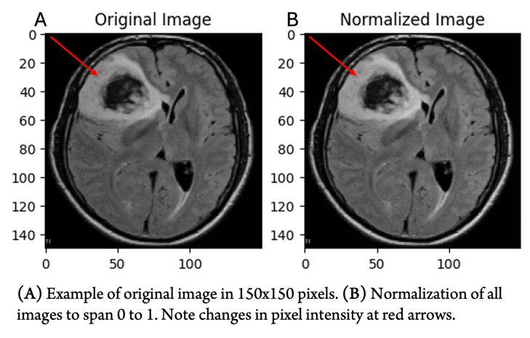
Figure 1. Data Image Preprocessing – Normalization of pixel intensities.
Recent Publications
- Heilig M, Egli M (2006) Breiman L (2001) Random forests. Machine Learning 45:5–32.
- Gao P, Shan W, Guo Y, et al. Development and validation of a deep learning model for brain tumor diagnosis and classification using MRI. JAMA Network Open 5:e2225608 (2022).
- Ibraimova A, Satybayeva A, Neverova Y, et al. Automated screening of brain disorders: A machine learning model for MRI classification. Int J Commun Netw Inf Secur 15:118–133 (2023).
- Liu Z, Tong L, Chen L, et al. Deep learning-based brain tumor segmentation: A survey. Complex Intell Syst 9 (2022).
- D. W. Hosmer Jr, S. Lemeshow, R. X. Sturdivant, Applied Logistic Regression (John Wiley & Sons, 2013).

Photograph

Biography
Aarav Goyal conducted this research in a research internship through the AI Research Scholars Program, where he worked under the mentorship of Ms. Shreya Parchure, at the University of Pennsylvania. His research interests include machine learning, deep learning, cryptography, and their applications in healthcare. He is a student researcher with a strong foundation in computer science and mathematics.
Email: aaravgoyaldxb@gmail.com

