Added Value of Shear Wave Elastography in Assessment of Undescended Testis in Pediatric Population
Dr Bishal Jha, Faculty of Medicine, Cairo University, Egypt
Dr Saroj Ghimire, Faculty of Medicine, Cairo University, Egypt

Abstract (300 word limit)
Statement of the Problem:
Undescended testis (UDT) is one of the most common congenital anomalies in pediatric males and is associated with significant long-term complications, including infertility and increased risk of malignancy. Early and accurate evaluation of testicular integrity is essential for appropriate management. Conventional ultrasonography, although widely used, has limitations in detecting subtle parenchymal changes and assessing tissue viability. Shear wave elastography (SWE), a novel non-invasive imaging modality that quantitatively evaluates tissue stiffness, may provide additional diagnostic value by reflecting underlying histopathological changes such as fibrosis. Methodology & Theoretical Orientation: This cross-sectional study was conducted on 30 pediatric patients diagnosed with UDT at Cairo University Pediatric Hospital. All patients underwent grayscale ultrasonography followed by SWE using the Canon Aplio system. Parameters evaluated included testicular location, volume, echogenicity, vascularity, and mean elasticity values. Statistical analysis was performed using Mann–Whitney U test, Kruskal–Wallis test, ANCOVA, Pearson correlation, and ROC curve analysis to assess diagnostic performance. Findings: A total of 35 undescended testes were analyzed and compared with 35 normal controls. Testicular volume was significantly reduced in UDT cases (p < 0.001), with significant differences in echogenicity (p = 0.001). SWE values were significantly higher in UDT (11.82 ± 4.93 kPa) compared to controls (5.36 ± 1.09 kPa) (p < 0.001). Increased stiffness showed strong correlation with abnormal anatomical position and hypoechogenicity. ROC analysis demonstrated excellent diagnostic accuracy (AUC = 0.980), with a cutoff value of approximately 7.0 kPa providing sensitivity of 97.1% and specificity of 94.3%. Conclusion & Significance: SWE provides significant added value in the evaluation of UDT by enabling quantitative assessment of testicular stiffness, which reflects underlying fibrosis and structural damage. It demonstrates high diagnostic accuracy and may serve as a reliable, non-invasive adjunct to conventional ultrasound in preoperative evaluation and risk stratification. Incorporating SWE into routine imaging protocols may improve clinical decision-making and long-term patient outcomes.

Image
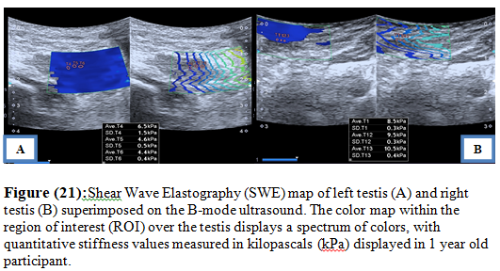
Recent Publications (minimum 5)
- Shin HJ, Jeon TY (2017) Ultrasonography of cryptorchidism: diagnostic performance and clinical significance. Ultrasonography 36: 1-8.
- Huang DY, Sidhu PS (2020) Ultrasound elastography: review of techniques and clinical applications. Ultrasound in Medicine & Biology 46: 865-879.
- Močnik D, Marčun Varda N (2023) Ultrasound elastography in children: current perspectives and clinical applications. Radiology and Oncology 57: 1-10.
- Nepal P, Ojili V, Songmen S (2018) Imaging of undescended testis: current practice and future directions. Radiographics 38: 1640-1655.
- Yurtsever I, et al. (2024) Shear wave elastography in evaluation of testicular pathology. European Journal of Radiology 172: 110987.

Photograph
 Biography
Dr Bishal Jha is a postgraduate researcher in Diagnostic and Interventional Radiology at Cairo University. He holds an MBBS degree from Napelese army institute of health sciences-College of medicine, Nepal. His research focuses on advanced imaging techniques, particularly ultrasound elastography, in pediatric and genitourinary radiology. He has a strong interest in improving diagnostic accuracy through non-invasive imaging modalities and contributing to evidence-based clinical practice. His current work explores the application of shear wave elastography in assessing undescended testis, aiming to enhance early detection of testicular damage and optimize patient outcomes.
Email: bishaljha1@gmail.com

Notes/Comments:

