Neuroimaging in patients with Non-Small Cell Lung Cancer (NSCLC): A Quality Improvement Project
Dr Rohan Chandra MBBCh iBSc PGCert MedEd (FY3 Doctor, Worcestershire Acute NHS Trust)¹
Dr Cusworth (Respiratory Medicine Consultant, Worcestershire Acute NHS Trust)²

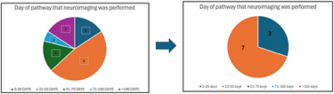
Abstract (300 word limit)
Background: Ensuring patients receive timely neuroimaging is essential in determining the best management for patients with Non-Small Cell Lung Cancer (NSCLC) with curative intent. The identification of brain metastases early in the diagnosis pathway may alter a patient’s management plan, aiding long term prognosis and minimising unnecessary radical intervention. A pre- and post-intervention quality improvement project was performed to ensure the practice of requesting neuroimaging aligned with the National Institute for Health and Care Excellence (NICE) guidance. Methods: A two-cycle Quality Improvement Project was undertaken between October 2024 and September 2025 following a PDSA (Plan-Do-Study-Act) model. Baseline data was collected on the number of patients with stage IIa, IIb and IIIa NSCLC for curative intent who received neuroimaging, time from referral to imaging and MDT documentation quality. Following initial analysis, the root-cause identified poor MDT prompts and lack of awareness amongst clinicians which led to delayed neuroimaging in the cancer pathway or no imaging at all. The intervention implemented an educational-style presentation of the baseline data to the combined Respiratory/Oncology/Radiology Multidisciplinary Team on 7th November 2024. Results: Following the intervention a marked improvement was observed in all domains. The average time for neuroimaging decreased from 58 days to 26 days. The proportion of patients with curative-intent who received neuroimaging increased from 58% to 70.5%. When neuroimaging was documented in the MDT proforma, 92.8% of patients received imaging, compared to 87% in the initial cycle. Conclusion: Targeted educational sessions to clinicians alongside MDT-based intervention significantly improved neuroimaging uptake and reduced delays in the NSCLC pathway. Highlighting the results of the first cycle with radiology/respiratory/oncology clinicians proved to create the greatest impact. Furthermore, the formation of an updated provisional MDT proforma ensured a sustainable, low-cost resource change with ability to be altered in the future to align with national guidance.

Image
Figure 1: Improvement of day in which patients received neuroimaging following referral into cancer pathway. Average day improved from 58 days to 26 days.

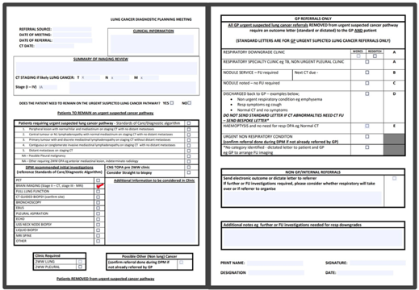
Figure 2: Provisional MDT proforma including additional section to highlight whether brain imaging has been completed
Photograph

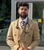

Biography (150 word limit)
Dr Chandra has a MBBCh and intercalated BSc from Cardiff University, Wales alongside a Post-Graduate Certification in Medical Education from the University of Warwick. He currently works as a locum resident doctor in the NHS primarily in the Worcestershire Acute NHS Trust Hospitals with keen interest in radiology specifically interventional radiology.
Email: rohan.chandra@nhs.net

