Usage of MRCP in the evaluation of biliary disease: A Quality Improvement Project
Dr Rohan Chandra MBBCh iBSc PGCert MedEd (FY3 Doctor, Worcestershire Acute NHS Trust)¹
Dr Dina Al-Dewagi MBCHB, FRCR (Consultant Radiologist, Worcestershire Acute NHS Trust)²

Abstract (300-word limit)
Introduction: Magnetic Resonance Cholangiopancreatography (MRCP) is a key investigation for suspected biliary pathology. However, inappropriate requesting in the absence of a full clinical history and inaccurate biochemical documentation, leads to significant overload of inpatient scanning and reporting ability. A pre- and post-intervention quality improvement project was performed to ensure the practice of requesting MRCP, aligned with the National Institute for Health and Care Excellence (NICE) guidance. Methods: A two-cycle Quality Improvement Project was undertaken from October 2024 to September 2025 following a PDSA (Plan-Do-Study-Act) model at Worcestershire Royal Hospital, UK. Baseline data assessed justification of MRCP requests, and the accuracy of biochemical information provided on request cards. Following analysis, the main issue was associated with poor documentation of liver function tests (LFTs) and poor understanding of MRCP indications. The initial findings were highlighted during the Countywide Radiology Meeting. The following intervention was initiated in July 2025: ICE system modification requiring mandatory input of abnormal LFT values before MRCP requests. Results: Following intervention, a total of 60 patients’ data were analysed. Justification of MRCP requests improved from 79% to 85%. Positive diagnostic findings for CBD dilatation increased significantly from 26.6% to 70%, highlighting improved appropriateness of MRCP requests. The percentage of biochemical inaccuracies also decreased with LFT discrepancies falling from 60.6% to 28.9% for USS requests and from 56% to 23% for MRCP requests. Conclusion: A sustainable IT-based intervention alongside targeted education to healthcare professionals led to a significant improvement in MRCP justification and biochemical accuracy. Integrating mandatory biochemical input prior to requesting MRCPs, promoted enhanced radiological efficiency and improved alignment with national guidelines.

Image

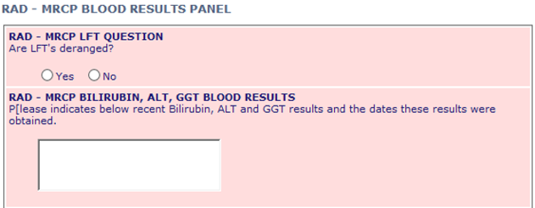

Figure 1: Updates to ICT system: Additional boxes added to ICE system prior to requested MRCP: asked to insert deranged LFTs value

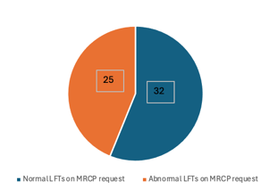
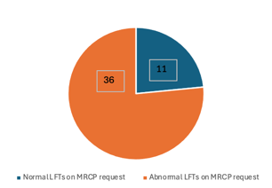

Figure 2: 1st cycle results (Left): 57/100 MRCP requests stated deranged LFTs. However, 56% requests showed bilirubin was normal. 2nd cycle results (right): 47/60 MRCP requests stated deranged LFTs. With only 23% showing LFTs were normal

Recent Publications (minimum 5)

Photograph


Biography (150 word limit)
Dr Chandra has a MBBCh and intercalated BSc from Cardiff University, Wales alongside a Post-Graduate Certification in Medical Education from the University of Warwick. He currently works as a locum resident doctor in the NHS primarily in the Worcestershire Acute NHS Trust Hospitals with keen interest in radiology specifically interventional radiology.

Notes/Comments:

