Evaluation of Image Quality and Workflow Efficiency of Upright

Abdomen PA Radiography Performed Concurrently with Chest PA

Hyeran Nam, RT , BS, Department of Radiology, Seoul National University Boramae Medical Center, Seoul, Korea

Abstract
Statement of the Problem: Conventional erect abdomen anteroposterior (AP) radiography is widely used for evaluating acute abdominal conditions, yet it requires patient repositioning and may compromise workflow efficiency and image consistency. This study investigated whether an upright abdomen posteroanterior (PA) technique performed immediately after chest PA imaging could provide non-inferior or superior diagnostic performance while improving workflow efficiency. Methodology & Theoretical Orientation: This prospective study included 72 adult patients presenting with acute or postoperative abdominal pain who were eligible for upright positioning. Patients were randomly assigned to either an erect abdomen AP group or an upright abdomen PA group (36 patients each). All examinations were conducted using a standard two-image protocol without additional radiation exposure. Quantitative image analysis included signal-to-noise ratio (SNR), contrast-to-noise ratio (CNR), pixel histogram characteristics, gas–fluid level length, and positioning accuracy. Workflow efficiency was assessed using acquisition time, positioning error rate, and repeat imaging frequency. Qualitative assessment was independently performed by three blinded readers using a 5-point Likert scale. Statistical analysis included the Shapiro–Wilk test, independent t-test or Mann–Whitney U test, and interobserver agreement analysis using ICC and kappa statistics. A predefined 5% non-inferiority margin was applied. Findings: The upright PA group demonstrated significantly higher SNR and CNR values compared with the AP group (p < 0.01). Image homogeneity and gas–fluid level visualization were superior in the PA group. Acquisition time was significantly shorter, and positioning errors were reduced. Diagnostic acceptability was higher in the PA group (94.4% vs. 77.8%), with excellent interobserver agreement (ICC = 0.83). Non-inferiority criteria were satisfied. Conclusion & Significance: Upright abdomen PA radiography performed concurrently with chest PA provides superior image quality and workflow efficiency while maintaining diagnostic reliability. This technique represents a practical alternative to conventional erect abdomen AP imaging, particularly in acute and postoperative settings where
minimizing patient repositioning is advantageous.

Image
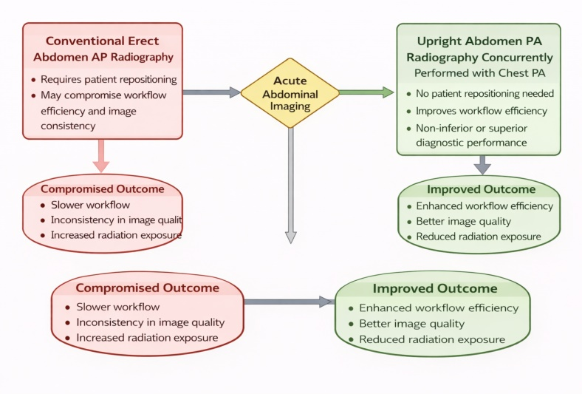

Figure 1 : Schematic illustration of the study design comparing conventional erect abdomen AP radiography and upright abdomen PA radiography performed concurrently with chest PA.
Recent Publications
- Evaluation of Diagnostic Usefulness According to Angle Changes in Wrist PA and Lateral Radiography for Patients with Distal Radius Fractures. Journal of the Korean Radiological Technologists Association (KRTA). 2015.
- Evaluation of image quality and workflow efficiency of upright abdomen PA radiography performed concurrently with chest PA.
Proceedings of the Korean Association of Radiologic Technolo gists Autumn Conference. 2023; 45–49..

Photograph

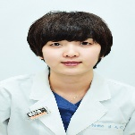 Biography
Hyeran Nam is a Radiologic Technologist at SMG–Seoul National University Boramae Medical Center, South Korea, with extensive clinical experience in general radiography. Her professional focus is on optimizing patient radiation dose, improving image quality, and enhancing workflow efficiency in routine clinical practice. She emphasizes evidence-based imaging protocols that balance diagnostic accuracy with patient safety. She has demonstrated academic excellence through her research activities and received the Best Oral Presentation Award at the Korean Association of Radiologic Technologists (KART) Autumn Conference for her innovative work on wrist radiography techniques. Her research interests include quantitative image quality assessment, protocol optimization, and workflow-driven imaging strategies aimed at improving clinical outcomes. Currently, she is actively engaged in research focused on streamlining radiographic procedures while minimizing unnecessary radiation exposure and maintaiing diagnostic reliability.
Email: nhr0511@gmail.com

Notes/Comments: The authors prefer poster presentation if oral presentation is not available.

