A Novel Approach to Brain Tumor Classification Using Deep Neural Networks
Rohan Tummala, CA

Abstract

The American Cancer Society estimates that in 2023 about 24,810 malignant brain and spinal cord tumors will be diagnosed in the United States and about 18,990 people will die from these tumors. Early detection of malignant brain tumors is crucial in improving survival. Currently, MRI is the standard radiological method used to identify brain tumors. However, these tests are prone for human error, inefficiencies, and often require invasive tissue diagnosis for confirmation. Advancement in machine learning algorithms has shown to improve accuracy in detection of brain tumors. In this study, a novel deep learning approach, called Inception Resnet, a type of pretrained Convolutional Neural Network(CNN), was used to identify and classify three common brain tumors. These classes were pituitary, meningioma, and glioma. Pituitary tumors are the most harmless of the three as they are noncancerous. This contrasts with both glioma and high grade meningioma tumors which are life-threatening. It should be noted, however, that high grade meningioma tumors are very rare. Along with these three classes, a separate control class with no brain tumors was also used. This dataset contained 5,952 MRI images that included 1621 glioma images, 574 meningioma images, 1751 pituitary images and 2000 images with no tumor. Based on this data, a model was created that was able to diagnose brain tumors with an accuracy of 96.7%.
Image
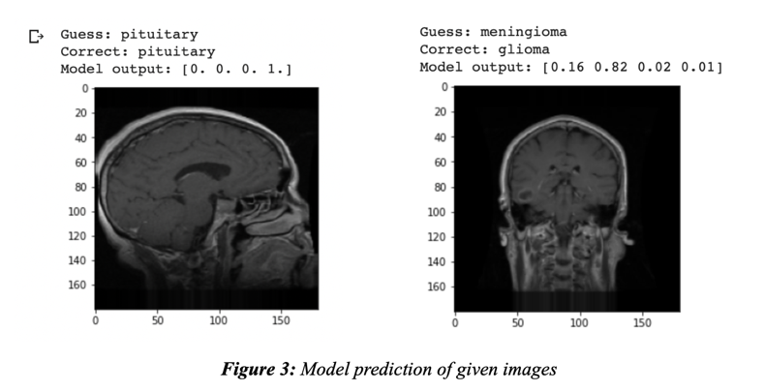
Recent Publications
- “Key Statistics for Brain and Spinal Cord Tumors”(2023, January 12). American Cancer Society.
- Huang, J., Shlobin, N., Lam, S., DeCuypere, M., 2021, “Artificial Intelligence Applications in Pediatric Brain Tumor Imaging: A Systematic Review”, World Neurosurgery, pp. 99-105
- McFaline-Figueroa, J.R., Lee, E.Q., 2018, “Brain Tumors”, The American Journal of Medicine, pp. 874-882.
- Mambray, M.C., Barajas, R.F., Cha, S., 2015, “Modern Brain Tumor Imaging”, Synapse, pp. 8-23.
- Szegedy, C., Ioffe, S., Vanhoucke, V., & Alemi, A. 2016, “Inception-v4, Inception-ResNet and the Impact of Residual Connections on Learning”. arXiv, 1602.07261.
- Rawat, W., & Wang, Z. 2017, “Deep Convolutional Neural Networks for Image Classification: A Comprehensive Review”. Neural Comput., 29(9), 2352–2449. doi: 10.1162/neco_a_009

Photograph

Biography
Rohan has conductive several research projects at the intersection of machine learning and healthcare, with a specific focus in computer vision and imaging algorithms. This project targets a specific issue in brain tumor prediction using a novel CNN to do so.
Email: rohantummala07@gmail.com

Notes/Comments:

