Clinical impact of 99mTc-MAA SPECT/ CT-based personalized predictive dosimetry in selective internal radiotherapy: a real-life single-center experience in unresectable HCC patients
Benoît Collette2*†, Ana‐Maria Bucalau1*† , Illario Tancredi3, Michael Vouche3, Martina Pezzullo3, Jason Bouziotis4, Rodrigo Moreno‐Reyes2, Nicola Trotta2, Hugo Levillain2, Jean Luc Van Laethem1 and Gontran Verset1
1 Department of Gastroenterology, Hepatopancreatology and Digestive Oncology, Hôpital Erasme/Bordet Institute‐Hôpital Universitaire de Bruxelles, Université Libre de Bruxelles (ULB), Brussels, Belgium ; 2 Department of Nuclear Medicine, Hôpital Erasme/Bordet Institute‐Hôpital Universitaire de Bruxelles, Université Libre de Bruxelles (ULB), Brussels, Belgium ; 3 Department of Radiology, Hôpital Erasme/Bordet Institute‐Hôpital Universitaire de Bruxelles, Université Libre de Bruxelles (ULB), Brussels, Belgium ; 4 Department of Biomedical Research, Hôpital Erasme/Bordet Institute‐Hôpital Universitaire de Bruxelles, Université Libre de Bruxelles (ULB), Brussels, Belgium ; †Ana‐Maria Bucalau and Benoît Collette have contributed equally to this work.

Abstract
Aim: We aim to evaluate the contribution of personalized predictive dosimetry in our population of HCC patients by comparing them to our historical cohort whose activity was determined by standard dosimetry.
Methods: This is a retrospective, single‐center study that included patients with HCC who received SIRT after simulation based on either standard dosimetry (group A) or on personalized dosimetry (group B). Primary endpoints were best overall response (BOR) and objective response rate (ORR) evaluated by mRECIST at 3 months. Safety and toxicity profiles were evaluated at 1‐ and 3‐months post‐treatment. For group A we compared the activity to be administered determined a posteriori using Simplicit Y90 ® and the activity actually administered determined by the standard approach.
Results: 66 patients received 69 simulations leading to 40 treatments. The median follow‐up time was equal for both groups, 21 months (range 3–55) in group A and 21 months (range 4–39) in group B. The per patient analysis revealed a significant benefit of personalized predictive dosimetry in terms of better overall response at 3 months (80% vs. 33.3%, p = 0.007) and at 6 months (77.8% vs. 22.2%, p = 0.06). This trend was found in the analysis by nodule with a response rate according to mRECIST of 87.5% for personalized dosimetry versus 68.4% for standard dosimetry at 3 months, p = 0.24. Only one grade 3 biological toxicity (hyperbilirubinemia) was noted in group A. The comparison between the administered activity and the recommended activity recalculated a posteriori using Simplicit Y90 ® showed that the vast majority of patients who progressed (83.33%) received less activity than that recommended by the personalized approach or an inadequate distribution of the administered activity.
Conclusions: The use of personalized dosimetry allows a better selection of HCC patients who can benefit from SIRT, and consequently, improves the effectiveness of this treatment.

Image
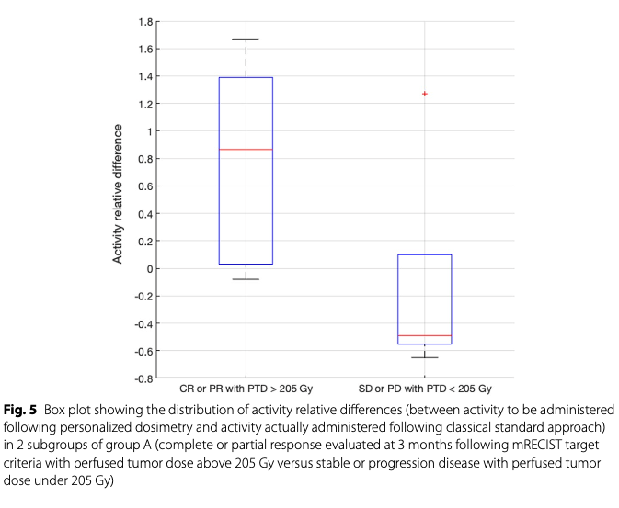

Recent Publications
- Bucalau A-M, Collette B, et al. (2023) ; Clinical impact of 99mTc-MAA SPECT/ CT-based personalized predictive dosimetry in selective internal radiotherapy: a real-life single-center experience in unresectable HCC patients ; European Journal of Hybrid Imaging (2023) 7 :12.
- Trotta N, Collette B, et al. (2022) Comparison of PMT‐based TF64 and SiPM‐based Vereos PET/CT systems for 90Y imaging and dosim‐ etry optimization: A quantitative study. Med Phys 49:7567–7582

Photograph

Biography
Experienced Medical Physicist currently working to improve Selective Internal RadioTherapy in the treatment of liver cancer by developing personalised dosimetry (PhD thesis work in progress), strongly implied in patient safety, member of the (belgian) FANC working group about regulation in Nuclear Medicine and the Medical Jury
Email: benoit.collette@hubruxelles.be

