Spontaneous small bowel volvulus in young adult male
Dr Sajanakan Sriselvakumar, MBBS, Mater Public Hospital, Brisbane, Australia.

Abstract
Small bowel volvulus is a rare surgical pathology in western countries with a rather misunderstood pathophysiology. This condition refers to the abnormal torsion of the small bowel loops on its mesenteric axis and blockage of the mesenteric vessels, thus leading to bowel obstruction. Typical symptoms include abdominal pain and distention, vomiting and bloody stools. Volvulus can also cause ischemia due to a compromised blood supply. Small bowel volvulus can be life-threatening and require immediate surgery. In this case report, we present a 28-year-old male patient who was admitted to the emergency department with significant, unrelenting abdominal pain, vomiting with no blood and had no previous history of abdominal surgery. CT scan identified small bowel volvulus and torsion of the mesentery. The biopsy report confirmed no malignancy in this patient. The patient underwent surgery and was discharged two days later.

Image
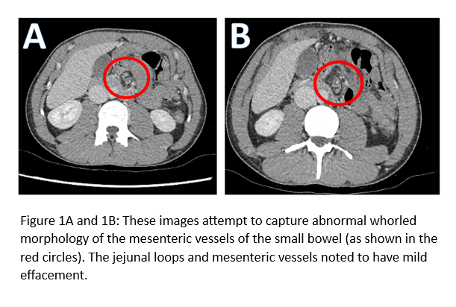
Recent Publications
1. Le CK, Nahirniak P, Anand S, Cooper W. Volvulus. StatPearls. Treasure Island (FL): StatPearls Publishing Copyright © 2023, StatPearls Publishing LLC.; 2023.
2. Roggo A, Ottinger LW. Acute small bowel volvulus in adults. A sporadic form of strangulating intestinal obstruction. Ann Surg. 1992;216(2):135-41.
3. Vaez-Zadeh K, Dutz W, Nowrooz-Zadeh M. Volvulus of the small intestine in adults: a study of predisposing factors. Ann Surg. 1969;169(2):265-71.

4. Yang KH, Lee TB, Lee SH, Kim SH, Cho YH, Kim HY. Congenital adhesion band causing small bowel obstruction: What's the difference in various age groups, pediatric and adult patients? BMC Surg. 2016;16(1):79.

5. Curbelo-Peña Y, Saavedra-Perez D, Stickar T, Molinas-Bruguera J, De Cozar-Duch J, Quer-Vall X, et al. Intussuscepted Metachronous small bowel tumor after treatment for colorectal adenocarcinoma. Int J Surg Case Rep. 2019;60:94-7.


Dr Sajanakan Sriselvakumar is currently working as a Junior Doctor in Emergency medicine at Mater Public hospital. He is interested in radiology and has been involved in multiple research projects in radiology. He has also presented his research at national and international conferences.
Email: sajansri12@gmail.com
Notes/Comments:

