Pelvic neurofibroma in a patient presenting with pelvic pain and urinary frequency: A case report
Ali Hajihashemi, MD ^{1,} Mahsa Geravandi, MD¹ ¹Department of Radiology, Isfahan University of Medical Sciences,
Abstract: Neurofibromas are benign peripheral nerve sheath tumors typically found in cutaneous or subcutaneous tissues. Retroperitoneal neurofibromas are rare, and their presentation with urinary symptoms is even rarer. We present the case of a 20-year-old male who presented with a six-month history of pelvic pain, fatigue, urinary frequency, and incontinence. Imaging studies revealed an infiltrative, heterogeneous hypoechoic mass in the pelvic cavity extending to the rectovesical pouch, with pressure effects on the bladder wall. A biopsy confirmed the diagnosis of neurofibroma, and the patient underwent radical cystectomy and orthotopic diversion. Retroperitoneal pelvic neurofibromas should be considered in the differential diagnosis of urinary symptoms, and imaging studies can aid in the early detection and assessment of tumor extension. Local excision is the primary treatment, and the prognosis is generally favorable. This case underscores the importance of considering rare tumors in the differential diagnosis of common presenting symptoms.
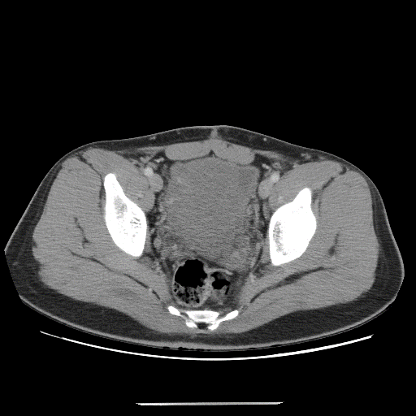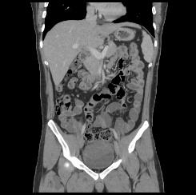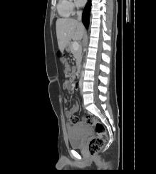
Figure 1: Axial (A), coronal (B), and sagittal(C)abdominopelvic CT scan with IV contrast: a large enhancive heterogeneous mass in the pelvic region between the urinary bladder and rectum with pressure effect and suspicious invasion to posterior and superior walls of the bladder

[1] Wong-You–Cheong JJ, Woodward PJ, Manning MA, Sesterhenn IA. Neoplasms of the urinary bladder: radiologic-pathologic correlation. Radiographics. 2006 Mar;26(2):553-80.
[2] Hassell DS, Bancroft LW, Kransdorf MJ, Peterson JJ, Berquist TH, Murphey MD, Fanburg-Smith JC. Imaging appearance of diffuse neurofibroma. American Journal of Roentgenology. 2008 Mar;190(3):582-8
[3] Murphey MD, Smith WS, Smith SE, Kransdorf MJ, Temple HT. From the archives of the AFIP: imaging of musculoskeletal neurogenic tumors: radiologic-pathologic correlation. Radiographics. 1999 Sep;19(5):1253-80.
[4] Pilavaki M, Chourmouzi D, Kiziridou A, Skordalaki A, Zarampoukas T, Drevelengas A. Imaging of peripheral nerve sheath tumors with pathologic correlation: a pictorial review. European journal of Radiology. 2004 Dec 1;52(3):229-39.
[5] Knight SW, Knight TE, Santiago T, Murphy AJ, Abdelhafeez AH. Malignant Peripheral Nerve Sheath Tumors—A Comprehensive Review of Pathophysiology, Diagnosis, and Multidisciplinary Management. Children. 2022 Jan 1;9(1):38.
Biography:
As a radiology resident at the Isfahan University of Medical Science, I have dedicated my life to studying and practicing medical imaging. My journey began with a passion for science and medicine, which led me to pursue undergraduate studies in biology at a prestigious university. As a radiologist and researcher, I am committed to making a lasting impact on radiology and the lives of patients worldwide. I am always pushing the boundaries of what is possible and constantly looking for new and innovative ways to improve patient care and advance the science of medical imaging. My dedication and passion for my work inspire others in the field, and I am widely recognized as a radiology research and innovation leader.

Email ID’s: Mahsa.geravandi1993@gmail.com 

