Clinical Use of Blood Flow Analysis Through 4D-Flow Imaging in Aortic Valve Disease
Omer Mansoor, BSc, University of Calgary, Canada
Dr. Julio Garcia, PhD, University of Calgary, Canada

Abstract (300 word limit)

Bicuspid aortic valve (BAV), which affects 1% of the general population, results from the abnormal fusion of the cusps of the aortic valve. BAV can lead to the dilatation of the aorta, aortic coarctation, development of aortic stenosis (AS), and aortic regurgitation. Surgical intervention is usually recommended for patients with BAV and bicuspid aortopathy. This review aims to examine 4D-flow imaging as a tool in cardiac magnetic resonance imaging for assessing abnormal blood flow and its clinical application in BAV and AS. We present a historical clinical approach summarizing evidence of abnormal blood flow in aortic valve disease. We highlight how abnormal flow patterns can contribute to the development of aortic dilatation and novel flow-based biomarkers that can be used for a better understanding of the disease progression.

Image

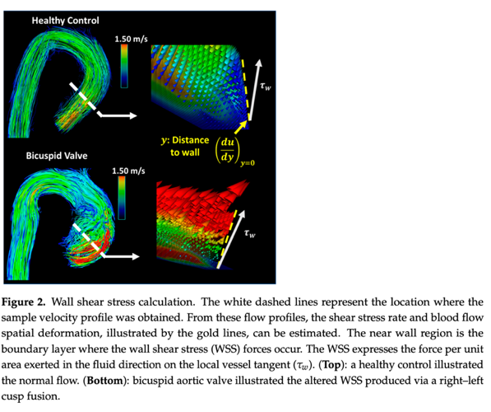

Recent Publications (minimum 5)
- Kvitting, J.P.E.; Dyverfeldt, P.; Sigfridsson, A.; Franzén, S.; Wigström, L.; Bolger, A.F.; Ebbers, T. In vitro assessment of flow patterns and turbulence intensity in prosthetic heart valves using generalized phase-contrast MRI. J. Magn. Reson. Imaging 2010, 31, 1075–1080.
- Ha, H.; Kvitting, J.P.; Dyverfeldt, P.; Ebbers, T. 4D Flow MRI quantification of blood flow patterns, turbulence and pressure drop in normal and stenotic prosthetic heart valves. Magn. Reson. Imaging 2019, 55, 118–127.
- Andersson, M.; Ebbers, T.; Karlsson, M. Characterization and estimation of turbulence-related wall shear stress in patient-specific pulsatile blood flow. J. Biomech. 2019, 85, 108–117.
- Freidoonimehr, N.; Arjomandi, M.; Sedaghatizadeh, N.; Chin, R.; Zander, A. Transitional turbulent flow in a stenosed coronary artery with a physiological pulsatile flow. Int. J. Numer. Methods Biomed. Eng. 2020, 28, 36.
- Binter, C.; Gotschy, A.; Sündermann, S.H.; Frank, M.; Tanner, F.C.; Lüscher, T.F.; Manka, R.; Kozerke, S. Turbulent Kinetic Energy Assessed by Multipoint 4-Dimensional Flow Magnetic Resonance Imaging Provides Additional Information Relative to Echocardiography for the Determination of Aortic Stenosis Severity. Circ. Cardiovasc. Imaging 2017, 10, e005486

Photograph

Biography (150 word limit)



Omer Mansoor is a first-generation Canadian-Pakistani immigrant. He completed his undergraduate studies in Biological Sciences at the University of Calgary with distinction. Omer served as Vice President Operations & Finance for the Students' Union, managing a $20 million budget and a staff of 50+ full-time and 300+ part-time employees. He is currently pursuing a Doctor of Medicine (M.D.) degree at the University of Calgary.
Omer holds positions as the National Officer of Public Health for the Canadian Federation of Medical Students and Program Coordinator for Communicable Diseases at the International Federation of Medical Students' Association. He has been involved in projects on public health, antimicrobial resistance, vaccinations, and childhood diseases. Omer has also mentored youth for the United Nations Association of Canada and served as a Youth Delegate to the World Health Summit.
He has interned at Cision Vision, a healthcare startup from MIT, and completed a fellowship with HaloHealth, a physician angel investor group. Omer has been actively engaged in humanitarian work as part of the Youth Board for the International Development & Relief Foundation and has held leadership roles in various organizations.
Passionate about radiological healthcare, international development, technology, entrepreneurship, policy creation, and intersectional thinking, Omer is driven to make a positive impact in these areas.

Email: mohammad.mansoor@ucalgary.ca

Notes/Comments:

