Food Insecurity & School Absenteeism among Rural Children
Dr Ashekur Rahman Mullick, MPH Student, Department of Occupational & Environmental Health, National Institute of Preventive & Social Medicine (NIPSOM), Dhaka, Bangladesh

Abstract

This study aimed to assess to what extent food insecurity affects school absenteeism among rural school going children. A school based cross-sectional study was conducted among 460 rural school going children (class 4 to class 10) in Saltha upaziila of Faridpur district, Bangladesh from January-December, 2019. Children providing assent after getting consent from their parents were inducted as study participants. Semi-structured questionnaire was used to collect data on the food insecurity and socio-demographic variables. To examine further the paths from food insecurity to absenteeism through child work activities, recursive path analysis was used in which activities were regressed on child food insecurity by using linear regression and absenteeism was regressed on child food insecurity and work activities by using binary logistic regression using odds ratio and 95 % of confidence intervals. Level of significant was set at 0.05. Among the participants about 53.7% were female and in 52.7% cases participant’s father were farmer and their mean income was 98208.18 ± 13618.196 Taka per year. Findings of Binary logistic regression analysis also showed that food insecurity was positively associated with helping of parents for household shopping, cooking, taking care of siblings, participating in school sports, watching TV during leisure time. However, helping parents in field for raising food crops and taking evening nap were negatively associated with food insecurity. Findings of this study showed that the frequency of adolescent school absenteeism was significantly high (39.6 %) among moderately food insecure groups (P < 0.001). Age of participants (p=0.000), Educational status of participants (p=0.00), Head of family (p=0.017), House type (p=0.000), Paternal occupation (p=0.0145) and household economic status (p=0.000) were significantly associated with food insecurity status. Therefore, national policies and programs need to stress on how to improve family income, earning capacity, housing condition, educational status by introducing different types of opportunities and socioeconomic status to handle food insecurity which is a key contributor of school absenteeism.

Keywords: Absenteeism, Rural, School going children, Insecurity.

Image
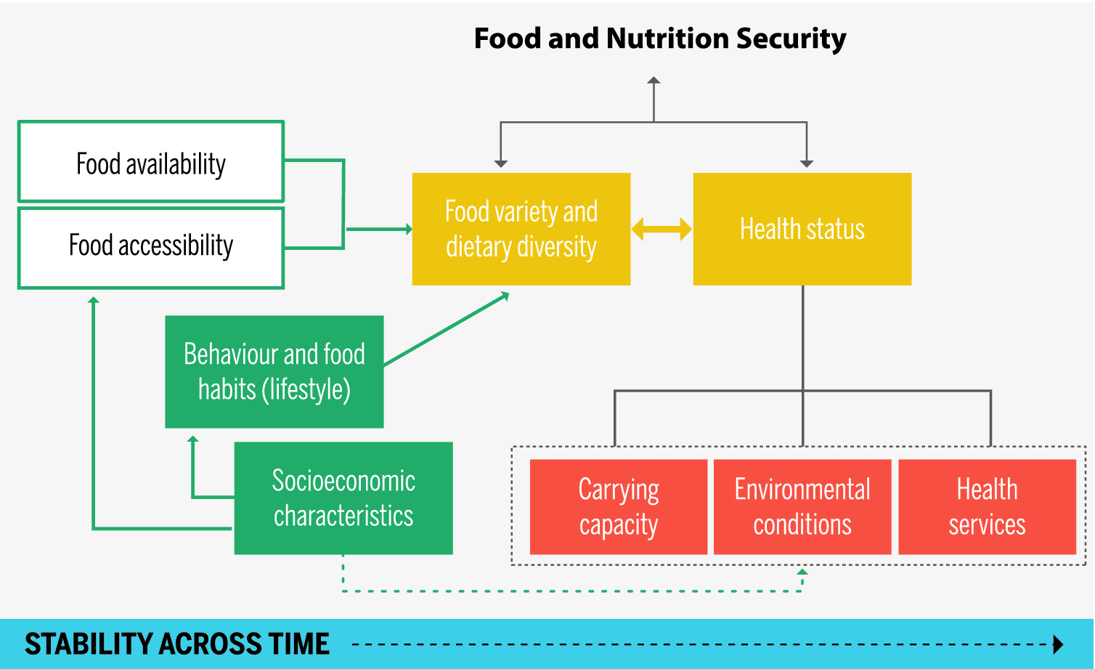
Fig: Flow chart of Food Insecurity
Recent Publications
- Agbadi, P., Bj, H. and Mittelmark, M. B. (2017) ‘Household food security and adequacy of child diet in the food insecure region north in Ghana’, pp. 1–16. doi: 10.1371/journal.pone.0177377.
- Daneshzad, E., Yavari, P. and Rahimi-foroshani, A. (2015) ‘Food insecurity, socio-economic status, and educational achievement: a cross-sectional study in high school girls, Noshahr, Iran’, 1(3), pp. 141–148.
- Darling, E. S. (2014) ‘Assessing the Effect of Marine Reserves on Household Food Security in Kenyan Coral Reef Fishing Communities’, pp. 1–20. doi: 10.1371/journal. Pone. 0113614.
- Gerritsen, S. (2016) ‘Children, Food and Poverty Food Insecurity among Primary School Students in The Wellington Region’, (April).
- Kearney, C. A. and Bensaheb, A. (2006) ‘School Absenteeism and School Refusal Behavior: A Review and Suggestions for School-Based Health Professionals’, 76(1), pp. 3–7.
- Tamiru, D. et al. (2016) ‘Household food insecurity and its association with school absenteeism among primary school adolescents in Jimma zone, Ethiopia’, BMC Public Health. BMC Public Health, pp. 1–8. doi: 10.1186/s12889-016-3479-x.

Photograph

 Biography
Dr Ashekur Rahman Mullick has his expertise in evaluation and passion in improving the health and wellbeing. His open and contextual evaluation model based on responsive constructivists creates new pathways for improving healthcare. He has built this model after years of experience in research, evaluation, teaching and administration both in household and education institutions.
Email: ashekmullick@gmail.com

