IMPROVING THE PROCESS OF DIAGNOSING AND TREATING ORTHOPEDIC DISEASES BY CREATING A PERSONALIZED CLINICAL DECISION SUPPORT SYSTEM BASED ON THE PRINCIPLES USED IN COGNITIVE BEHAVIORAL THERAPY(CBT): AN ACTION RESEARCH STUDY
FAEZE KALHORI, MA, SEPID Orthopedic Clinic, TEHRAN, IRAN
HAMID FARROKHI, ORTHOPEDIC SERGEON, SEPID Orthopedic Clinic, TEHRAN, IRAN
MARYAM KALHORI, MA, SEPID Orthopedic Clinic, TEHRAN, IRAN

Abstract
The diagnosis and treatment system of orthopedic diseases is based on the disease, However, we are facing in practice with a patient with various emotional, cognitive, behavioral, and physiological aspects. However, creating a specific structure and classification to guide the therapist in this regard has not been done.
This action research is done to create a structure based on patient, cognition, and participation and design the processes of diagnosis and treatment. The method used in this action research is practical and implemented using problem-solving, observation, and interview techniques in an orthopedic clinic in Iran and with a treatment team in 7 periods from 2017 to 2023 to create a classification model. It indicates the formation of a purposeful structure for the assessment, diagnosis, decision-making, and treatment departments in orthopedic patients using the principles of cognitive behavioral therapy, which the treatment team and the patient have approved.
we can integrate the knowledge of medicine and psychology and use it in diagnosis and treatment processes. Design new structures for more effective treatment (a kind of integration in treatment). This structure can be complementary to the process of diagnosing and treating orthopedic diseases by creating a suitable decision-making platform with the patient. It can be designed and used for other diseases. It can also be used in artificial intelligence..

Image
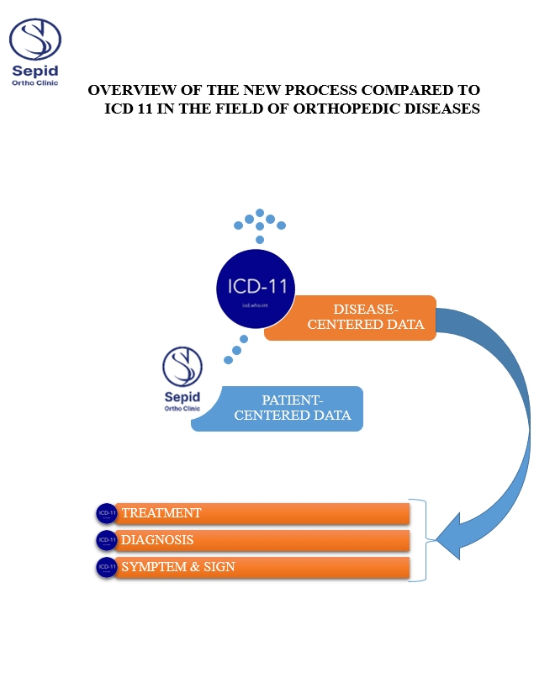

Photograph

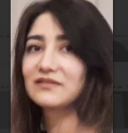 Biography
FAEZE KALHORI MA in clinical psychology A senior expert with a history of education and experience in public health & mental health from 2002 to 2019 at the University of Medical Sciences, her experience in improving the diagnosis and treatment process with the patient-centered model with an emphasis on awareness and participation. The introduced model creates a path for the formation of new and patient-based classifications in diagnosis and treatment that have been designed and implemented by a specialist and experienced team in the SEPID Orthopedic Clinic and with Dr. FARROKHI's management. SEPID Clinic is an orthopedic clinic in Tehran that has been providing outpatient services to orthopedic patients since 2015.
Email:faeze.kalhori.psy@gmail.com

Comments: This is one of a series of articles that is being prepared and presented in this research project, which is presented from the perspective of the clinical psychology team and with the permission of other members.

