A Systematic Review on Exploring the Lifelong Impact of Early Attachment Styles on Adult Depressive Experiences

Madeena Saeedi, BSc, MSc, GMBPsS, - Queen Mary University of London, United Kingdom

Abstract

Attachment style and depression are two vital areas of study that have gained significant attention in recent years, and understanding their connection can provide valuable insights into preventing depression in adults. This systematic review paper aims to investigate the association between early attachment styles and adult depression. The study employed a population, exposure, and outcome framework with specific inclusion and exclusion criteria for the selected articles, which were obtained from three databases The outcomes revealed that childhood maltreatment and insecure attachment styles, particularly insecure-avoidant and insecure-anxious, were significantly associated with adult depression. However, there was one outlying study that did not find significant associations between attachment styles and depression.

Image

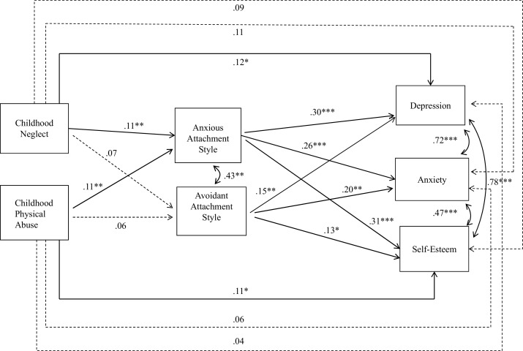

Fig. 1. Paths from childhood neglect and physical abuse to mental health outcomes (depression, anxiety, and self-esteem) through adult attachment styles. Standardized betas are presented. Solid lines are significant paths, dotted lines are not significant. Analyses control for age, sex, race, and family socio-economic status.

Recent Publications / Reference

Saeedi, M., Kabene, Dr. S., & Tahir, Dr. M. (2021). The Power of the Placebo Effect Comparative usage of Placebos in Mental and physical Health. International Journal of Pharmaceutical Research, 13(03). https://doi.org/10.31838/ijpr/2021.13.03.016

Photograph

Biography

Having demonstrated dedicated commitment to the advancement of clinical psychology, Madeena Saeedi emerges as an accomplished Senior Assistant Psychologist in NHS whose scholarly pursuits and research endeavours have garnered her prominent recognition within the contemporary psychological discourse. Her scholarly portfolio encompasses a diverse array of seminal contributions, ranging from illuminating the multifaceted dynamics of the “placebo effect's impact on mental health” to uncovering neural correlates of pain perception. Leveraging her academic prowess and pragmatic proficiency, Madeena adeptly applies her comprehensive training in psychological therapies to diverse populations, including individuals dealing with schizophrenia, ADHD, autism, and geriatric dementia. This seamless integration of theoretical insight and pragmatic application positions Madeena Saeedi as a consummate scholar-practitioner poised to make significant contributions to the growing field of clinical psychology.

Email: madeena.saeedi@yahoo.com

Notes/Comments:

