SWPS UNIVERSITY OF SOCIAL SCIENCES AND HUMANITIES FACULTY OF PSYCHOLOGY

Experimental Study

NEWS EFFECT ON THE INTERPRETATION OF FUTURE SELF, SELF-ESTEEM AND DEPRESSION MOOD BY ACTIVATING DEFAULT MODE NETWORK

Warsaw (2019)

Abstract

The psychological effects of reading news were studied in the two groups (n=61) of undergraduate students who read 6 news during 15 minutes. To activate the Default Mode Network, the participants were asked to think about their future during one minute with a given scenario that either they received positive or negative comment on the social media. The interpretation of the future self, Rosenberg Self-Esteem Questionnaire (Scale 1- Self-Esteem Evaluation, Scale5 Depression Mood Evaluation) were obtained after reading stories. The results show that exposure to the negative news increased the level of depression mood, and were resulted in negative interpretation of the future self. Even though reading positive news demonstrated higher self-esteem evaluation, there was no significant differences in the self-esteem level across groups. However, exposure to positive news affect us to think positively. These findings demonstrate that reading different stories alter people`s perceptions and mood.

Key words: news effect, self-esteem, mood, depression, positive news, negative news, default mode network

INTRODUCTION

The twentieth century has been affected us by exposing a number of images and news. After the websites have launched to publish the news in a second, to access to the news became easy via news sites, twitter, Instagram and so on. Likewise, the twentieth century became resulting in psychological distress. (Mary, McNaughton-cassill, 2001).
When people exposure to bad news can cause anxiety, mood disorders, and can be even addictive. Bad news disrupts our thinking, changes our brain, and it puts us on the stress, while positive news in other words, human interest stories, and increase trust and hope in human kind. Positive information benefits us emotionally, physically, and mentally. It can contribute in a meaningful way to happier and healthier life.
In previous research shows that the majority of news is negatively biased. Bad news represent violence, conflict, and suffering (violent crime; tragedy and suffering; conflict and discord; social and collective protests involving violence or threats of violence; and war with military affairs). (Szabo, Hopkinson, 2007). As a result of these bad news, depression, and anxiety are associated with intensified negative feelings after viewing news broadcasts on the TV (Sanches, 1994). Negative events such as September 11th could lead to symptoms of depression, PTSD, and general psychological morbidity in the viewers. (Galeta et al., 2002).
Cognitive shortcuts triggered by the news can also lead us to gradually see the world as a darker, and darker place, chipping away at certain optimistic tendencies. When people are led to believe things are falling apart, it affects their decision making.
Our brains react disproportionately to different types of information. Scandalous, shocking, people based loud, fast-changing details all stimulate us. Grapping stories, garish images and sensational facts capture our attention. As a result of news consumption, we walk

around with a distorted mental map of the risks, and threats actually face. Therefore, negative knowledge destroys success or happiness (Dobelli, 2013).
Reading stories activates brain regions dealing with emotional processing and memory. We feel the character` struggles and victories, then remember them as a part of ourselves. It makes us more understanding folks. When we are reading a depressing news story, the cerebral cortex in our brain surges in response to this negative stimuli and makes us more likely to remember this bad news compared to good news. Because when we read an article about a negative event, we actually visualize the even in our minds. This moves to the brain to be more electrically changed.
Exposure to the news also related to the self-esteem. In a study demonstrated that the use of the friend networking site stimulated the number of relationships formed on the site. Positive feedback on the profiles enhanced adolescent`s social self-esteem and well-being. In contrast, negative feedback decreased their self-esteem and well-being. (Valkenburg, Peter, Schouten, 2006).

Default Mode Network (DMN)

The DMN is our state of reverie, the state where mental cognition is the strongest and where memories come to surface, making us think about our future, past or who we are. The USC study shows that the possibility that exposure to narrative story telling can have a widespread effect on triggering better self-awareness, and empathy for other. Regardless of the language or origin of the person being exposed to it (Li, Mai, & Liu, 2014).
Default Mode Network consists of The Medial PFC, Posterior Cingulate Cortex that is charge of episodic memory recall, the Inferior Parietal Lobe to understand the emotions and interpreting sensory data, the Lateral Temporal Cortex active in emotional association and usual memory. Hippocampal formation where long term memories are processed.

When we start a task with a goal, the DMN turns off and another mental schemes comes on the task positive network. (TPN). When someone is in his thoughts he turns his DMN, and he also reinforces it.
The DMN is most commonly shown to be active when a person is not focused on the outside world and the brain is at wakeful rest, such as daydreaming, and mind-wandering. But it is also active when the individual is thinking about others, thinking about themselves, remembering the past, and planning for the future.
In this research to activate the DMN, participants were asked to interpret their situation in which either they received positive or negative comment on their social media by their groups. Then participants dreamed about their future during one minute.

Current Study and Hypotheses

This study was designed to explore the idea that exposure to news media by reading negative and positive news can be source of the different interpretation of the future self, with correlation of depressive mood and self-esteem.
- Exposure to the negative news will be more positively related to the depression mood than the group that who exposed to positive news.
- Exposure to the negative news will be more correlated to the negative future interpretation of future self than people who exposed to positive news.
- Exposure to the positive news will be more related to the self-esteem level than the group who exposed to negative news.

METHOD

Participants

A convenience sample of 61 undergraduate students in economy journalism, and principles of image modules at University of Istanbul in Turkey were tested. The participants’ mean age was
20.8 (SD=1, 9), years ranging from 18 to 26, and the majority were women (n=35). Students were explained instructions, allowed to discontinue to the research when they feel uncomfortable. Each of the participant participated voluntarily in the research without gaining any benefit.

Materials News Exposure
12 news reading storywas used in the research. 6 of them were negative news that encompassed the conflict story, anxiety problems among adolescents, criminal and natural disasters news. Rest of 6 news were positive news explained the inspiring stories, cooperation and collaboration stories. First group was exposed to negative news, and second group was exposed to positive news.
Table1. Contents of the Negative News Seen by the Research Participants

Camera images of the student whom killed Panic Attack increases among adolescents Other side of the picture: Madison Halleron The water of Turkey is under dangerous Unemployed Journalist
The warning for severe earthquake

Table2. Contents of the Positive News Seen by the Research Participants

Aziz Sancar: The way going to Nobel Prize

Life is getting longer One arm 7 Profession
Young people with Autism gives hope Established rural library by aid of social media
The photographer demonstrates that humankind were not die

Self-Interpretation (perception) of the future self

In the interpretation of the future self was used 18 statements defined with specific adjectives. 9 of the adjectives were regarding of the negative interpretation that covered the pessimistic opinions, (i.e. I consider that my future will be hopeless), while rest of 9 adjectives related to positive interpretation about future self (i.e. I think that I will be happy in the future). The reliability of the scale was measured in the SPSS. The statements of the negative statements exposure to the negative news were acceptable (Cronbach` Alpha= 0.70, and 0,72), and the statements of the positive news of positive adjectives were acceptable. (Cronbach` Alpha=0.76, and 0,53).
Positive statements of adjectives were self-confident, under control, predictable, hopeful, happy, positive, optimistic, supported by others, peaceful future. Negative statements of adjectives were disappointed, hopeless, helpless, ambiguous, darkness, unsafe, irresponsible, uneasy, negative future. Participants chose any of these options after reading the stories.

Self-Esteem Scale

The Rosenberg Self-Esteem scale (Rosenberg, 1965) was presented in the research to define both the participants’ self-esteem and to measure the depression mood. Therefore, participants were fulfilled the scale1 which consist of 10 questions to measure self-esteem level. And also scale 5 so as to find out the depression mood level. There was 6 questions in the depression mood scale.

PROCEDURE

The research handled between 24th September and 1st of October at University of Istanbul in the Department of Communication classes. The classes divided to two groups. While one group were exposed to the negative news, second group was exposed to positive news during 15 minutes. The groups were randomly chosen. Then, participants read the news by their subjects. After reading the stories, the participants were asked to think about their future during one minute with a given scenario that either they received positive or negative comment on the social media. And then they chose the statements of the future self. Finally, participants completed the Rosenberg Self-Esteem Questionnaire that is scale1 (self-esteem scale), and Scale5 (depression mood scale).

RESULTS

The data were analysed with the paired sample t-test. In the pair 1, the negative interpretation of the future self, people who exposed to negative news was compared to people who exposed to positive news. (M=3, 48). (t24=5,965, P<0,001). There was significant differences in the negative interpretation of future self when people exposed to the negative news.

In the pair 2 the positive interpretation of the future self, people who exposed to positive news was compared to people who exposed to negative news. (M=4, 40). (t24=7, 23, P<0,001). There was significant differences in the positive interpretation of future self when exposed to the positive news.
It has been demonstrated that when people exposed to negative news, they are tend negatively to interpret their future. On the other hand, as people exposed to positive news they have a bias positively to interpret their future.
Table 3

The correlation level across groups by using paired t-test

Paired Differences |  |  |  |  | t | df | Sig. (2-  tailed)
Mean | Std.  Deviation | Std. Error Mean | 95% Confidence  Interval of the Difference |  | t | df | Sig. (2-  tailed)
Mean | Std.  Deviation | Std. Error Mean | Lower | Upper | t | df | Sig. (2-  tailed)
3.48000 | 2.91719 | 0.58344 | 2.27584 | 4.68416 | 5.965 | 24 | 0.000
4.40000 | 2.63755 | 0.52751 | 2.95127 | 5.12873 | 7.239 | 24 | 0.000

*In the pair one, the graph shows that the negative interpretation of the future self, people who exposed to negative news and people who exposed to positive news.
*In the pair two, the graph shows that the positive interpretation of the future self, people who exposed to positive news and people who exposed to negative news.
Correlation test was used to determine the relationship of the depressive mood level across exposure to the positive and negative news. When people exposed to negative news compared to the positive news, there was moderately significant differences. In the exposure to negative news the depressive mood level (M=3, 06), in the positive news was (M=1, 48).
It shows that reading negative news were resulted in moderate depression mood. On the other hand, people who read positive news has shown low depression mood.

(Interpretation of the Depressive Mood: 0= Lowest, 1-2= Low, 3-4= Moderate, 5-6=High).

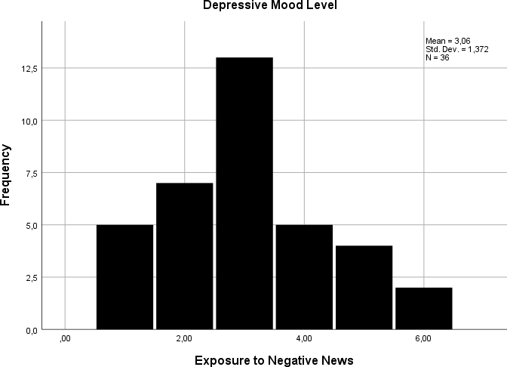

*In this graph, it is shown that the depression mood level in the group was exposed to the negative news.

*M=3, 06 indicates the moderate depression mood level
Exposure to Negative News
10.00
8.00
6.00
4.00
2.00
0.00
7.00

6.00

5.00

4.00

3.00

2.00

1.00

0.00
Depsression Mood Level

*In this figure, the scatter plot shows that the correlation between exposure to negative news and Depression Mood Level

Note. In this figure it demonstrates that people who exposure to the negative news more susceptible to the depression mood level.

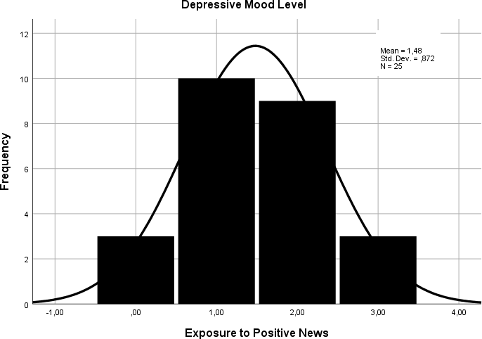

*In this graph, it is shown that the depression mood level in the group which was exposed to the positive news.

*M= 1, 48 indicates the low depression mood.
Exposure to the Positive News
7.00
6.00
5.00
4.00
3.00
2.00
1.00
0.00
7.00
6.00

5.00

4.00

3.00

2.00

1.00

0.00
Depression Mood Level

*In this figure, the scatter plot shows that the correlation between exposure to positive news and Depression Mood Level
Note. In this figure it demonstrates that people who exposure to the positive news do not have correlation with depression mood level.
Self-Esteem scale 1 was used to determine what extent positive and negative news play a vital role in the evaluation of the self-esteem. The results were collected in the correlation test. The self-esteem level, as exposure to negative news were (M=1, 26), and exposure to positive news (M= 0, 94).
The result has been demonstratedthat when exposed to negative news, there is a tiny differences in the self-esteem evaluation. However, the moderate self- esteem level were accepted (M=2). Thus, there was no significant differences in the self-esteem evaluation.
(Interpretation of self-esteem Evaluation: 0-1=High, 2-4=Moderate, 5-6= Low).

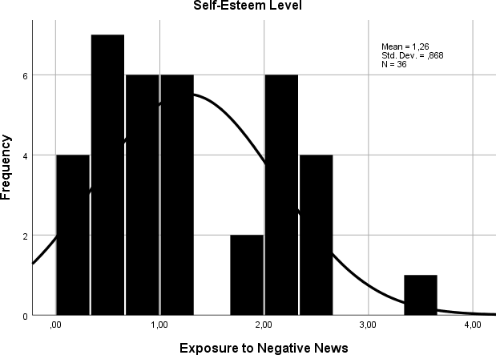

*In this graph, the self-esteem level in the group that who exposed to the negative news is shown.

*Mean= 1, 26 indicates the self-esteem level from high to moderate.

*In this figure, the scatter plot shows that the correlation between exposure to negative news and Self- Esteem Level.
Exposure to the Negative News
10.00
8.00
6.00
4.00
2.00
0.00
4.00
3.50
3.00
2.50
2.00
1.50
1.00
0.50
0.00
Self-Esteem Scale
Note. In this figure it demonstrates that people who exposure to the negative news have less correlation with self-esteem level compared to the people who exposure to the positive news.

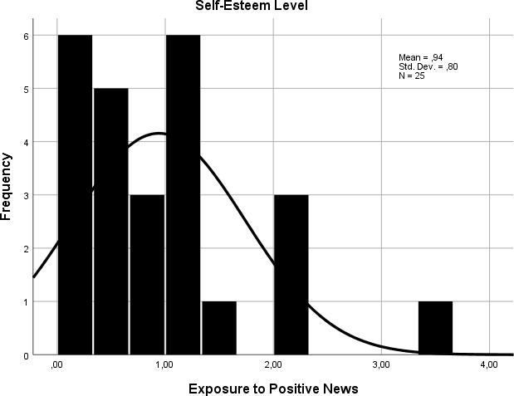

* In this graph, the self-esteem level of the group that who exposure to the negative news is shown.

*Mean=0, 94 indicates high self-esteem.
Exposure to the Positive News
10.00
8.00
6.00
4.00
2.00
0.00
4.00

3.50

3.00

2.50

2.00

1.50

1.00

0.50

0.00
Self-Esteem Level

*In this figure, the scatter plot shows that the correlation between exposure to positive news and Self- Esteem Level.
Note. In this figure it demonstrates that people who exposure to the positive news have high correlation with self-esteem level.

DISCUSSION

The study showed that exposure to different news affect differently our mood and the perception of the future self. It has been known that people have been exposed dozens news each day. However, there is no many research that concerned about this issue. People because of their nature want to understand what is going on around them to feel safe, to be protected from any dangerous. The news play important role to inform people.
The problem is that people cannot control the news occurrence which has been received without source. The study in Oxford shows that the number of countries where formally organized social media manipulation occurs has greatly increased, from 28 to 48 countries globally.” (Bradshaw, &Howard, 2018).

Therefore, people can expose any manipulation at any time without having any protection. As a sample, in Turkey the criminal video cases were broadcasted on the various social media. Exposure to these images changes people`s mood, and their perception of the self.
This research focused more on the exposure to news and its effect on people. The downside was that self-esteem level measured in the communication department. It was expected that students in the communication department have higher self-esteem level. Despite this fact that results show that people` moods changes exposed to the news. As previous research show that it increases depressive mood.
The novelty in this research that adding the interpretation of the future self, and the self-esteem scale after exposure to negative and positive news by activating DMN. However, it was not directly measured whether the DMN was active or not during reading news. Previous research was focused on more TV news rather than reading news. These results show that what people read direct to what they think. When people read the positive stories, they think optimistic future. On the flip side exposure to negative news affect dramatically folk` interpretation of the future self.
Future research should be a much wider segment of population, as opposed to a student sample, sophisticated research is needed across cross cultural study. Studies in this area are crucial because each moment in the life people are exposed various news. Then they can protect themselves against news by discovering effect of the news.

References

Szabo, A, Hopkinson, K. (2007). Negative Psychological Effects of Watching the News in the Television: Relaxation or Another Intervention May Be NEEDED to Buffer Them. International Journal of Behavioural Medicine 14 (2), 57-62.
Mary E, McNaughton-cassill (2001). The news media and psychological distress. Anxiety, Stress and Coping, 14 (2), 193-21.
Valeknbur, P, Peter, J, Schouten, A (2006). Friend Networking Sites and Their Relationship to Adloescents` Well Being and Social Self-Esteem. CyberPsychology & Behaviour, 9 (5), 584-590.
Dobelli, R. (2013). The Art of Thinking. Great Britain, Hodder & Stoughton

Jessica R.Andrews, Hanna. (2012). The Brain`S Default Network and its Adaptive Role in Internal Mentation. Neuroscientist 18 (3), 251-270.
Li, W, Mai, X, and Liu, C (2014). The default mode network and social understanding of others: what do brain connectivity studies tell us. frontiers in Human Neuroscience 8 (74), 1-15.
What is the Default Mode network (2014 August 27). ScienceBeta. Retrieved from <https://sciencebeta.com/default-mode-network/>,
Abernethy, C (2017 JAN 30). Why We Need Good News. Thrive Global.

Retrieved from <https://medium.com/thrive-global/why-we-need-good-news-af4fa81c2961>,

Signal, J (2014 August 8). What All This Bad News Is Doing to Us. The Cut News. Retrieved from <https://www.thecut.com/2014/08/what-all-this-bad-news-is-doing-to-
us.html>,

Sheppard, S (2019 May 10). Why Your BRAIN Craves Bad News. Rewire.

Retrieved from <https://www.rewire.org/living/brain-craves-bad-news/>,

Cevin, B (2018 May 18), To Declare War on Your Brain. Medium. Retrieved from https://medium.com/discourse/stop-thinking-positive-is-not-enough-the-default-mode-
and-how-to-declare-war-on-your-brain-bda1c6b080ce>,

Beres, D (2017 October 9). Universal Brain Activation Discovered When Reading Stories. BIG THINK. Retrieved from <https://bigthink.com/21st-century-
spirituality/universal-brain-activation-discovered-when-reading-stories>,

Bradshaw, S, Howard, P (2018). Challenging Truth and Trust: A Global Inventory of Organized Social Media Manipulation. Oxford University. Retrieved from < http://comprop.oii.ox.ac.uk/research/cybertroops2018/>,

