Advaita Vedanta: A model of spiritual development and psychological well-being
Swami Brahmaparananda Saraswati, Arsha Vidya Tirtha Jaipur, India
Swamini Atmaprakashananda Saraswati, Arsha Vidy UK
Neha Sharma, Warwick Research Services, UK

Abstract (300 word limit)

Although religion and spirituality typically incorporate significant affective and relational components, in Advaita vedanta these components been examined both systematically and empirically. In the present paper, spiritual teachings of Advaita Vedanta and aims to identify and amplify the implicit psychology that is embedded in the texts of the tradition in explored.

Advaita Vedanta, is a school of Indian philosophy and tradition teaching tradition to spiritual realization. Advaita emphasizes the true nature of the human individual is a non-dual Self (Atman) which is manifestations of one undivided universal Self (brahman). This model for the structure and function of the human psyche is the individual Jiva; which in a state of unawareness and ignorance, see "I-ness", then act out of impulse, anger, fears, confusion, anxiety, passions, and a sense of ego. These ignorance leads to bondage caused by inborn ignorance (avidyā) of this fact, and liberation (mokṣa) is what takes place when a person gains knowledge of this truth.

Present study uses a methodology to study bondage and liberation through different levels of realities, three state of consciousness and practices of self-realization. Vedanta, brings to lung an understanding of the Vedantic vision of the Self, which extends his psychological understanding of the psyche to include the Self as revealed in the Upanisads (Vedanta).

Image
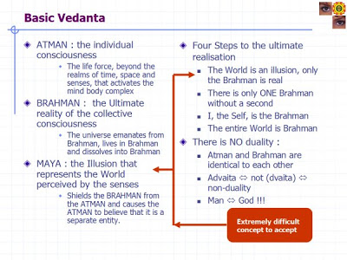
Recent Publications (minimum 5)
- Saraswati B, & Sharma, N (2018). The Impact of Arsha Vidya Programs on the Health and Functioning of Older Adults. J aging Sci 2018, Vol 5; pg 37.
- Saraswati B, & Sharma, N (2018).The impact of Arshavidya on psychological health of students: A cohort study. Paper presented to the 16TH International Conference on Children's spirituality, Laval University, Quebec, Canada; 24 July –27 July 2018
- Saraswati B, & Sharma, N (2018). Philosophy of Advaita Vedanta: Science, Consciousness and beyond’. Paper presented to 6th Academic International Conference on Multidisciplinary Studies and Education (AICMSE), 16-18 August 2018, Oxford, UK

Photograph

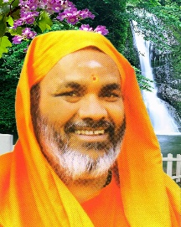
Biography (150 word limit)
Swami Brahmaparananda Saraswati has been mentor and leader in Arshavidya Tirtha, Jaipur, India. He has been working for two decades to combine Indian spirituality with modern world. Social reform and spreading the true sense of Indian spirituality, religion and ethics given a prominent place in his aims and he specific activiities for elderly, children and families. He has been co-authored in international collaborative research studies and published several books.
Email: nmpmedicalresearch@gmail.com

