The Use of Role Play as Therapy: Exploring experiences of Fear and Trauma through role play games with Cognitive Analytic Therapy.
Daborn T RMN, BA hons.

Abstract
Role play games (RPGs) offer the chance for people to explore another’s experience of reality. This is mediated via hypothetical action and empathetic experience. Research has shown that combat veteran’s report their experience of working through trauma for an RPG character helped them with their own symptoms. This was still reported when the RPG trauma was unrelated to their own experience. Attempting to further these findings, this poster explores the use of an HP Lovecraft inspired horror RPG. The RPG allows players to explore both positive and negative coping strategies when faced with trauma or other psychological stresses.
This poster focuses on the impact of applying tools to a readymade game designed for recreation (whilst horror related) as opposed to a game designed for psychotherapeutic treatment. Clinically this could allow patients to engage in trauma therapy directly or indirectly through role-play. Furthermore it could allow those in treatment to explore coping strategies in a “safe” space. Cognitive Analytical Therapy tools, such as Guided sequential diagrammatic reformulations and letter writing are also used to aid in emotional development. These are useful in considering self-states and reciprocal roles, as well as the personal and emotional development of an individual. They are therefore well suited to post-structuralism narrative development.

Image
(By Dennis Detwiler)

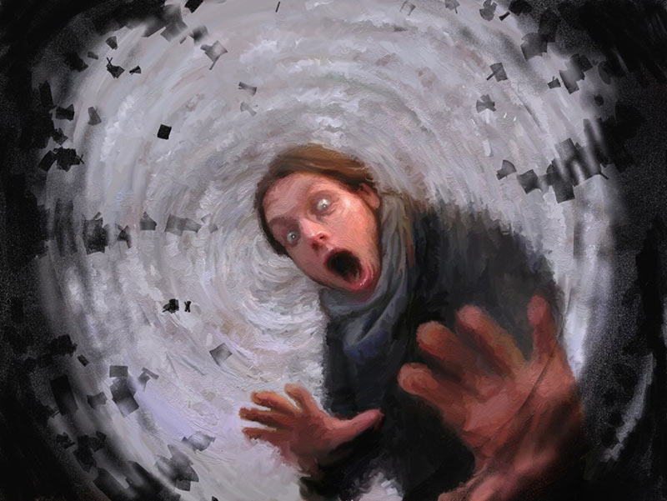

Photograph

Biography
Tim is a Mental Health nurse practicing in a community setting in South London having recently graduated from London South Bank University. He is strongly influenced by his first degree in Anthropology and training in Adult General Nursing and brings these together to create a holistic understanding of the human condition. Email: timothy.daborn@slam.nhs.uk

Notes/Commen

