Using Shared Decision Making to Improve Outcomes in Patients with Mental Illness
Jillian Perrier, RN MSN

Abstract

Using Shared Decision Making as a treatment model has been implemented in primary care and medical specialties, but is relatively new to the field of psychiatry. This integrative review of the literature was done to answer the question, “In patients with a mental illness diagnosis, does treatment using a Shared Decision Making model vs. a provider centered approach improve patient outcomes?”. Nurse theorist Ida Jean Orlando focuses on the relationship between the nurse and the patient, and uses the art and science of nursing to explore a patient’s needs, while keeping them at the center of care (Petiprin, 2016). Evidence in the research shows that using a collaborative approach such as SDM in treatment of people with mental illness results in improved outcomes in care, better self-care management and help seeking behavior, enhanced patient satisfaction, and compliance with decisions (Kivelitz et al., 2018). There is a need for more research regarding SDM in treatment of mental illness. Specific areas that need closer examination are beginning to emerge through the existing research, such as the need to incorporate decision making tools, assess barriers and facilitators to SDM, determine a patient’s desire to participate in decision making, and incorporate social supports into a person’s treatment.

Keywords: shared decision making, mental illness, psychiatric care, collaboration

Image

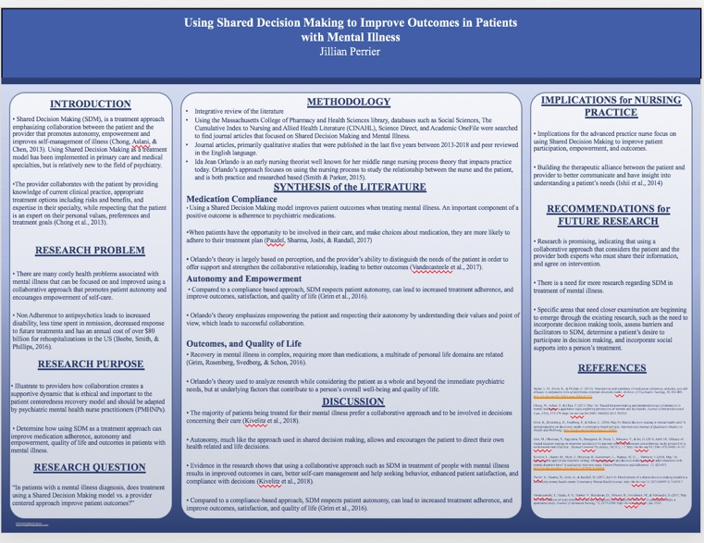

Photograph

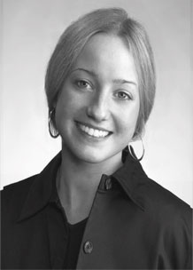
Biography
Jillian Perrier is a recent graduate from Massachusetts College of Pharmacy and Health Sciences (MCPHS) in Worcester, Massachusetts USA, where she earned her master’s degree in nursing. Her focus of study was in psychiatry, completing the Psychiatric Mental Health Nurse Practitioner track at MCPHS. Prior to completing this degree, she earned her Bachelor of Science in nursing from the University of Massachusetts in Amherst, MA USA. For the past 7 years her work as a nurse has been in the field of psychiatry treating people with mental illness and substance use disorders. Her practice has been focused in a community outpatient setting, as well as an inpatient facility at a rural hospital. She is dedicated to empowering people who have mental illness and strives to develop a collaborative relationship that promotes each person’s autonomy.
Email:jillianmarieperrier@gmail.com
Notes/Comments:

