Autism: Understanding identity formation and its impact on an individual’s wellbeing.
Dr Barbara Sandland. University of Birmingham

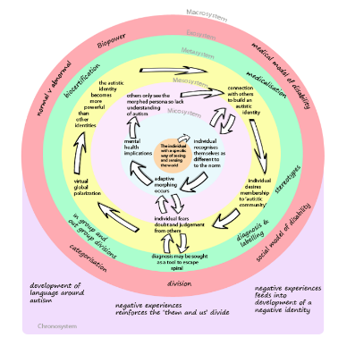
Figure 1: The Sandland Spiral. The process of building an autistic identity through spheres of influence, constrained by societal powers.

Abstract
Research suggests that identity verification is central to personal wellbeing. Yet the medicalized diagnosis of autism gives little consideration to how the autistic identity is built and understood. Indeed, for many, a diagnosis is a piece of paper they are given, that facilitates little understanding of what that means for them. For the significant population of individuals gaining diagnosis in adulthood, there are years of experiences that have a direct impact on a sense of self and mental health. By understanding these experiences, we can begin to understand the long-term implications on mental health, and in turn develop appropriate supportive structures to tackle this important issue and reduce the statistics that show autistic people are significantly more likely to die from mental health challenges and associated self-harm or suicide.
A biopsychosocial model is used to understand the ways in which the medical, psychological, and social elements of autism interact with each other to impact mental health and wellbeing. A sequential mixed methods study explored the lived experiences of 140 individuals, spanning all adult age ranges, 7 genders, 9 ethnicities, 11 religions and 12 countries.
The participants of this study experienced a wide range of mental health difficulties associated with their experiences prior to and after diagnosis of autism. Key factors impacted on identity verification, and in turn mental health, were schooling, bullying, adaptive morphing and in-group/out-group experiences.
Autism is an identity built through engagement with medical professionals and the autistic community, alongside experiences of judgement and exclusion from many in the non-autistic community. This research serves as a call for action to develop post-diagnostic support systems that prioritise identity verification and the likely associated mental health needs of the individual. While nurturing an understanding that autism does not define the whole person, being only one of a nexus of identities.

Image

Recent Publications
- Sandland, B., MacLeod, A., Hall, N., and Chown, N. (2023). Accommodation through personalisation: ensuring the autistic student has an equal opportunity for success in the PhD viva voce. Journal of Further and Higher Education.
- Sandland, B. (2023). The post-doctoral black hole. The Importance of Transitioning Out support for autistic students. Journal of Inclusive Practice in Further Education. 15:1. 102-114
- Sandland, B., MacLeod, A., and Hall, N. (2023). Neurodiverse students within higher education – initial thoughts from a collaborative project. Education in Practice. 4:1. 26-37
- Sandland, B. (2022) The Spiral of self-identification of autism through firsthand experiences. University of Birmingham PhD. Available at https://etheses.bham.ac.uk/id/eprint/12143/
- Sandland, B. (2018). Understanding the ‘Mask’ in Autism: Girls’ perspectives and the impact of wearing it. Good Autism Practice. 19:1

Photograph

 Biography (150 word limit)
Dr Sandland is a neurodivergent post-doctoral researcher at The University of Birmingham, UK. As a neurodivergent individual and mother to neurodiverse children she brings personal insight, alongside critical research, to her work. Her doctoral work, presented here, explored a previously under-researched field of autism studies, and by using her ‘insider-perspective’ she was able to reach a population of participants often missed from research to date. Dr Sandland’s background is as a qualified secondary school teacher, with many years’ experience as a Special Educational Needs Coordinator. As a result of her unique multi-perspective experiences, Dr Sandland is highly sought after to speak at conferences within the field of Neurodiversity and Education. Most recently at The Neurodiversity in Higher Education Conference, Bristol; The Annual SEND Conference, Leicester; and The City of New York Neurodiversity Conference; New York.
Email: b.sandland@bham.ac.uk

Notes/Comments:

