Mental health status of people with long covid and its relationship with clinical and psychological constructs as self-efficacy, patient´s activation and health literacy.
Dr Bárbara Oliván-Blázquez (PhD). University of Zaragoza. Spain.
Sandra León-Herrero. University of Zaragoza. Spain.
Mario Samper-Pardo. University of Zaragoza. Spain.
Fatima Mendez-López. Health Intitute for helath Research Aragon. Spain.
Raquel Sanchez Recio. (PhD) Uniersity of Zaragoza. Spain.
Dr. Rosa Magallón-botaya (PHD, MD). University of Zaragoza. Spain.

Abstract (300 word limit)
Long COVID patients suffer a negative impact on their quality of life nad there is still a need to better understand the individual experience and circumstances surrounding these patients. The objective of this study is to analyze the role of the mental health status in clinical and psychological constructs such as self-efficacy, patient 's activation and health literacy.
Methodology: 100 patients suffering from Long COVID participated in this study. The main variable was depression and anxiety measured by HADS. Other variables collected were: sociodemographic data, number of symptoms, sleep quality and personal constructs as self-efficacy, patient´s activation and health literacy. A bivariate and multivariate analysis were performed.
Results: Mental health status was related with number of symptoms, sleep quality and personal constructs as self-efficacy, patient 's activation and health literacy. Multivariate analysis confirmed this relationship and these variables are predictors of mental health.
Conclusion: It is relevant to analyze and treat mental health disorders in people with long covid since it has a relationship with clinical and psychological constructs relevant for their quality of life.

Image
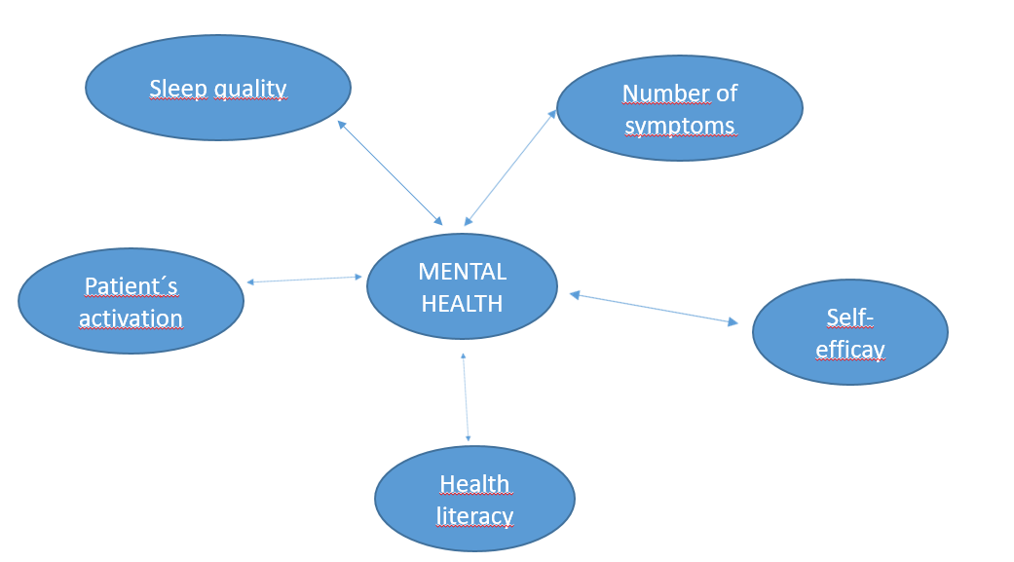

Figure: Use of health and social services and number of times of utilization
Recent Publications (minimum 5)
- Atzrodt CL, Maknojia I, McCarthy RDP, Oldfield TM, Po J, Ta KTL, et al.(2020). A Guide to COVID-19: a global pandemic caused by the novel coronavirus SARS-CoV-2. FEBS J, 287(17),3633–50.
- Mahase E. Covid-19: What do we know about “long covid”? BMJ. 2020; 370:m2815.
- Samper-Pardo M, Olivan-Blazquez B, Magallon-Botaya R, Mendez-Lopez F, Bartolome-Moreno C, Leon-Herrera S. (2023) The emotional well-being of Long COVID patients in relation to their symptoms, social support and stigmatization in social and health services: a qualitative study. BMC Psychiatry, 25; 23(1):68.
- Ramakrishnan RK, Kashour T, Hamid Q, Halwani R, Tleyjeh IM. (2021). Unraveling the Mystery Surrounding Post-Acute Sequelae of COVID-19. Front Immunol, 30; 12.
- Raman B, Cassar MP, Tunnicliffe EM, Filippini N, Griffanti L, Alfaro-Almagro F, et al. (2021). Medium-term effects of SARS-CoV-2 infection on multiple vital organs, exercise capacity, cognition, quality of life and mental health, post-hospital discharge. Clinical Medicine, 31:100683

Photograph

 Biography (150 word limit)
Dr Oliván-Blázquez is professor at the University of Zaragoza, at the Psychology and Sociology Department since September of 2011 (Knowledge area: Social Psychology). She earned the degree in Occupational Therapy (1997), Physiotherapy (2000) at the University of Zaragoza (Spain) and the degree in Psychology (2005) at the National University of Distance Education (Spain). In October of 2009, she received a PhD from the Medicine Department of the University of Zaragoza. She has participated in several research projects which have been financed by national and international grands and takes part in a National Research network in Primary Care Health System. One of her mail research lines is depression and social determinant of health. She has published nearly 100 articles in peer-reviewed journals, most of them published in first and second quartile journals indexed in JCR index. She has taken part also at national and international conferences.

Email: bolivan@unizar.es

Notes/Comments:

