Bipolar disorder in the elderly – a clinic overview

Mateus Teixeira de Moura, MD, Universidade de Brasilia, Brazil
Flavio Vieira Machado, MD, PhD, Universidade de Brasilia, Brazil
Gabriela Lopes Martins, MSc, Universidade Federal de Minas Gerais, Brazil
Lair da Silva Goncalves, MD, Secretaria de Saude do Distrito Federal, Brazil
Einstein Francisco Camargos, MD, PhD, Universidade de Brasilia, Brazil
Otavio de Toledo Nobrega, PhD, Universidade de Brasilia, Brazil

Abstract
Statement of the Problem: The prevalence of bipolar disorder (BD) in the general population is estimated to range from 1 to 2%. Among the elderly, BD accounts for 5 to 19% of all psychiatric disorders, being one of the most frequent chronic conditions in psychogeriatric wards and responsible for up to 20% of hospital admissions of older individuals. The purpose of this study is to describe the clinical and psychiatric characteristics of a sample of older BD outpatients. Methodology & Theoretical Orientation: Clinical data were obtained by interviewing the patient and family members during 2022 and reviewing medical records, including psychiatric history data (age of onset of symptoms, time with the illness, and number of psychiatric hospitalizations), mood state, and cognitive function. The study was due to ethical approvement. The sample was composed of 20 individuals aged 60 or over, diagnosed with BD type I according to DSM 5th edition. Findings: Among the patients evaluated, none had manic or depressive symptoms at the time of the evaluation; 15 (75%) presented early onset of the disease and 5 (25%) presented late onset. Moreover, 6 (30%) had never been hospitalized, 8 (40%) had one to three hospitalizations, and 6 patients (30%) had four or more hospitalizations. According to the Clinical Dementia Rating, 9 patients (45%) showed no cognitive decline, while 11 (55%) showed mild cognitive impairment. Conclusion & Significance: We observed that only 30% of the patients had never been hospitalized, which reveals great morbidity associated with BD in the elderly. Noteworthy this rate may reflect old psychiatric practices, from a time when there were fewer therapeutic options and hospitalizations were more frequent. Furthermore, our observation is compatible with a high frequency of cognitive decline among elderly patients with BD. Studies in this area are fundamental to better evaluate this growing population.

Image

Table. Clinical and demographic characteristics of study participants.

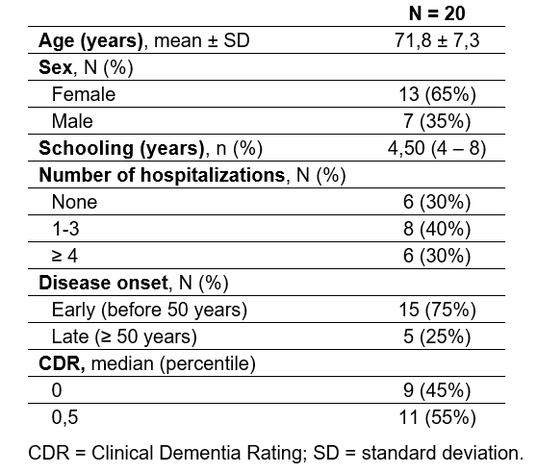

Recent Publications (minimum 5)
- ARNOLD, I. et al. Old Age Bipolar Disorder—Epidemiology, Aetiology and Treatment. Medicina, v. 57, n. 6, p. 587, 8 jun. 2021.
- COSTA LANE VALIENGO, L. DA; STELLA, F.; FORLENZA, O. V. Mood disorders in the elderly: prevalence, functional impact, and management challenges. Neuropsychiatric disease and treatment, 2016.
- LJUBIC, N. et al. Treatment of bipolar disorders in older adults: a review. Annals of General Psychiatry, v. 20, n. 1, p. 1–11, 2021.
- VIETA, E. et al. Bipolar disorders. Nature reviews. Disease primers, v. 4, n. 1, p. 18008, 8 jun. 2018.
5. ZUNG, S et al. Bipolar disorder in the elderly: clinical and scio-demographic characteristics. Scientia Medica, v. 19, n. 4, p. 162–169, 2009.


Biography
Mateus Teixeira de Moura, MD, has a degree in Medicine from the Universidade Federal de Minas Gerais, Brazil, (2016) and a medical residency in Psychiatry from Hospital São Vicente de Paulo, SES/DF, Brazil (2021). Currently, is a Master's student at Universidade de Brasilia, Brazil, in ​​the Medical Sciences program. He is interested in research and teaching in higher education.
Email: mateusteixeira141@gmail.com

Notes/Comments: Acknowledgments to the FUNDACAO DE APOIO A PESQUISA DO DISTRITO FEDERAL - FAPDF for the financial support granted for the accomplishment of this work.

