Night Shift Work as An Exposure Factor on the Risk of Depression among Nurses
Yufan Wang, University of Edinburgh, UK

Abstract
Objectives: This integrative review aims to ﬁll the gap and synthesise existing research, from 2017 to 2022, that investigates the impact of night shift work schedule on the risk of depression among nurses. Speciﬁcally, this paper hopes to answer: do nurses working night shifts experience higher risk of depression than nurses working only day shifts? This paper is also supported by a set of real-world data gathered from a group of nurses and healthcare workers in Hong Kong in 2022. This data is especially valuable, as no study has investigated the impact of night shift on depressive symptoms among nurses since the onset of the Covid-19 global pandemic.
Methods: The review was reported according to the PRISMA guidelines. Three databases, PubMed, PsycInfo, and Web of Science were systematically searched to source relevant articles. Quality of the selected studies were assessed using the STROBE checklist, before a meta-analysis was conducted. In a recent sample of Hong Kong healthcare workers, statistical associations of various variables and risk of depression were assessed using unpaired Studentʼs t-test and linear regression, where a p- value <0.05 was considered statistically signiﬁcant. Results: Night shift work was not signiﬁcantly associated with the increased risk of depression among nurses in the meta-analysis of selected observational epidemiological studies. Recent data sample revealed consistent non-signiﬁcant association.
Conclusions: Night shift work did not signiﬁcantly increase risk of depression among nurses. Other potential stressors should be investigated. This is urgent as the global pandemic has paralysed the healthcare system and placed huge responsibilities on healthcare professionals, especially nurses.

Image
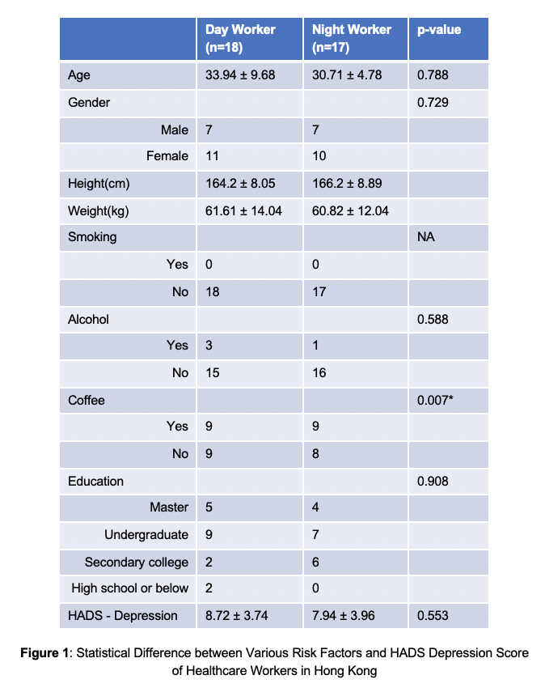

Photograph

 Biography
Yufan is a third year Psychology undergraduate from the University of Edinburgh. She is passionate about research investigating the psychological resilience and mental wellbeing of minority groups. She produced this paper from participating the 2022 Summer Undergraduate Research Programme hosted by the Chinese University of Hong Kong, under the supervision of Prof. Tse Lap Ah Shelly from the Jockey Club School of Public Health and Primary Care. Besides actively planning and leading large-scale mental health charity events for students in Edinburgh, Yufan is also a registered social worker who help adults with schizophrenia to live their lives to the fullest.

Email: babywangyufan@gmail.com

