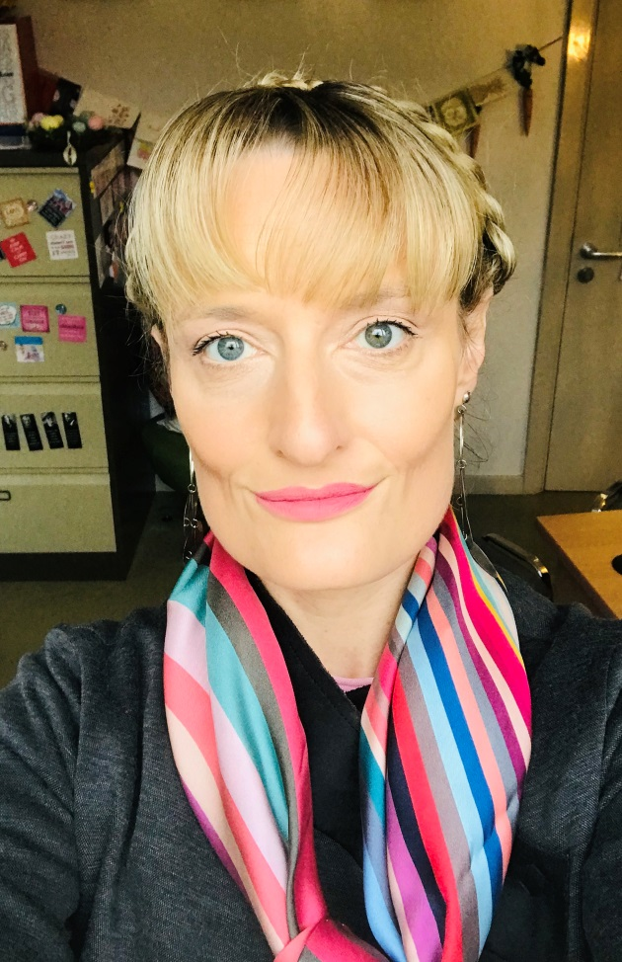
TITLE: Triage of children with mental health difficulties presenting in A&E in a General Hospital
AUTHOR: Dr Anne-Frederique Naviaux, MD Consultant Psychiatrist, HSE, Summerhill Mental Health Centre, Wexford (Ireland) and Universite Catholique de Louvain (Belgium)
ABSTRACT:
In Wexford and Waterford, an “out of hours” child psychiatric service has been developed, in order to provide help when the CAMHS services are not accessible. Providing a service for under 18 years old patients with mental health issues presenting in Accident and Emergency (A&E) or hospitalised on a Ward (Paediatric, psychiatric or other), it functions with extremely limited resources (a consultant psychiatrist and a doctor in psychiatric training), and therefore needs an efficient triage procedure.
Several triage tools were internationally developed for dealing with emergencies; the difficulty was to find a triage tool that would be specific enough for a paediatric population but that would also be useful for patients with Mental Health issues.
The purpose of this article is to review existing triage tools, and especially the 2016 Irish Children’s Triage System (ICTS), and to discuss how we believe this triage tool could respond to our specific needs in this new ‘out of hours’ CAMHS cover for Waterford /Wexford area.
BIOGRAPHY
Anne-Frederique Naviaux is a consultant Psychiatrist and Child Psychiatrist, who finished her Master in Psychiatry in 2004 (Universite Catholique de Louvain, Belgium). She worked in France as a ‘praticien hospitalier’ in Child Psychiatry and for the World Health Organization, before joining the research department in Trinity College (Dublin, Ireland) in 2011. She has been a lecturer in France (IFSI) since 2004 but has also joined the College of Psychiatrists of Ireland in 2012.
She currently works for the Health Service Executive in Ireland as Head of Service in Summerhill Adult Mental Health Centre (Wexford) and as Clinical Lead for Liaison Psychiatry in Wexford General Hospital (WGH). Since 2016, she has been developing in collaboration with the Paediatric Team in WGH and University Hospital Waterford, an out of hours emergency service for young people with Mental Health Issues.
PRESENTING AUTHOR DETAILS
Full Name: Anne-Frederique Naviaux
Contact Number: office: +353 53 9123 899, mobile: +353 85 228 9238
Address: Summerhill Community Mental Health Centre, Summerhill Heights, Slippery Green, Wexford, Ireland
E-mail: annefrederique.naviaux@hse.ie
Category: Oral Presentation or workshop

