Psychological immunity: content, structure and functions
Galina V. Moskalenko, Saint Petersburg University of State Fire Service of Emercom of Russia, St. Petersburg, Russian Federation

Abstract (300 word limit)
Statement of the Problem: Psychological immunity is cognitive-behavioral neoformation that develops in ontogenesis and provides a sense of psychological well-being and a condition of psychological safety.
The main element of the structure of psychological immunity is the boundaries of the psychological space of the individual. The width and flexibility of borders determines not only the characteristics of the psychological space, but also the characteristics of psychological immunity.
The main personal property in the structure of psychological immunity is awareness, which allows you to track, i.e. to monitor the current state of the person and, if necessary, through disgust and anxiety, launch the corresponding patterns of behavior. Meaningfulness is the second important component in the structure of psychological immunity, which determines the intensity and direction of a person's response. The higher the levels of awareness and meaningfulness, the faster and more consistent the situation is the response to the. If psychological immunity successfully copes with its tasks, then there is no need for it to turn to psychological defenses or coping behavior.
The duration of the effectiveness of psychological immunity is determined by the characteristics of the psychological stability (third important element) of a person, which contributes to a proportionate and adequate response in stressful and frustrating situations.
Absolutely no matter, positive or negative events occurred on a person’s life path: both provoke the occurrence of responses in proportion to the impact. So, extreme forms of reaction to a negative impact will be patterns of behavior caused by dysphoria: addictive behavior, delinquent behavior, suicidal behavior, and euphoria (risky behavior) on a positive one. To prevent such destructive forms of behavior, psychological immunity reduces the intensity of response to impacts, including it in a person’s life experience, so with age and experience in experiencing various situations, the brightness of the experience of events decreases.

Image
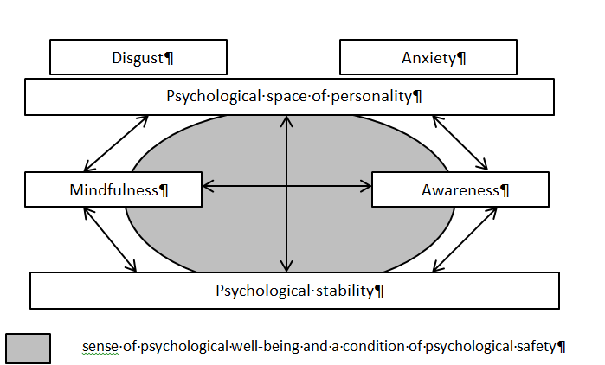
The structure of the psychological immunity
Recent publications (minimum 5)
- Garkavi, L. Kh., Kvakina, E. B., & kolova, M. A. (1990). Adaptive reactions and resistance of the organism. Rostov-on-Don: Rostov University. (in Russ.).
- Grachev, G. V. (2003). Personality and society: Informational and psychological safety and psychological protection. Moscow: PER SE. (in Russ.)
- Kagan, H. (2006). The Psychological Immune System. A New Look at Protection and Survival. Bloomington, Indiana: AuthorHouse.
- Krasnyanskaya, T. M., & Tylets, V. G. (2015). Psychological resources of personal safety with various experiences of extremeness. Mediko-biologicheskie i sotsial'no-psikhologicheskie problemy bezopasnosti v chrezvychainykh situatsiyakh = Medico-Biological and Socio-Psychological Problems of Safety in Emergency Situations, 2, 100–107. doi: 10.25016/2541-7487-2015-0-2-100-107 (in Russ.).
- Mikheeva, A. V. (2010). Stress tolerance: Towards definitions. Vestnik Rossiiskogo universiteta druzhby narodov. Seriya: Voprosy obrazovaniya: yazyki i spetsial'nost' = Bulletin of the Peoples’ Friendship University of Russia. Series: Educational Issues: Languages and Specialty, 2, 82–87. (in Russ.)


Biography (150 word limit)
Galina Moskalenko has her interest in the problem of psychological immunity because it is a term of everyday life of common people who don’t have any extreme experience. Psychological immunity is poorly researched in Russian psychology in spite of its relevance and importance in understanding the mechanism of coping with daily stresses.
Email: moskalenko_galina@list.ru

Notes/Comments:

