Factors Influencing Knowledge and Attitude among the Caregivers of Patients with Schizophrenia at Mathari Teaching and Referral Hospital, Kenya

Edna Anab, RN, MPH, Maseno University, Kisumu, Kenya
Dr. Agatha Christine Onyango, BSc N, MPH, PhD, Maseno University, Kisumu, Kenya
Catherine Mutunga, RN, MSc N, PhD, Mount Kenya University, Thika, Kenya

Abstract

Schizophrenia is a mental disease that affects how a person feels, behaves, and thinks. WHO estimates that 60% of people attending primary care clinics have diagnosable mental disorder. About 51 million people worldwide suffer from Schizophrenia globally. The main objective of the study was to determine factors that influence the knowledge and attitude of the caregivers of schizophrenic patients at Mathari Teaching and referral Hospital. Caregiver’s knowledge facilitates recognition of mental illness and health-seeking behavior. A cross- sectional descriptive study design was carried out to assess factors influencing knowledge and attitude among the caregivers of patients with schizophrenia at Mathari teaching and referral hospital, Kenya. Data was collected using questionnaire and key informant interview. Schizophrenia was diagnosed using diagnostic and statistical manual of mental disorder (DSM-V-TR) criteria. A total of 303 caregivers visiting the patients with schizophrenia in the wards were selected for study using systemic sampling technique. Pearson correlation coefficient, logistic regression and multiple regression was used to determine the magnitude of the correlation between dependent and independent variables. Most (72%) of the participants did not know the name of the condition which the patient was suffering from. Majority, 164(54.1%) of the caregivers had a positive attitude towards schizophrenia. There was a perfect positive correlation with the length of time the patient had suffered from the condition (.08423 zero order) with the knowledge of the caregiver. From the study finding, there was a perfect positive correlation with age, gender, highest level of education and nature of occupation (.06543, .04186,.0088 and .0039) with the knowledge of the caregiver. There was also a perfect positive correlation with age, gender religion, relationship to client, and nature of occupation (.0054, .0009.0357, .0574 and 0068 zero orders respectively). Study findings indicated a positive correlation between knowledge and the attitude since a caregiver with more knowledge had a positive attitude. The study recommends, treatment literacy classes for caregivers of schizophrenia patients.

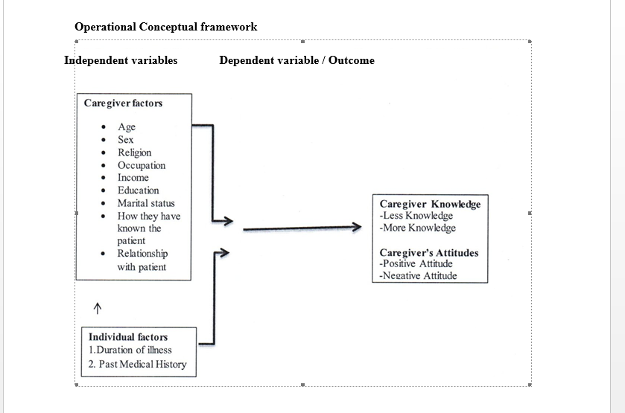
Recent Publications
- Edna Anab, Agatha Christine Onyango, Catherine Mwenda, Caregiver’s Knowledge and Attitude Regarding Care of Schizophrenia at Mathari Teaching and Referral Hospital, Kenya, American Journal of Psychiatry and Neuroscience. Vol. 6, No. 1, 2018, pp. 15-27. doi: 10.11648/j.ajpn.20180601.13 Harper C (2009)

Photograph

Biography
Edna has experience in both clinical management and program coordination, having worked with various local health facilities and non-governmental organizations. She is a Registered Nurse (Bachelor of Science in Nursing and Public Health) and a Public Health Specialist (Master’s in Public Health major Epidemiology and Population Health).She has passion for mental health and has insights of various strategies/ approaches employed to enhance implementation of sustainable health programs, whilst advocating for health systems strengthening. Edna played a key role in supporting National and County leadership towards spurring acceleration of the country’s effort to eliminate mother to child transmission of HIV and syphilis. She previous worked with Kenya National HIV/STI Control Program (NASCOP) as a PMTCT Technical Advisor on the PMTCT Rapid Response Team and is currently working with AMPATH as a PMTCT Regional Manager. Edna is adventurous and eager for new challenges.
Email: ednanab@yahoo.com

Notes/Comments:

