The role of supervision and professional efficacy in enhancing the professional competency of mental health professionals
Lee Gyungjoo, Assistant Professor, College of Nursing, Catholic University of Korea, South Korea
Kim Soung Nam, Administrator, Dongdaemun-Gu, Primary Mental Health Welfare Center, South Korea
Kim Gyung Hee, Professor, Seoul Women’s College of Nursing, South Korea
Lee Sung Nam, Team Leader, Health Promotion Division, Seoul Metropolitan Government, South Korea
Kim Suk Ja, Nursing director, St, Andrew’s hospital, South Korea,
Kim Sun Mi Doctoral Student, Graduate School, Catholic University, South Korea

Abstract
Advanced nurse practitioners play an important role in the improvement of mental health of the global population. Therefore, it is important to train quality mental health professionals and to improve their clinical competency through effective training programs. This study aimed to identify the role of supervision and professional efficacy in enhancing the professional competency of Psychiatric and Mental Health Nurse Practitioners (PMHNP) in South Korea. It used a cross-sectional exploratory survey to establish a structural equation model of the role of quality supervision and professional efficacy in the relationship between quality of training institutions, the learned knowledge and skills, and professional competency. Study participants were 297 PMHNP working in hospitals and community mental health centers nationwide. They were conveniently recruited from 17 regions covering all of South Korea. They received a one-year training program and national license as mental health professionals based on mental health acts in South Korea. Participants were administered questionnaires that measured the quality of training, the quality of supervision, satisfaction with the overall training course, knowledge and skills learned in the training, professional efficacy, and professional competency. All measures were reliable with Cronbach’s alphas between .91 and .97. A structural equation model was conducted using AMOS 23.0. Overall model fits were good, with chi-square = 133.53 (p<.001), NFI = .91, TLI = .88, CFI = .92, and RMSEA = .12. The quality of supervision significantly improved the acquisition of knowledge and skills among PMHNP. Professional efficacy significantly mediated the relationship between knowledge and skills and professional competency. In order to train well-qualified mental health professionals with high competency, specific strategies to enhance the quality of supervision are needed. Effective educational contents and methods for improving not only professional knowledge and skills but also professional efficacy of mental health professionals should also be developed.

Image
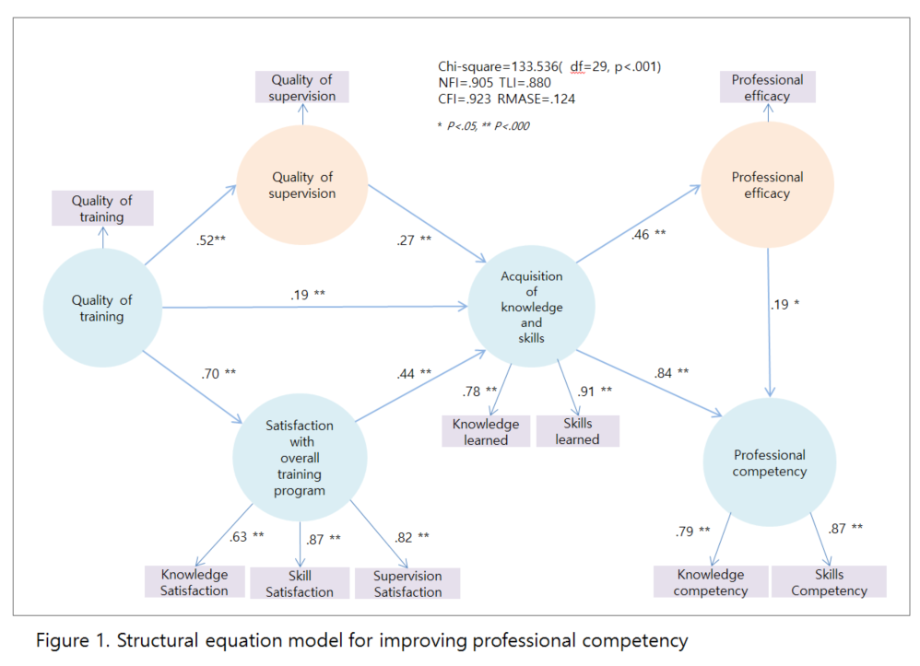
Recent publications
- Delaney KR, Robinson KM, Chafetz L (2013) Development of integrated mental health care: Critical workforce competencies. Nursing Outlook 61:384-391.
- Delaney KR, Carlson-Sabelli L, Shephard R, Ridge A (2011) Competency-based training to create the 21st century mental health workforce: Strides, stumbles and solutions. Archives of Psychiatric Nursing, 24:225-234.
- National Organization of Nurse Practitioner Faculties (2003) Psychiatric mental health nurse practitioner competencies.
- National Organization of Nurse Practitioner Faculties (NONPF) (2013) Population focused nurse practitioner competencies.
- Weber MT, Delaney KR, Snow D (2016) Integrating the 2013 psychiatric mental health NP competencies into educational programs: What are we now? Archives of Psychiatric Nursing 30:425-431.


Biography
Presenting author : Gyungjoo Lee has her expertise in teaching, research, and counselling for improving the mental health of clients and their families. She is a passionate professor who teaches nursing students about psychiatric mental health nursing at the Catholic University of Korea. She is also interested in the development of a training program for enhancing the quality of Psychiatric-Mental Health Nurse professionals in South Korea. Her research field is family counselling for improving children’s mental health. She has been contributing to the community as an educator, researcher, and child and family counselor.
Email: kjdooly@catholic.ac.k

Notes/Comments: This study was supported by a grant of the Korean Mental Health Technology R&D Project, Ministry of Health & Welfare, Republic of Korea
(No: HM16C1970-030017).

