

Abstract
Non-syndromic orofacial clefts and increased risk for psychiatric disorders.

Karin K Tillman¹, Jonas Höijer², Mia Ramklint³, Lisa Ekselius⁴, Daniel Nowinski⁵, Fotios C Papadopoulos⁶

¹ Karin K Tillman, M.D., Department of Neuroscience, Child and Adolescent Psychiatry, Uppsala University
² Jonas Höijer, MSc, Biostatistician, Unit of Biostatistics, Institute of Environmental Medicine, Karolinska Institute
³ Mia Ramklint, M.D., Ph.D., Department of Neuroscience, Psychiatry, Uppsala University
⁴ Lisa Ekselius, M.D., Ph.D., Department of Neuroscience, Psychiatry, Uppsala University
⁵ Daniel Nowinski, M.D., Ph.D., Department of Surgical Sciences, Plastic Surgery, Uppsala University
⁶ Fotios C Papadopoulos, M.D., Ph.D., Department of Neuroscience, Psychiatry, Uppsala University

Objectives: Children with orofacial clefts (OFC) have an increased risk of poor mental health. This study aimed to investigate the risk of psychiatric diagnoses in individuals with OFC, stratified by cleft type.
Methods: A nationwide register-based cohort of all individuals born with non-syndromic OFC in Sweden between 1973 and 2012 (n=7842) was compared to a matched community cohort (n=78409) as well as to their unaffected siblings. By linking to Swedish registers, the risk of psychiatric diagnoses, suicide attempts and suicides was examined by using Cox regression, adjusted for perinatal factors, season and year of birth, sex, parental socioeconomic factors and parental psychiatric morbidity and history of suicide attempts. Effect modification by sex was investigated with interaction terms in the models.
Results: Children with OFC had a significantly higher risk of intellectual disability, language disorders, psychotic disorders, autism spectrum disorder, attention deficit hyperactivity disorder, other behavioral or emotional disorders with onset in childhood and personality disorder. When investigating the three different subtypes of OFC, children with cleft palate only had the highest risk ratios and children with cleft lip the lowest. When stratifying on sex, we found that the risk increases were generally significantly higher for females than for males. The unaffected siblings of children with OFC were less likely to be diagnosed with a psychiatric disorder.
Conclusions: Children with non-syndromic clefts had a significantly higher risk of neurodevelopmental disorders. This increased risk was significantly higher in females and cannot fully be explained by shared environmental or genetic factors.
Keywords— epidemiology, neurodevelopmental disorders, nonsyndromic clefts, psychiatric comorbidity

Professional Biography (100-150 words)

Karin Tillman is a senior Consultant Child and Adolescent Psychiatrist working at the Department of Neuroscience, Psychiatry and Child and Adolescent Psychiatry at Uppsala University, Sweden. She has an employment as a course leader for the Psychiatry and Child and Adolescent Psychiatry courses for medical students at Uppsala University. She is also a PhD student at the Department of Neuroscience at Uppsala University. She works clinically in a private Child and Adolescent Psychiatry Practise in Stockholm, Sweden, performing neurodevelopmental assessments and treatments of children and adolescents. Her first study was recently published in the Journal of the American Academy of Child and Adolescent Psychiatry in November 2018.

Recent Publications

- Tillman KK et al (2018) Increased Risk for Neurodevelopmental Disorders in Children With Orofacial Clefts. J Am Acad Child Adolesc Psychiatry. 57(11):876-883. doi: 10.1016/j.jaac.2018.06.024.

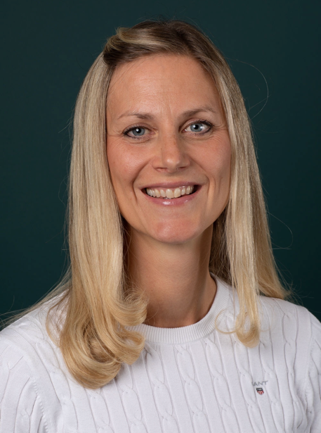 email id: karin.tillman@neuro.uu.se

