SCREENING OF AUTOCHTHONOUS LACTIC ACID BACTERIA AS PROBIOTIC FOR LACTATING BUFFALOE
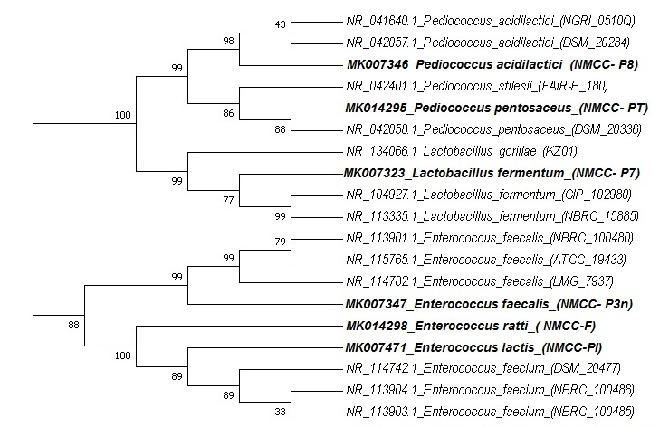
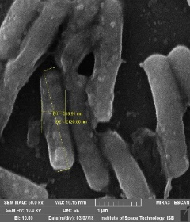
Dr. Shakira Ghazanfar, PhD
Dr. Ghulam Muhammad Ali, PhD
Mr. Sarmir khan, Mr. Sajid Mustafa, Miss Sidra Irshad khan, Miss Irum Arif, Miss Sana Waqas
National Institute of Genomics and Agriculture Biotechnology, National Agricultural Research Centre, Park Road, Islamabad-45500, Pakistan

Abstract (300 word limit)

Statement of the Problem: Due to the extensive use of antibiotics in animal feed, antimicrobial resistance has been increased. Because of this reason, the rumen microbiologists search for new probiotics to improve the rate of livestock productivity. Methodology & Theoretical Orientation: The objective of present study was to isolate breed specific lactic acid bacteria (LAB) as potential animal probiotics from Nilli Ravi Buffalo. 68 Gram-positive and catalase-negative bacterial strains, presumptive LAB, from gastrointestinal tract of 10 Nilli Ravi Buffalo of Livestock Research Station Pakistan, have been isolated. These isolates were evaluated for their potential antimicrobial activity using common animal pathogens (E. coil, Salmonella, Staphylococcus aureus, Listeria. Findings: Only six bacterial strains (NMCC- PI, NMCC- PT, NMCC- P3n, NMCC- P7, NMCC- P8 and NMCC- F) showed a positive antibacterial activity. The isolates identified through gene sequence analysis included Lactobacillus fermentum (94.45%), Pediococcus acidilactici (96.58%), Pediococcus pentosaceus (97.74%), Enterococcus faecalis (95.32%), Enterococcus durans and Enterococcus lactis. The probiotic profile of these six LAB strains was prepared by using standard criteria. All strains fulfil the basic criteria of animal probiotic properties but NMCC-1 showed the best result regarding its ability to survive at low pH (2.0), bile salt (0.03%) and gastric juice. It also showed a significant aggregation and hydrophobicity. Conclusion & Significance: Our results demonstrated that the LAB may serve as a promising alternative breed specific animal probiotic candidate in the dairy feeding system.

Image

Recent Publications (minimum 5)
    - Muhammad Naeem, Iftikhar Ahmed, Amina Zubari, Zahir Ahmed and Shakira Ghazanfar 2018. Screening of cattle gut associated Bacillus strains for their potential use as animal probiotic 2018. Indian Journal of animal Sciences
    - Shakira Ghazanfar, Maria Qubtia, Fariha Hassan, Muhammad Afzal, Iftikhar Ahmed, Muhammad Imran. Effects Dietary supplementation of Saccharomyces cerevisiae on Production and Health Status in Dairy Cattle” The Journal of Animal and Plant Sciences. 2018
    - Kamran Ali, Ihsan Ullah, Hayaz Uddin, Shakira Ghazanfar, Mustansar Ali Ghazanfar. 2017 Study on the effects of dietary supplementation of inactive dry yeast (Saccharomyces cerevisiae) on feed intake, body weight gain and fecal microbiota of crossbred’s steers. International Journal of Bioscience (IJB). Vol. 10, No. 4, p. 288-294, 201.
    - Farah N, Sadia M, Shakira Ghazanfar, Tahir SS, Naseem R, Muhammad Imran. 2016. Isolation, characterization and application of indigenous Lactic Acid Bacteria in milk fermentation. International Journal of Biosciences 9(6), 415-430
    - Shakira Ghazanfar, Muhammad Iqbal Anjum, Atiya Azim and Iftikhar Ahmed. 2016. Effect of dietary supplementation of probiotic yeast (Saccharomyces cerevisiae) culture on growth performance, blood parameters, nutrient digestibility and fecal flora of dairy heifers” ‘The Journal of Animal and Plant Science 25(1): 53-59.
Photograph

Dr. Shakira Ghazanfar got Ph. D. degree in 2016. I am working as SSO, in National Agriculture. Research Center, Pakistan. An important achievement of my career is that I am working on the whole genome sequence of lactic acid bacteria isolated from Pakistani ecology, and I am preparing the probiotic products for animals. Published more than 20 research papers, 1 book chapter and supervised/supervising thesis research of 09 MPhil and 3 PhD students. Initiated project for the Establishment of NIGAB-Microbial Culture Collection (NMCC) at NARC I am also working on the production of the safe, healthy feed for animal use to improve dairy animal health and production.
Email: Shakira_akmal@yahoo.com

Notes/Comments:

