Iniencephaly: A Case Report
Dr. Cem Yener, M.D, Edirne, TURKEY

Abstract
Iniencephaly is a rare neural tube defect characterized by the presence of occipital bone defects at foramen magnum, fixed retroflexion of head, spinal dysmorphism, and lordosis of cervicothoracic vertebrae. Iniencephaly is in the same family of neural tube defects as spina bifida, but it is more severe. The frequency varies between 0.1-10 / 10,000. Most of the fetuses are female. Etiopathogenesis is not known. According to some sources, it has been associated with trisomy 13, 18 and monosomy X. AFP(alfa-feto protein) as a biochemical marker is generally increased. Here we present a 30 years old 19 weeks pregnant women that was referred to our Perinatology Department. We detected polihydramnios, extreme retroflexion of the head, absent neck, low set ears and major cardiac anomaly on ultrasonography. We informed family and with family consent we terminated pregnancy (Image 1). In conclusion, iniencephaly is a neural tube defect with unknown etiopathogenesis. There is no standard treatment for iniencephaly since most infants rarely live longer than a few hours. Medicine is based more on prevention using supplementation with folic acid. Numerous studies have demonstrated that mothers can reduce the risk of neural tube birth defects such as iniencephaly by up to 70 percent with daily supplements of at least 4 mg of folic acid. Pregnant women should avoid taking antiepileptic drugs, diuretics, antihistamines, and sulfa drugs, which have been shown to be associated with an increased risk of neural tube defects. Maternal obesity and diabetes are also known to increase the risk for these disorders so prenatal care is important for these patients.

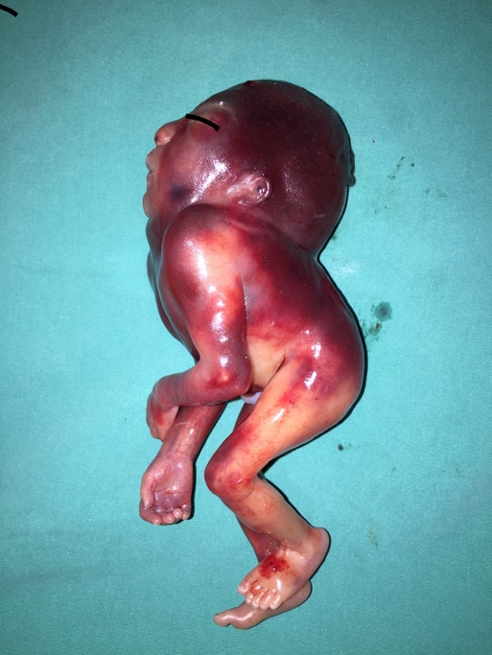
Image 1: Macroscopic view of the fetus after termination procedure.
References
- Foderaro AE, Abu-Yousef MM, Benda JA, Williamson RA, Smith WL. Antenatal ultrasound diagnosis of iniencephaly. J Clin Ultrasound. 1987 Oct;15(8):550-4.
- Aleksic S, Budzilovich G, Greco MA, Feigin I, Epstein F, Pearson J.
Iniencephaly: a neuropathologic study. Clin Neuropathol. 1983;2(2):55-61.
- Shoham Z, Caspi B, Chemke J, Dgani R, Lancet M. Iniencephaly: prenatal ultrasonographic diagnosis--a case report. J Perinat Med. 1988;16(2):139-43.
- David TJ, Nixon A. Congenital malformations associated with anencephaly and iniencephaly. J Med Genet. 1976 Aug;13(4):263-5.
5. Dobyns WB. Developmental aspects of lissencephaly and the
lissencephaly syndromes. Birth Defects Orig Artic
Ser.1987;23(1):225-41.

 Biography
Dr Cem Yener is a specialist doctor in Department of Gynecology and Obstetrics. He is now working on Division of Perinatology at the Trakya University Medical Faculty, Turkey. His expertise is especially in high risk pregnancies, targeted ultrasound, chromosomal and congenital anomalies, amniocentesis, chorionic villus biopsy and cordocentesis.
Email: cemyener@trakya.edu.tr

