The training of health promotion agents in Côte d'Ivoire: socio-anthropological issues in community interventions
Adou Serge Judicaël ANOUA, Doctorate Degree of Health Socio-anthropology,
Alassane Ouattara University, Côte d’Ivoire
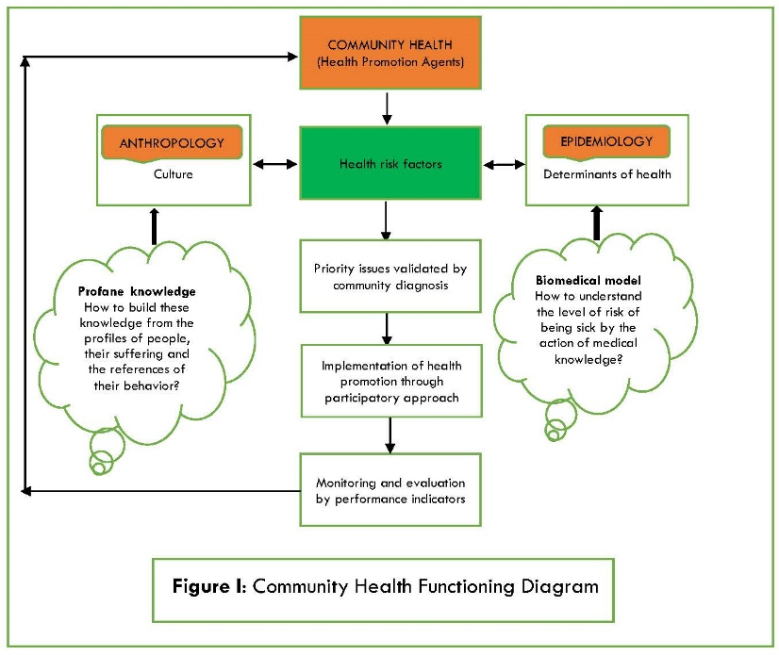

Abstract
Statement of the Problem: The epidemiological transition remains a major challenge for public health in Côte d'Ivoire. It stems from the medicalized vision of the health system. In fact, the action plans of the various national programs are in no way officially supported by any sociological support study. The reference structure for prevention remains the service of epidemiological surveillance. The implication of such an attitude is the fact of sociological resistance in the acculturative process. In this context, the human component is a dimension of importance. From this we deduce that this epidemiological monopoly underlying the public health approach in Côte d'Ivoire seems to us to be wrong. How to reduce this complex health situation? And how to get people to take charge of their own health individually and collectively? Intervention: Faced with these questions, we propose the establishment of a training system in health promotion anchored in lifestyle. It is a matter of guiding the different social strata of the population towards the adoption of the behaviors in favor of a general well-being, in addition to the control of their own health. It is in this context that the opening in 2014 of the community health training program at Alassane Ouattara University in Bouaké, meets a healthy wait. This stream recruits nurses, midwives and doctors. They are trained in theory and practice from a multidisciplinary perspective in order to establish the mechanism of behavioral change in the population. Results: The first promotion has just been released in 2018, with the Master's degree in Community Health. Conclusion: It is envisaged for these new graduates, the creation of a national network to maintain relations, strengthen the spirit of professional belonging and develop a framework for collaboration and exchange of experiences for improving skills.
Image

Recent publications
- Cherubini, B. (2011). Introduction. Des évolutions attendues en promotion de la santé. Dans : Bernard Cherubini éd., Agir pour la promotion de la santé: Une politique ouverte à l’innovation ? (pp. 9-28). Toulouse, France: ERES. doi:10.3917/eres.cheru.2011.01.0009.
- Debout, C. (2008). Sciences des soins infirmiers : réflexions épistémologiques sur le projet d'une discipline. Recherche en soins infirmiers, 93(2), 72-82. doi:10.3917/rsi.093.0072.
- Fond-Harmant, L. & Dia, A. (2008). Santé publique et transfert de compétences Nord-Sud : les conditions d'une approche inter-culturelle. Santé Publique, vol. 20(1), 59-67. doi:10.3917/spub.081.0059.
- Massé, R. « Relativisme culturel et relativisme éthique. Pour une approche critique dans l’engagement face aux populations locales », in Christine Bellas Cabane (éd.), Soins de santé et pratiques culturelles, Paris, Karthala, 2008, pp. 101-123.
- Sharon Moynihan, Leena Paakkari, Raili Välimaa , Didier Jourdan & Patricia Mannix McNamara (2015) Teacher competencies in Health Education: Results of a Delphi Study PLOS One December 2, 2015 DOI: 10.1371/journal.pone.0143703

Biography

ANOUA Adou Serge Judicaël is a Doctor in socio-anthropology and Assistant Professor in the Department of Anthropology and Sociology at the Alassane Ouattara University. He is a coordinator of the Laboratory of Studies and Research in Reproductive Health care Transition. He intervenes at the Basic School of the National Institute for Training of Health Agents of Bouaké, at the graduate cycle of the National Institute for Training of Health Agents of Abidjan and in Master of Health Community at the Continuing Training Center at Alassane Ouattara University. He has published several papers in journals and is an editorial board member. My domain of speciality is the socio-anthropology of health. The general problem that occupies my scientific reflection is the issue of Reproductive Health in rural Africa, particularly in Côte d'Ivoire. I also conduct research activities in the domain of community health and environmental health and nursing care.

Email: anoua_08@yahoo.fr

