Title: Laryngeal height and COPD: diagnostic approach based on clinical findings
Angela m Arevalo, MD, Parquesol Health Care, Valladolid, Spain

Abstract (300 word limit)
Statement of the Problem: The progressive aging of the population requires a variety of services; health professionals from Primary Care to the development of new strategies of attention for pluripathological patients. Chronic obstructive pulmonary disease (COPD) represents one of the most important causes of morbidity and mortality (overall prevalence in Spain 10.2%). The WHO estimates that in 2030 it will be the third leading cause of death worldwide. The total expenditure associated with COPD represents 0.2% of Spanish GDP. Although spirometry represents the gold standard in the diagnosis of COPD, there are studies that show the laryngeal height as a clinical finding decreased in patients with airway obstruction.
Methodology & Theoretical Orientation: We propose an observational correlation study to establish the relationship among the laryngeal height and other clinical findings with the diagnosis of COPD. Patients will be selected in two groups, according to the presence or absence or COPD, and matched by age and sex. We also try to find any correlation between the laryngeal height in centimeters and the airflow limitation, sub stratified by severity, age and gender. The final aim of this study is to validate this clinical sign and develop if possible a predictive rule, which proves feasible to apply to Family Medicine.
Findings: Our first results show relevant differences in the laryngeal height, higher in the NON-COPD group. We also have found different measurements depending on the age and GOLD category.
Conclusion & Significance: The laryngeal height sign in diagnosis of COPD is not widespread in medical practice. There is not a defined cut point value, based on the anatomical, physiological or statistical findings, so the possibility to propose cutting points according to age, gender and stage of COPD could improve the early diagnosis and treatment, and the benefits of the prevention strategies.

Image
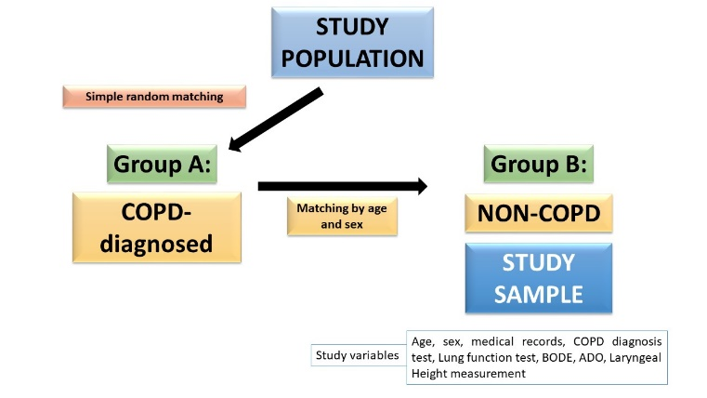
Image 1: General information about selection of the study population and variables collected
Recent publications (minimum 5)
1. Ancochea J, Badiola C, Duran-Tauleria E, et al. The EPI-SCAN Survey to Assess the Prevalence of Chronic Obstructive Pulmonary Disease in Spanish 40-to-80-Year-Olds: Protocol Summary. Arch Bronconeumol. 2009; 45:41-7.
2. Peces-Barba G, Barberà J, Agustí A, et al. SEPAR-ALAT Clinical Guidelines for diagnosis and treatment of COPD. Arch Bronconeumol. 2008; 44:271-81
3. Martin-Escudero JC. Complexity in chronic obstructive pulmonary disease. Individualized treatment, new approaches, phenotypes and comorbidities. Rev Clin Esp. 2011; 211(Suppl 2):13-21
4. Straus SE, McAlister FA, Sackett DL, Deeks JJ; CARE-COAD1 Group. The accuracy of patient history, wheezing, and laryngeal measurements in diagnosing obstructive airway disease. JAMA. 2000;283(14):1853-1857.
5. Leite Dias de Mattos W, Hass Signori L, Broges F, et al. Accuracy of clinical examination findings in the diagnosis of COPD. J Bras Pneumol. 2009; 35(5); 404-408.
6. Casado V, Navarro SM, Alvarez AE, Villafañe M, Miranda A, Spaans N. Laryngeal measurements and diagnostic tools for diagnosis of chronic obstructive pulmonary disease. Ann Fam Med. 2015; 13(1):49-52.


Biography (150 word limit)
Angela M Arevalo has her expertise in pulmonary disease as former Thoracic Surgery Consultant and now working in Primary Care. She is now collaborating with Mrs. Veronica Casado in the improvement of the Standards of Care about lung diseases, by means of health promotion strategies, early diagnosis and treatment, all in order to improve the quality of life of the target population.

Email: aarevalopardarl@gmail.com

Oral or Poster or Workshop:

Notes/Comments:

