Title: Anogenital squamous cell carcinoma in neglected patient and primary care
Danka Svecova, University Professor, MD, PhD,
Faculty of Medicine, Comenius University in Bratislava, Slovakia

Abstract

Statement of the Problem: Skin cancer is the most commonly diagnosed cancer worldwide. Most of skin cancer is nonmelanoma cancer, either basal cell carcinoma or squamous cell carcinoma. Methodology & Theoretical Orientation: Screening for skin cancer showed insufficient screening examination by a physician as well as by patient. Gynecologist for genital wart with podophyllotoxin cream treated a Caucasian 56-years old female patient. She did not achieve complete response and therefore she has interrupted the therapy and the collaboration with the gynecologist. Findings: At the time of evaluation the lesion had a size of man’s palm in anogenital region and showed characteristic features of neoplasm. The regional lymph nodes have produced infiltrated painful bubo. PCR analysis for HPV proved negative. Histopathology revealed well-differentiated squamous cell keratinizing carcinoma from the tumor as well as from the regional lymph node packet. Staging computed tomography scans proved negative and pelvis scans disclosed regional lymphadenopathy underlying the tumor. Palliative radiation therapy (by linear accelerator) was administered for the oversize tumor to the total TD 50.0Gy. The patient died 6 months after diagnostic assessment from the cardio-respiratory failure. Staging computed tomography before her death did not disclose distinct metastases in her inner organs. Well-differentiated squamous cell keratinizing carcinoma could be growing endophytically affecting the underlying adipose tissue and musculature, with spreading into the regional lymph node. The rate of metastasis into inner organs seems to vary according to the aggressiveness and metastatic behavior of each SCC. Conclusion & Significance: The case report calls for attention to the importance of collaboration among various specialists assisting with the diagnosis and management of skin neoplasm. Education in screening for skin cancer is important in preventive primary care.

Image
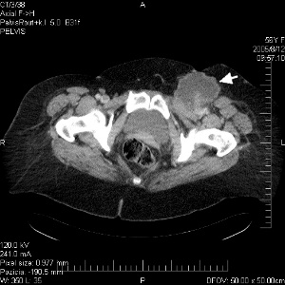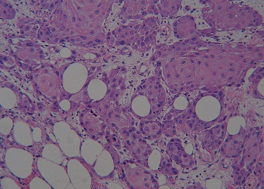
Fig.1: CT scan showed necrotic enlarged packing of lymph nodes in the left groin (arrow-head).
Fig.2: Squamous cell carcinoma infiltrates adipose tissue (hematoxylin and eosin, x250)
Recent publications
- Madan V, Lear JT, Szeimies RM (2010) Non-melanoma skin cancer. Lancet 375:673-85.
- Goulart JM, Quigley EA, Dusza S et al. (2010) Skin cancer education for primary care physicians: a systematic review of published evaluated interventions. J Gen Intern Med 26: 1027-35.
- Cassarino DS, Derienzo DP, Barr RJ (2006) Cutaneous squamous cell carcinoma: a comprehensive clinicopathologic classification. Part one. J Cutan Pathol 33:191-206.
- Petter G, Haustein UF (2000) Histologic subtyping and malignancy assessment of cutaneous squamous cell carcinoma. Dermatol Surg 26: 521-530.
- Fernandez_Flores A. CD30+cells in regressing keratoacanthoma and in non-keratoacanthomatous squamous cell carcinoma (2008). Bratisl Lek Listy 109:508-512.

 Biography
Dr. Danka Svecova, Medicine Doctor (PhD. – dermatology), now is a professor of Dermatovenerology, Head of Bullous Disorders Unit at Dept. of Dermatovenerology, University Hospital and Faculty of Medicine, Comenius University in Bratislava, Slovakia. She is a board member of Division Committee for Dermatovenerology and Immunology for PhD. She is a member of committee for Probation of Specialization for Dermatovenerology at Comenius University in Bratislava and University of J.P. Safarik in Kosice. At Hokkaido University in Sapporo, Japan, she participated in research on Skin Allergology and Immunology under the supervision of Professor Akira Ohkawara. She held several grant projects on fungal infection, therapy of psoriasis, borreliosis immunomodulatory and anti-inflammatory efficacy of normal polyphenols, immunogenetic determination to psoriasis vulgaris and pemphigus vulgaris, clinical trial of anti-IL17A/F bispecific nanobody in psoriasis vulgaris (multicentric European study), GWAS (Genome wide association study) on pemphigus vulgaris (multicentric study).
Email: danka.svecova@fmed.uniba.sk

Oral or Poster or Workshop:
Notes/Comments:

