Local Doctors’ Hesitancy For Erectile Dysfunction (ED) Screening Among Diabetic Patients: An Enigma
Z. Muhamad Nur Kausar¹, M.N. Rafidah², Y. Yazwani, Sungai Dua Health Clinic¹, North Province Wellesley District Health Office²

Abstract
Erectile dysfunction (ED), a common microvascular complication of Diabetes Mellitus with prevalence range from 35% to 70%.
Objective: This paper aims to analyse determinants of ED screening rate among diabetic patients at North Province Wellesley(NPW) Public Health Clinics.
Method: A cross-sectional study was done in June 2017 using universal sampling method. Self-administered questionnaires were given to all 63 doctors in 6 health clinics. The questionnaires cover demographic data and determinants of poor screening rate of ED. Likert scale was used and score 1 indicates strong disagreement whilst score 5 indicates strong agreement to the statement.
Result: 50 respondents opt to participate (Response rate 79.4%). Female are the primary respondents (76%) and 94% of the respondents are married. Mean perceived competency to manage ED was 3.06 (95% CI 2.82-3.30). Mean perceived receptivity to ED question is 3.02 (95% CI 2.77-3.27) and mean doctor who feel embarrassed to ask about ED is 2.46 95% CI 2.18-2.74). Mean score of external barriers that may contribute to poor screening of ED are 2.64 (95% CI 2.35-2.93) for high treatment cost, 3.58 (95% CI 3.29-3.87) for time constraint and 3.70 (95% CI 3.44-3.96) for lack of privacy. Fisher’s exact test indicates that there is a significant relationship between gender and perceived receptivity (p value: 0.011) and also between gender and embarrassment (p Value: 0.033)
Conclusion: Gender plays a major influence in performance of ED screening and perceived competency to manage ED is still at an unsatisfactory level. More efforts need to train our health personnel regarding ED counselling method and reduce their embarrassment regardless of gender. Since several clinics placed two doctors in one room, there is no doubt patients’ privacy is compromised. Therefore, an alternative to ensure patient’s confidentiality during ED screening must be made priority.
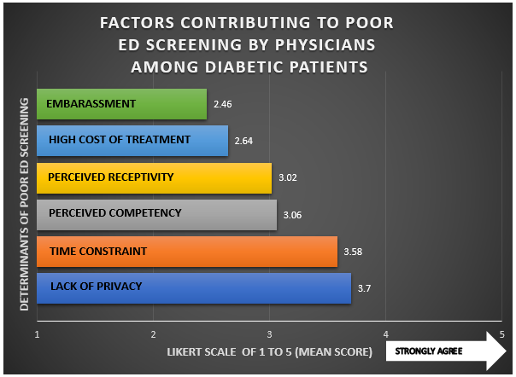
Reference:
1. Diabetes. (2017, July). Retrieved September 13, 2017, from http://www.who.int/mediacentre/factsheets/fs312/en
2. Esposito, K., Maiorino, M. I., & Bellastella, G. (2014). Diabetes and sexual dysfunction: current perspectives. Diabetes, Metabolic Syndrome and Obesity: Targets and Therapy,2014(7), 95-105. doi:10.2147/dmso.s36455
3. Perttula, E. (1999). Physician attitudes and behaviour regarding erectile dysfunction in at-risk patients from a rural community. Postgraduate Medical Journal,75(880), 83-85. doi:10.1136/pgmj.75.880.83
4. Penson, D. F., Latini, D. M., Lubeck, D. P., Wallace, K. L., Henning, J. M., & Lue, T. F. (2003). Do Impotent Men With Diabetes Have More Severe Erectile Dysfunction and Worse Quality of Life Than the General Population of Impotent Patients?: Results from the Exploratory Comprehensive Evaluation of Erectile Dysfunction (ExCEED) database. Diabetes Care,26(4), 1093-1099. doi:10.2337/diacare.26.4.1093
5. Ng CJ, Low WY, Tan NC, et al. The role of general practitioners in the management of erectile dysfunction-a qualitative study. Int J Impot Res 2004;16:60-3.
6. Tong, S. F., Low, W. Y., Ismail, S. B., L. T., & S. W. (2013). Determinants of doctors’ decisions to inquire about sexual dysfunction in Malaysian primary care settings. Transl Androl Urol ,281-290. doi:10.3978/j.issn.2223-4683.2013.09.14


Biography
Dr Muhamad Nur Kausar is a medical officer at a public funded health clinic in Penang. Focusing on men’s health, he is actively promoting ED Intervention Programme in his district especially in diabetic patients. He has presented a poster at Diabetic Asia Conference 2017 on ED in diabetic patient and presented his paper on impact of his intervention programme in National Quality Assurance Conference 2017 in Malaysia and won Jury Special Award (Oral category).
Email: drkausarzulkifli@gmail.com

