Title: Health Education for promotion of health seeking towards abnormal vaginal discharge: Public Health Midwives’ Challenges
IMPS Ilankoon MSC, CSE Goonewardena, MD, RC Fernandopulle, MS, PPR Perera, PhD,
Faculty of Medical Sciences,
University of Sri Jayewardenepura, Sri Lanka

Abstract
Abnormal vaginal discharge is a common gynaecological complaint among women aged 15 to 49 years. Public Health Midwife (PHM) is the grass root level health care provider in Sri Lankan health care system. This study was carried out to assess PHMs’ knowledge on vaginal discharge, attitudes, and present health education activities related to vaginal discharge.
This community based cross sectional study was conducted among all consenting PHMs who work in Colombo district, Sri Lanka. A self-developed, validated, pretested self-administered questionnaire was used to collect data. Descriptive and inferential statistics were used by using SPSS software version 16.
A total of 308 PHMs participated and the mean age was 40.69 years (SD±10.72). Nearly half of the participants had work experience for more than 11 years. Majority of PHMs have performed health education during home visits (72.7%) and at clinics (66.2%). Mean knowledge score regarding vaginal discharge and causes was 53.6 (SD ± 12.43). Only few participants (3.2 %) had good knowledge on vaginal discharge while 48% of participants obtained poor knowledge. Lack of knowledge was observed in the areas of reproductive tract infections and causes for pathological vaginal discharge. The mean knowledge scores was significantly higher among those who had less than 40 years of age (p= 0.004) and work experience less than 15 years (p=0.002) to their counterparts.
Majority agreed that educate females on vaginal discharge is one of their primary responsibilities (97%). Nearly 17% of participants rated their competency in providing health education on vaginal discharge as poor. Lack of available time (84.7%), lack of teaching aids (75%) and women’s anxiety and shyness in asking questions or revealing health problems at community (73.4%) were the major challenges faced.
Although the PHMs showed motivation towards health education at community level, insufficient level of knowledge was found. Thus, there is a need of upgrading their knowledge and skills as a strategy to meet the growing demand for quality health education and referral activities at community level.

Image
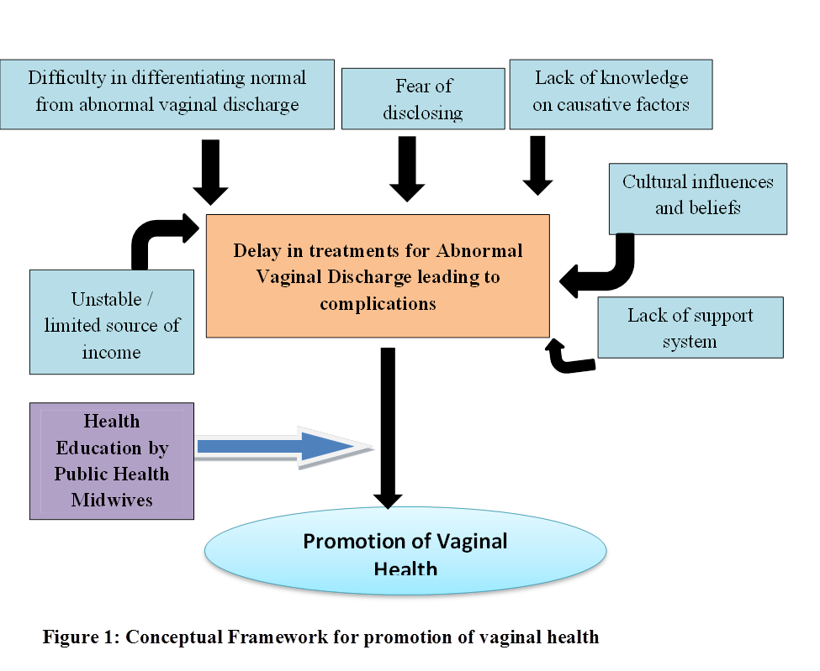
Recent publications (minimum 5)
- IMPS Ilankoon, CSE Goonewardena, PPR Perera, R Fernandopulle, 2017. Women’s Knowledge and Experience of Abnormal Vaginal Discharge Living in Estates in Colombo District, Sri Lanka. International Journal of Women’s Health and Reproduction Sciences. 5( 2), 90–96. DOI: 10.15296/ijwhr.2017.17
- IMPS Ilankoon, CSE Goonewardena, PPR Perera, R Fernandopulle, 2017. An Insight to How Estate Women in Sri Lanka Manage Abnormal Vaginal Discharge. Iranian Journal of Public Health. 46(2):268-269
- Dawson AJ, Wijewardena K, Black E. Health and education provider collaboration to deliver adolescent sexual and reproductive health in Sri Lanka. South East Asia Journal of Public Health. 2013;3(1):42-49.
- Karunathilake I and Silva PD. Retention of Family Health Workers in Rural Communities as an Important Strategy in Task-shifting- The Sri Lankan Experience. JMAJ. 2010; 53(06): 424-426.
- Silva APD. The contribution of Public Health Midwives to better health in rural communities in Sri Lanka, Second Global Forum on Human Resources for Health 25 - 29 January 2011 | Bangkok, Thailand

.

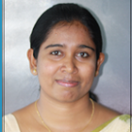
Biography
IMPS Ilankoon is a lecturer attach to Faculty of Medical Sciences, University of Sri Jayewardenepura, Sri Lanka. Her research interests include nursing education, women’s health and primary health care. She has conducted research related to childhood nutrition, nursing education, women’s health and primary health care workers. She has published her findings in international journals and in different research forums. At present she is reading for her PhD and her PhD research is on primary health care worker’s role in promotion of vaginal health among women living in socially marginalized communities in Colombo District, Sri Lanka. She has found the need of educating and empowering Public Health Midwives (PHMs) in order to promote women’s health in the community setting as the PHMs are the available family health care worker in the Sri Lankan health care system. At present she is developing a health education intervention for PHMs including theoretical knowledge on vaginal discharge, health education skills and communication skills.
Email: prasanthi@sjp.ac.lk

Oral or Poster or Workshop:

Notes/Comments:

