

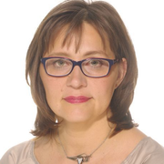

Curative mud and paraffin treatment for hand and wrist
pain syndromes in female workers.

V-R. Tuulik^{1,2}, S. Saarik¹, V. Tuulik¹, M. Übner^{1,3}, T. Vare¹, E. Makienko¹
¹The Centre of Excellence in Health Promotion and Rehabilitation, ²West Tallinn Central Hospital, Tallinn, Estonia, ³Pärnu College, University of Tartu, Pärnu, Estonia

The aim of the study: to measure the effectiveness of curative mud and paraffin treatment in case of hand and wrist pain syndromes in female workers.
Objectives: Musculoskeletal disorders are the main causes of work disability in the EU. Insufficient microcirculation (MC) is one of the earliest functional impairments that occurs in case of overuse syndromes and repeated local thermostress treatment could repair the MC in the overused regions. We used local hot packages with Haapsalu Bay curative mud and hot paraffin for the treatment of overused hand pain syndromes. Curative mud contains a lot of minerals and bioactive organic compounds which stimulate natural recovery.
Method: 39 workers with upper limb overuse pain were exposed to 10 local thermotherapies on the hands. 42 ⁰C mud group: 20 persons with the mean age of 52.2±9.9, BMI 27.6±5.1, working years 11.2±9.0 and warm paraffin treatment group: 19 persons with the mean age of 52.9±8.2, BMI 26.3±5.2, working years 11.6±9.9. The mean pain score on the Visual Analogue Scale in the curative mud group was 4.9 before and 2.7 after the treatment and in the paraffin group 3.9 before and 2.5 after the local treatment on the hands.
Results: In the group of local warm curative mud application the pain score decreased 44.9% (p<0.0001), and in the group of paraffin treatment 36.1% (p<0.012).
Conclusions: Local warm applications of mud or paraffin could be a method for the prevention and treatment of hand and wrist overuse pain syndromes.

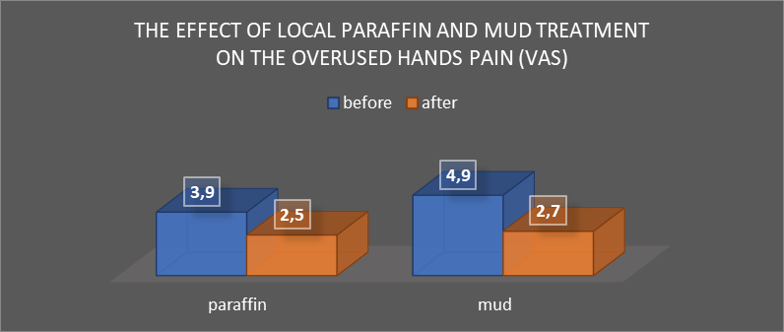

Biography
Varje-Riin Tuulik has graduated from Tartu University and has the European Certificate in Physical and Rehabilitation Medicine (PRM) since 2010. She works as a senior PRM physician in West-Tallinn Central Hospital and conducts her scientific work in balneology at Tallinn University Haapsalu College.

Presenting author details:
Full name: Varje-Riin Tuulik
Contact number: +372 56479502
Email id: Varje.Tuulik@keskhaigla.ee
Category: e-poster presentation
Session name: preventive medicine and occupational health
Research interest: balneology, occupational medicine, prevention and rehabilitation

