A Novel Synthetic Route To Micellar Polymer Additives For Fuels And Lubricants
Assia Stiti
Dr. Ana Maria Cenacchi Pereira
Pr. Sebastien Lecommandoux
Pr. Daniel Taton
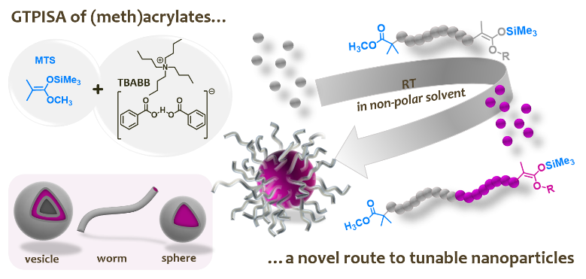
Figure 1. Group transfer polymerization induced self-assembly (GTPISA) of (meth)acrylate monomers at RT in non-polar solvent as an organocatalyzed route to block copolymer nanoparticles (spheres, worms and vesicles).

Polymerization-induced self-assembly (PISA) enables the synthesis at large scale of a wide variety of functional nanoparticles.^{[1–6]} However, most of the work is related to controlled radical polymerization (CRP) methods and is generally undertaken at elevated temperatures (> 50 °C). We present the first work on methacrylate-based nanoparticles fabricated by group transfer polymerization-induced self-assembly (GTPISA) in non-polar media (n-heptane). This GTPISA process is achieved at room temperature using 1-methoxy-1-(trimethylsiloxy)-2-methylprop-1-ene (MTS) and tetrabutylammonium bis-benzoate (TBABB) as initiator and organic catalyst, respectively. Under these conditions, well-defined metal-free and colorless diblock copolymers are produced with efficient crossover from the stabilizing first block to the non-soluble segment. The resulting methacrylate block copolymers simultaneously self-assemble into nanostructures of various sizes and morphologies. Once the core of these micelles is cross-linked using EGDMA, the resulting nanoparticles become more resistant to temperature variations. The core functionalization of these micelles has also been achieved by introducing TEMPO functions, thus antioxidation applications for lubricants and fuels can then be considered. GTPISA in non-polar solvent proceeds rapidly, avoids the use of sulfur or halogenated compounds or metallic catalysts associated with the implementation of CRP methods.

[1] J. Cao, Y. Tan, Y. Chen, L. Zhang, J. Tan, Macromol. Rapid Commun. 2021, 42, 1–12.
[2] C. Liu, C. Y. Hong, C. Y. Pan, Polym. Chem. 2020, 11, 3673–3689.
[3] F. D’Agosto, J. Rieger, M. Lansalot, Angew. Chemie - Int. Ed. 2020, 59, 8368–8392.
[4] L. A. Fielding, M. J. Derry, V. Ladmiral, J. Rosselgong, A. M. Rodrigues, L. P. D. Ratcliffe, S. Sugihara, S. P. Armes, Chem. Sci. 2013, 4, 2081–2087.
[5] D. Le, D. Keller, G. Delaittre, Macromol. Rapid Commun. 2019, 40, 1–21.
[6] K. Fuchise, Y. Chen, T. Satoh, T. Kakuchi, Polym. Chem. 2013, 4, 4278.



Assia Stiti is a 3rd year of PhD student in the lab of Pr. Sébastien Lecommandoux at the LCPO (Laboratoire de Chimie des Polymères Organiques) in Bordeaux, France. The core of the laboratory's activities is the study of polymerization reactions and the development of innovative methodologies in chemistry, chemical engineering and physical chemistry of polymers. Her research project focuses on the engineering of functionalized polymers, nanoparticles and nanostructures of controlled size and shape for lubricant application. These researches are motivated by the industrial need to avoid high temperature and use of metals, sulfur or halogenated compounds.
Email: stitiassia@gmail.com

