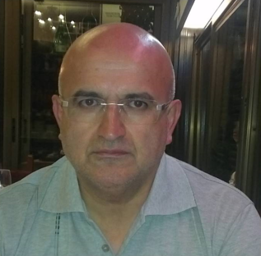


Performance of polymer parts made by fused deposition modeling process
A. Tcharkhtchi
1) Laboratoire PIMM, UMR 8006 CNRS, Arts et Métiers ParisTech, Paris 75013, France

Abstract
Fused deposition modeling (FDM) is one of the methods in thermoplastic additive manufacturing (AM) processes, in which a solid polymer filament is heated up to molten state melted, extruded though a nozzle, deposited on the surface of neighboring layers, welded onto them and finally solidified. The performance of the part depends on different parameters: temperature, rate of heating, the geometry and the size of the nozzle orifice and its trajectory, viscosity of the polymer, its thermal conductivity and so on. The major physical phenomenon during process is the coalescence of polymer filaments. The welding of different layers depends on this physical phenomenon. Between different parameters, the temperature distribution between polymer filaments in the FDM process determines the bonding quality, integrity and mechanical properties of the resultant prototypes. In this study, physico-chemical and rheological tests on different thermoplastic sample made by FDM process, have been carried out in order to understand the phenomenon of the bonding. This study has been performed also in macroscopic scale to follow the sintering in coalescence and densification steps.

Biography

Abbas Tcharkhtchi is professor, exceptional class at “Arts et Métiers ParisTech (ENSAM)”. He works in the field of microstructure-process-properties relationship of polymers and composites”. During last years he had several responsibilities: Head of polymers and Composites group of ENSAM, Head of processing, mechanic and materials department.
At present, He is the scientific Manager of the doctoral training of the ENSAM-Campus Paris at the PIMM laboratory and the Naval Academy and the responsible of 60 PhD students. He is the president of technical and scientific commission of Francophone Association of Rotational Molding (AFR). He is also the Director of common laboratory between ENSAM and CEA (French Atomic Energy Commissariat) for the development of the fuel cell and the use of hydrogen as energy source for the vehicles. Other responsibilities may be listed as follows: Member of International office of ENSAM, Member of national strategic committee of polymers and composites, elected member of the educational council of ENSAM. He authored around 110 publications and 6 patents; managed more than 50 industrial projects.

