Investigation on the mechanical, barrier and degradation properties of polyglycolic acid synthesized via ring-opening polymerization

Abstract (300 word limit)
Polyglycolic aicd (PGA) is a biodegradable thermoplastic that has been widely used in biomedical application since 1964. The polymer chain is the simplest aliphatic polyester, giving rise to high stereo-regularity and hence results in high crystallinity for PGA. Because of this molecular structure, PGA possesses superior properties in both mechanical and gas barrier performances. The tensile strength of high molecular weight PGA is much higher than that of polylactic acid (PLA) and polyethylene terephthalate PET. O₂ barrier property of PGA was extremely better than that PLA, PET and other commercialized packaging polymers. As a biodegradable polymer, PGA can be fully degraded into water and CO₂ via hydrolytic decomposition. The degradation rate of PGA can be within 20-50 days depending on the environment, such as pH, humidity, and temperature.
In the present study, the high molecular weight PGA sample was synthesized from ring-opening polymerization of glycolide with SnCl₂ catalyst. The weight average molecular weight of the sample was measured to be $\sim$187150 and the crystallinity was 48$±$1%. Mechanical property of the PGA sample was tested and compared with PLA, poly(butylene adipate-co-terephthalate) (PBAT) and PET. O₂ permeability of the PGA sample was measured from compression moulding sheets (thickness $≈$ 0.61mm). The O₂ permeability of the PGA sheets was found 100 times lower than that of PLA. The degradation of PGA in water at different temperatures was measured and the effects of pH and temperature on the rate of degradation were investigated.

Image
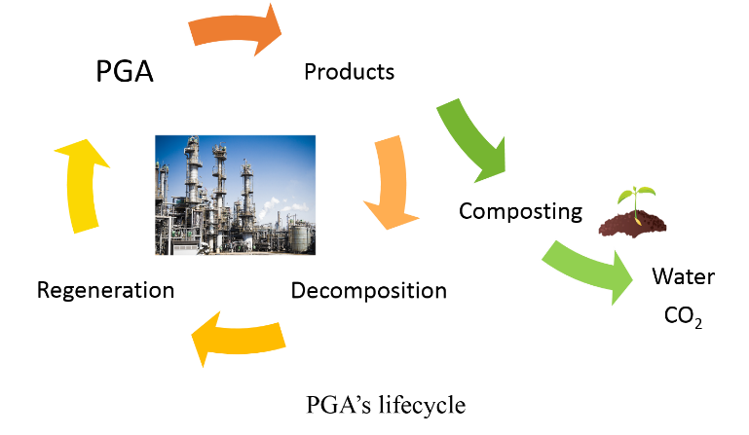
Recent Publications (minimum 5)
1. W.Liu and C. Sun (2016) CN205575974U Screw extruder and have this screw extruder's cyclic annular lactide preparation facilities, China


Biography (150 word limit)
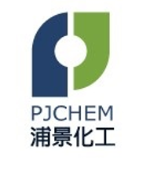
Dr. Bowen Tan is working as a marketing manager at Pujing Chemical Industry Co., Ltd. She obtained her first degree from Sichuan University, China and a Ph.D. in the barrier property of bio-based polymer membrane from Loughborough University. Bowen’s research interests lie in the field of bio-based and bio-degradable polymer. She has been investigating polyglycolic acids (PGA) for many years and has expertise on the processing and characterization of PGA products. She is Lead/co-author of papers published in well-regarded industrial and professional journals and presenter at international research conferences.
Email: tanbowen@pjchem.com

Notes/Comments:

Presenting author details
Full name: Bowen Tan
Contact number: +44 (0)7741620034
Mail id: tanbowen@pjchem.com
Category: (Oral presentation/ Poster presentation) Poster presentation

