Electrical properties of Nanocompocite Conducting Polymers (PANI-DBSA/MWNCT)
Kareema M. Ziadan , Hanaa H. Inayh and Hayfaa A. jasim, University of Basrah , College Science ,Department of physics, Basrah-Iraq

Abstract (300 word limit)

Statement of the Problem : Preperation ,Nanocomposite conducting polymers, and study the electrical properties for fabrication electronics device. Nanocomposite conducting polymers ,PANI-DBSA/MWNCT were prepared by adding different weight ratios of c-MWNCT (1,2,3,5 ) % to Polyaniline (PANI) doped with DBSA( PANI-DBSA ). Structural characteristics of nanofibers composites and the formation of functional group were measured by . X-ray diffraction (XRD) and FT-IR spectroscopy. X-Ray Diffraction, scanning electron microscope(SEM) ,show the homogeneous coating of PANI-DBSA onto the MWNCNT indicating that carbon nanotubes were well dispersed in conducting polymer matrix. The electric conductivity was measured and it was found that the thin films correlate with the ohmic behaviour at voltage under 10V.The electrical conductivity increases as the ratios of MWNCTs increases in PANI-DBSA/MWNCTs nanocomposite from(6.17x10⁻³ S/cm ) at 0wt% to (1.12x10⁻¹ S/cm ) at 5wt% .The effect of temperature on the electric conductivity of all ratios of thenanocompositesare also studied. The result indicated the activation energy decrease as MWNCTs increase from 0.15 at (0wt %) to 0.05 at (5wt %).

Image
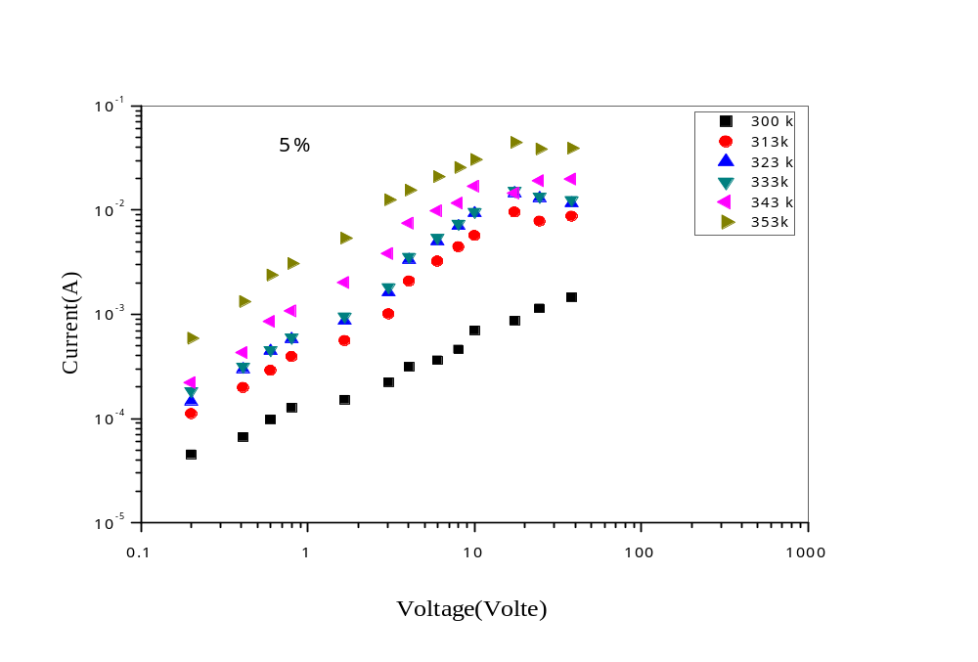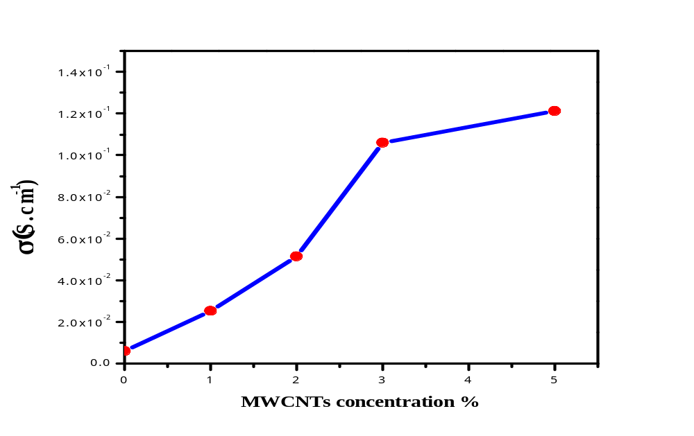
Figure 1. I-V characteristic of PANI-DBSA/MWNCT Figure 2.The electrical conductivity of PANI-DBSA/MWNCT
at different temperature as a function of MWNCT

Recent Publications (minimum 5)
- Neetesh Kumar , ( 2009)."Study of glucose oxidase immobilized carbon nanotube polyaniline composites" , , M.Sc.thesis ,THAPAR UNIVERSITY , INDIA
- Kareema M. Ziadan , Hanaa H. Inayh and Hafaa ,Chemistry and Materials Research SSN 2225- 0956 (Online)Vol.8 No.8, 2016
- Wan M. , M. Li, J. Li, and Z. Liu, (1994)." Structure and electrical properties of the oriented polyaniline films", J.Appl. Polym. Sci., 53, 131 .
4 Tariq J. Alwan, Kareema M. Ziadan, Kadhum K. Kadhum, (2013)".Alignment Nanofibers Conducting Polymer (PAni.CSA/PEO) Preparation by Electrospinning Technique", International Review of , 7, 2(185-193)
5. Tzong-Ming Wu , Yen-Wen Lin , Chien-Shiun Liao , (2005) . "Preparation and characterization of polyaniline/multi-walled carbon nanotube composites" Carbon 43 ,734–740.


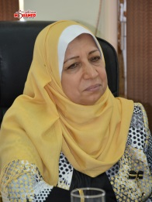Biography (150 word limit)
Prof. Dr. Kareema Majeed Ziadan Is received her Ph.D. degree from University of Basra, College of Science, Physics Department, Basra, Iraq. 1997 Field of interest : Electronic application of Conducting polymers and semiconductor ,her research , interests include: Solid state physics -Electronic application of Conducting polymers , semiconductor, and solar cell, Head of group of material science. Professor . at 2002, member in scientific committee in teragreen conference 2011, member in scientific committee in teragreen conference 2012,, member in scientific committee in TMREES14 conference 2014, member in scientific committee in TMREES15 conference
2015, TMREES18 conference ..
,Email: Kmziadan16@gmail..com

Notes/Comments:

Presenting author details
Full name: Kareema Majeed Ziadan
Contact number: mob. 0096477 12453551
Mail id:
Category: (Oral presentation/ Poster presentation) : Poster presentation

