Improved permeability and absorption of superabsorbent polymers by using ethylene glycol diglycidyl ether as a surface cross-linking agent.
Wooseung Shin, Master’s course, KITECH, the Republic of Korea,
Hae Chan Kim, Master’s course, KITECH, the Republic of Korea ,
Jungsoo Kim, Doctor’s course, KITECH, the Republic of Korea,
Ji eun Jang, Master's course, KITECH, the Republic of Korea ,
Youngwook Chang, Ph.D, Hanyang University, the Republic of Korea,
and Dong Hyun Kim, Ph.D, KITECH, the Republic of Korea

Abstract
Superabsorbent polymers (SAPs) are special polymeric materials that can absorb large amounts of water, saline solutions or physiological fluids as high as 10–1000 times their own weight due to a considerable amount of hydrophilic groups in their structure. Recently, a major research trends of SAPs are the relaxation of the gel-blocking phenomenon. Surface cross-linking reduces gel-blocking and improves absorbency under load (AUL). In this study, surface cross-linking was achieved through thermal ring-opening reaction with ethylene glycol diglycidyl ether (EGDGE) as a cross-linking agent. We prepared carboxylized vinyl monomer based SAPs with comonomer. However, the SAPs have low absorption capacity under load (AUL) and low permeability. When EGDGE is used for surface cross-linking agent, the SAPs have formed core-shell structure with different cross-linking densities between the exterior and interior. As a result, AUL and permeability of surface cross-linked SAPs were improved. We measured the absorption properties of the surface cross-linked SAPs according to the EGDGE input content, ratio of co-medium, reaction temperature, and reaction time.

Image
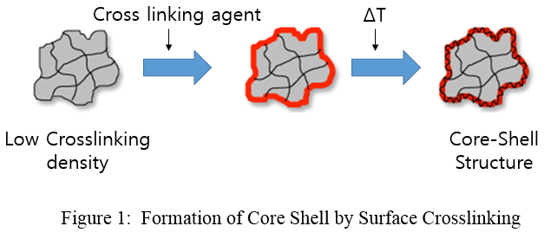
Recent Publications
- ZOHOURIAN, MEHR MJAD, and Kourosh Kabiri. "Superabsorbent polymer materials: a review." (2008): 451-447.
- Zohuriaan-Mehr, M. J., et al. "Advances in non-hygienic applications of superabsorbent hydrogel materials." Journal of materials science 45.21 (2010): 5711-5735.
- Jockusch, Steffen, et al. "Photoinduced surface crosslinking of superabsorbent polymer particles." Journal of Applied Polymer Science 111.5 (2009): 2163-2170.
- Moini, Nasrin, et al. "Simple and efficient approach for recycling of fine acrylic-based superabsorbent waste." Polymer Bulletin73.4 (2016): 1119-1133.
- Moini, Nasrin, and Kourosh Kabiri. "Effective parameters in surface cross-linking of acrylic-based water absorbent polymer particles using bisphenol A diethylene glycidyl ether and cycloaliphatic diepoxide." Iranian Polymer Journal 24.11 (2015): 977-987.

Biography
Woo-Seung Shin majored in chemistry from Incheon National University in the Republic of Korea. During his college years, he worked as an intern researcher at the Korea Institute of Industrial Technology (KITECH) and conducted research on tire tread rubber. He is a graduate student in department of materials science and chemical engineering of Hanyang University and also a researcher in KITECH. He is currently studying SAP’s surface cross-linking processes to improve the absorption properties and permeability of the SAPs.

Email: ws300@kitech.re.kr

Notes/Comments:

